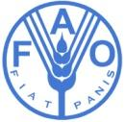 | 

Signature Page

Upon request from the Government of the Republic of Kazakhstan, represented by the Ministry of Ecology, Geology and Natural Resources of the Republic of Kazakhstan; the Food and Agriculture Organization of the United Nations (FAO) will provide technical assistance for the project entitled: ”Kazakhstan Resilient Agroforestry and Rangeland Project (Component 3)”
Upon signature of this project document by the duly authorized representatives of both parties, the project will be implemented in accordance with the background, rationale and management arrangements described herein.
On behalf of the Government: |  | On behalf of:  The Food and Agriculture Organization  of the United Nations
Name: |  | Name:
Title: |  | Title:
Date: |  | Date:

FAO-GEF PROJECT DOCUMENT

Project Title: | Kazakhstan Resilient Agroforestry and Rangeland Project (Component 3)

GEF ID: | FAO Entity Number: FAO Project Symbol: GCP/KZK/005/GFF
 | Countries: Kazakhstan
 | EOD (Implementation start): April 2021 NTE (Implementation end): April 2025
Environmental and Social Risk Classification: | low risk  moderate risk  high risk 
Gender Marker: | G0 X G1  G2a  G2b 
Contribution to FAO’s Strategic Framework:  (Indicate as appropriate) | Strategic Objective/Organizational Outcome:  20101 - Innovative practices and technologies piloted, tested or scaled up by producers, to sustainably increase productivity, address climate change and environmental degradation 40%  20102: Capacities of institutions are strengthened to promote the adoption of more integrated and cross-sectoral practices that sustainably increase productivity and production, address climate change and environmental degradation - 20%  30102 - Strategies, policies, guidelines and programmes to improve the rural poor’s access to, and control over, a set of services, finance, knowledge, technologies, markets and natural resources, including in the context of climate change 20%  40302: Public and private sector organizations capacities strengthened to increase investments in, and design and implement financial instruments and services and risk management mechanism for efficient and inclusive agricultural and food systems – 20%  Country Outcome(s): N/A  Country Programming Framework(s) Output(s):  Priority Area 4, Output 4.1  Regional Initiative/Priority Area:  Regional Initiative 3: Sustainable natural resource management under a changing climate
Project Budget (GEF/SCCF/LDCF): $1,940,367
Co-financing: $1,954,424
Total Project Budget: $3,894,791
Executive Summary

The overall objective of the joint WB-FAO Project is to restore land productivity in targeted degraded landscapes in the Republic of Kazakhstan. This will be done through scaling up of sustainable management practices that minimize pressures and negative impacts on natural resources that reduce risks and vulnerability and enhance capacity of rural communities. In particular, adoption of sustainable landscape management approaches and INRM practices should help stabilize and even reverse trends of land degradation and increase the carbon sequestration. The Project objective will be achieved during a four-year period through four project components.
The key interventions for achieving this objective, i.e., component 1, 2 and 3, follow the instruments for achieving the Project’s ‘situation sought’ of integrated landscape management and diversified agro-ecological food production systems. Component 1 will strengthen the enabling environment for sustainable management of drylands in Kazakhstan in response to the Impact Project’s identified barrier of sector-specific, top down approaches to dryland issues. Component 2 will finance investments in dryland management with the WB pillar focusing on dryland agroforestry and landscape restoration. Component 3 led by the FAO will focus on dryland pasture addressing the IP-identified barrier of inadequate investments in technical and financial capacities for sustainably managing drylands. This Project Document is dedicated to Component 3. Both pillars will contribute knowledge to the IP’s knowledge and coordination platform, restoration, thus managed by FAO, to address the barrier of fragmented approaches to combatting land degradation across dryland regions. The achievement of the project outcomes is expected to contribute toward the Project’s GEBs (such as gender equality and transparency concerning natural resource management) and socioeconomic co-benefits as described in the Project’s Theory of Change of: (i) sustainable management of dryland landscapes and production systems; (ii) land-based and value chain GHG mitigation; (iii) sustainable access of dryland communities to agro-ecosystems and forest ecosystem goods and services; (iv) reduced vulnerability of communities to economic and environmental shocks; and (v) reduced level of migration and conflict related to environmental degradation. Component 4 will focus on Project Management and Monitoring and Evaluation activities of the joint WB-FAO project.

Contents
1. Does the project include a “non-grant” instrument? no 10
1.a Project Description 11
1.b Project map and geo-coordinates. 49
2. Stakeholders. 49
3. Gender Equality and Women's Empowerment. 53
4. Private Sector Engagement 58
5. Risks 59
5.1 Risks to the project 59
5.1 Environmental and social risks from the project 60
6. Institutional arrangements and coordination. 67
6.1 Institutional arrangements for project implementation 67
6.2 Coordination with other relevant GEF-financed projects and other initiatives. 69
7. Consistency with national priorities. 69
8. Knowledge Management. 71
9. Monitoring and evaluation. 73
10. Benefits. 74
Annex A1: Project Results Framework 75
Annex B: Response to Project Reviews 83
Annex C: Status of Utilization of Project Preparation Grant (PPG) 83
Annex D: Calendar of Expected Reflows (if non-grant instrument is used) 83
Annex E: Project Map(s) and Coordinates 84
Annex F: GEF TF / LDCF/ SCCF Core Indicator Worksheet 104
Annex H: Work Plan (indicative) 113
Annex I: Financial Management 118
Annex J: Terms of Reference for Key Project Staff 120
Annex K: Environmental and Social Risk Certification 132
Annex L: Stakeholder Engagement Matrix and Grievance Redress Mechanism 132
Annex M: Pasture calculations for regeneration 144
Annex N: Project Mitigation Benefits 147
Annex O. Gender Action Plan 150

List of Tables, Figures and Boxes
Table 1: Legal Framework regulating Pastures and Grazing | 12
Table 2. Economic entities in target oblast by types and areas farmed | 18
Table 3: Analysis of a typical beef cattle outfit managing/accessing 400 ha of land | 22
Table 4. Estimation of grazing intensity for Kazakhstan | 23
Table 5: Census statistics for Aktobe, Pavlodar and national level 1999 and 2009 | 24
Table 6: Planning processes and procedures for the Republic of Kazakhstan | 28
Table 7: Stakeholder groups, mandate and potential roles in project | 43
Table 8. Project contribution to objectives of FAO Policy on Gender | 47
Table 9: Legal Framework regulating Pastures and Grazing | 52
Table 10: Project Baseline, Republic of Kazakhstan | 65
Figure 1: Ecoregions of the Republic of Kazakhstan | 14
Figure 2: Land Productivity consensus map combining the findings of the 6 different maps and models | 15
Figure 3: Trends in precipitation over last 20 years for Republic of Kazakhstan | 16
Figure 4. Land Degradation processes at work in Kazakhstan according to Trends. Earth modelling | 16
Figure 5. Presence of fire in 2019 and over period 2015-2019 | 17
Figure 6: Theory of Change model addressing barriers, LD indicators and proposed Components | 34
Figure 7: Simplified overview of options for results-based financial incentives within an LDN approach | 40
Figure 8. National context of selected Oblasts for Component 3 | 42
Box 1: Dryland Sustainable Landscapes Impact Program | 30
Acronyms
APFS Agro-Pastoral Field School
AWP/B Annual Work Plan and Budget
BH Budget holder
CBD Convention on Biological Diversity
CCM Climate Change Mitigation
CC Climate Change
CD Capacity Development
CPF Country Priority Framework (FAO)
CSO Civil Society Organisations
DSL Dryland Sustainable Landscapes
EIA Environmental Impact Assessment
EU European Union
FAO Food and Agricultural Organization of the United Nations
FE Final Evaluation
FLO Funding Liaison Officer
FFS Farmer Field School
FPMIS Field Programme Management Information System
GAP Gender Action Plan
GCP Global Coordination Project
GDP Gross Domestic Product
GDI Gender Development Index
GEBs Global Environmental Benefits
GEF Global Environment Facility
GoK The Government of Kazakhstan
GSP Global Soil Partnership
GHG Greenhouse Gases
GIS Geographical Information System
GIZ German Agency for International Cooperation
HH Household
HQ Headquarter
IW Inception Workshop
LADA Land Degradation Assessments in Drylands
LD Land Degradation
LDN Land Degradation Neutrality
LP Land Productivity
LTO FAO Lead Technical Officer
LTU FAO Lead Technical Unit
M Million
M&E Monitoring and Evaluation
NASEC National Agrarian Science and Educational Centre
NGO Non-Governmental Organization
NFA National Food Agency
NPD National Project Director
OP Operational Partner
OPA Operational Partner Agreement
OPIM Operational Partner Implementing Modality
PC Project Coordinator
PCU Project Coordination Unit
PIR Project Implementation Review
PMP Pasture Management Plan
PPG Project Preparation Grant
PPR Project Progress Reports
PRAGA Participatory Rangeland and Grassland Assessment (methodology)
PSC Project Steering Committee
PTF Project Task Force (FAO)
PY Project Year
REM Regional Exchange Mechanism
REU Regional Office for Europe and Central Asia
RF Project’s results framework
RIA Regulatory Impact Assessment
RS Remote Sensing
SDG Sustainable Development Goal
SFM Sustainable Forest Management
SEIA Strategic Environmental Impact Assessment
SLM Sustainable Land Management
SO Strategic Objective
SOC Soil Organic Carbon
SPM Sustainable Pasture Management
STAR System for Transparent Allocation of Resources
TOR Terms of Reference
TSP LDN Target Setting Program of the UNCCD and the Global Mechanism
UNCCD United Nations Convention to Combat Desertification
UNFCCC United Nations Framework Convention on Climate Change
US$ United States Dollar
WOCAT World Overview of Conservation Approaches and Technologies

PART I: PROJECT INFORMATION

Project Title: Kazakhstan Resilient Agroforestry and Rangeland Project
Country(ies): | Kazakhstan | GEF Project ID:
GEF Agency(ies): | (FAO) | GEF Agency Project ID (FAO entity number):
Project Executing Entity(s): | Association of legal entities "Association of environmental organizations of Kazakhstan" | Submission Date
GEF Focal Area (s): | Land Degradation | Expected Implementation Start | 1 April 2021
 |  | Expected Completion Date | 1 April 2025
Name of Parent Program | SUSTAINABLE FOREST MANAGEMENT IMPACT PROGRAM ON  DRYLAND SUSTAINABLE LANDSCAPES | Parent Program ID:
- Focal/Non-Focal Area Elements
Programming Directions | Focal Area Outcomes | Trust Fund | (in $)
Programming Directions | Focal Area Outcomes | Trust Fund | GEF Project Financing | Co-financing
LD-1-4 | Land Degradation | GEFTF | 192,661
CC STAR Allocation | Climate Change | GEFTF | 1,100,917
IP SFM Drylands |  | GEFTF | 646,790
Total project costs |  |  | 1,940,367 | 1,954,424
- Project description summary
Project Objective: Restore land productivity in targeted degraded landscapes in the Republic of Kazakhstan.
Project Components/  Programs | Component Type | Project Outcomes | Project Outputs | Trust Fund | (in $)
 |  |  |  |  | GEF Project Financing | Co-financing
3. Sustainable pasture management | Investment, Technical Assistance | 3.1. Expanded use of sustainable pasture management practices and technologies  3.2. Enhanced public and private investments in sustainable pasture infrastructure  3.3. Participation of the GoK in the international carbon trading system | 3.1.1. Training on sustainable pasture management practices  3.1.2. Demonstration of pasture/SLM rehabilitation and technologies  3.2.1. Demonstration of climate smart agricultural practices  3.3.1. Economic assessment of investments in carbon sequestering projects in the agriculture sector  3.3.2. Training on the international carbon trading system | GEFTF | 1,847,367 | 1,954,424
Subtotal |  |  |  | GEFTF | 1,847,367 | 1,954,424
Project Management Cost (PMC) |  |  |  | GEFTF | 93,000
Total project costs |  |  |  |  | 1,940,367 | 1,954,424
- Confirmed sources of Co-financing for the project by name and by type
Please include evidence for co-financing for the project with this form.
Sources of Co-financing | Name of Co-financier | Type of Cofinancing | Investment Mobilized | Amount ($)
GEF Agency | FAO | In-kind | No | 1,854,424
Private sector | AkTep LTD | In-kind | No | 100,000
Total Co-financing |  |  |  | 1,954,424

Describe how any “Investment Mobilized” was identified.
The US$60,000,000 investment is composed of the planned US$190 million IBRD-financed Aral Sea Development and Revitalization Project, and from the planned US$500 million IBRD-financed Sustainable Livestock Development Project. Both projects will be implemented in parallel to the proposed GEF-financed project and will reinforce restoration activities in the dry Aral Seabed and sustainable rangeland investments.
- Trust Fund Resources Requested by Agency(ies), Country(ies), Focal Area and the Programming of Funds

GEF Agency | Trust Fund | Country  Name/Global | Focal Area | Programming of Funds | (in $)
 |  |  |  |  | GEF Project Financing (a) | Agency Fee (b) | Total  (c)=a+b
FAO | GEFTF | Republic of Kazakhstan | Land Degradation | LD STAR Allocation | 192,661 | 17,339 | 210,000
FAO | GEFTF | Republic of Kazakhstan | Climate Change | CC STAR Allocation | 1,100,917 | 99,083 | 1,200,000
FAO | GEFTF | Republic of Kazakhstan |  | IP SFM Drylands | 646,790 | 58,210 | 705,000
Total GEF Resources |  |  |  |  | 1,940,367 | 174,632 | 2,115,000

- Project Preparation Grant

1. Does the project include a “non-grant” instrument? no
(If non-grant instruments are used, provide in Annex D an indicative calendar of expected reflows to your Agency and to the GEF/LDCF/SCCF Trust Fund).

- Project’s Target Contributions to GEF 7 Core Indicators
Update the relevant sub-indicator values for this project using the methodologies indicated in the Core Indicator Worksheet provided in Annex F and aggregating them in the table below. Progress in programming against these targets is updated at mid-term evaluation and at terminal evaluation. Achieved targets will be be aggregated and reported any time during the replenishment period. There is no need to complete this table for climate adaptation projects financed solely through LDCF and SCCCF.
Project Core Indicators |  | Expected at CEO Endorsement
3 | Area of land restored (Hectares) | 4,000 ha
4 | Area of landscapes under improved practices (excluding protected areas) (Hectares) | 816,000 ha
6 | Greenhouse Gas Emissions Mitigated (metric tons of CO2e) | 1,271,505 metric tons of CO2e over 20 years
11 | Number of direct beneficiaries disaggregated by sex as co-benefit of GEF investment | 30,000: 14,000 male and 16,000 female
Provide additional explanation on targets, other methodologies used, and other focal area specifics (i.e., Aichi targets in BD) including justification where core indicator targets are not provided.
G. Project Taxonomy
Please see Annex F for core indicator worksheet results.

PART II: PROJECT JUSTIFICATION

1.a Project Description
1.1 Systems Description

1.1.1 National Context

Kazakhstan has seen substantial economic growth following independence in 1991. It is currently listed as an upper-middle-income country with a gross domestic product (GDP) per capita of US$9,812.60 (2018). Much of this growth has been fuelled by oil, gas and other mineral reserves. Through extensive subsidy and other support programmes, the country has reduced poverty levels from over 60% in 1996 to 2.5% (2017).

Despite the gains, there have also been periods of economic downturns. The global financial crisis of 2007-08, food price crisis in 2008 and 2011, the overflow effects of the Russian economic crisis of 2014, the currency depreciation in 2015 together with falls in gas and oil prices following their highs early this century, have impacted Kazakhstan’s growth profile. These downturns particularly affected rural households and the more socially vulnerable populations. Dependence on finite resources that experience wide fluctuations in price has led for calls to diversify the economy through sustainable production that provides employment and opportunities for rural communities. Kazakhstan ranks high overall in key gender and development indicators, with a women’s Gender Development Index (GDI) of 0.795, compared with 0.790 for men; this cumulative GDI of 1.006 places Kazakhstan in Group 1, indicating high equality between women and men. Over time, the Kazakhstan government has taken various commitments such as ratifying Beijing + 25 declaration and CEDAW convention, yet the country is not continuing to narrow its gender gaps in participation in decision-making, labour force participation and gender wage gap (33%). Despite some parity of men and women in agriculture, forestry and fisheries, women are still less empowered, and challenged by lower paying jobs once they move out of agriculture sector positions. Only 12.9% of women occupy top executive positions in agriculture, and less are involved in decision-making dialogues.

This vision of a more sustainable, more diversified economy was outlined in the State Programme of the Agro-Industrial Complex Development of Kazakhstan for 2017–2021. The Programme has four principal pillars: to increase agricultural labour productivity by 2.5 times; double gross agricultural product and increase food exports by 2.5 times; triple investments in the agricultural sector; and increase credit availability by 9.5 times. Meeting these targets will necessarily depend on development of the livestock sector, given its cultural and economic role. Indeed, Kazakhstan’s low population and vast natural resources represent an underutilised potential, with some experts saying the country could surpass Brazil as a net beef exporter before the end of the decade. As the rural population comprises approximately 42% of the total population and most rural households depend on livestock in one way or another for their livelihoods, it stands to reason that this sector should be a central component of the State Programme taking into the consideration gender disparities and social norms.

Rangeland or native grasslands in its various compositions cover approximately 186.4 million hectares and represent 84.1% of agricultural land. Kazakhstan ranks fifth in the world for pastureland area, with many of these pastures being underutilized due to a lack of basic road and water infrastructure. The importance of livestock as a refuge sector during economic downturns and its link to rural societies and livelihoods was the basis for developing the National Livestock Development Programme for 2018-2027 (National Livestock Programme). This 10-year intervention has ambitious objectives, including:
Doubling of national beef production;
State sponsored investments of US$10 billion, which is expected to attract another US$10 billion from the private sector;
Incorporation of 80,000 small to medium size farmers in to export focused beef value chains;
Importation of high productivity livestock breeds and their acclimatation to local conditions;
Expansion of production grassland area through infrastructure investment, from the 58 million ha currently used to 100 million ha.;
Increased access to improved grass strains and seed; and
Improvement of market standards by investing in veterinary services, product traceability, logistic centers, etc.
Earlier gains in agricultural output and modernisation were made through extensive subsidy programmes that favoured agri-enterprises and corporate farms. In addition to increasing the productivity gap between smaller producers and larger agri-enterprises, the ‘trickle-down’ effects to local communities were minimal and many producers continued to face poverty or exited the sector to find other economic opportunities. Therefore, the Plan emphasizes a ‘Farmer-Centric Model’ which is built around ‘family farms units’, with the aim of increasing income, job opportunities and living standards for the country’s rural populations and closing the professional, technological and economic gaps that currently exist.

These economic and social issues are taking place against a background of significant environmental challenges. Seventy percent of the country is estimated to be suffering from some form of land degradation (LD), including most of the former sea floor of the Aral Sea. LD rates are especially evident in arid zones under Saxual forest, Steppe and dryland agriculture land areas. Soil fertility has been severely affected in these areas by erosion and salinity, while bush encroachment by woody weeds is threatening formerly productive grasses in the more humid areas of the country. The use of fire and other aggressive land management practices often worsen the situation, creating ideal conditions for further weed encroachment and soil carbon loss. The more arid systems are fragile and costly in terms of time and resources to restore them to their ‘Land Potential’ as recognised under the LDN Framework. Therefore, the approach of ‘avoid, reduce and restore’ is particularl1y important in this process as a means of avoiding further LD through agro-silvo-pastoral techniques applied through integrated landscape approaches in dryland production systems.

This is well understood by the Government of the Republic of Kazakhstan (GoK). The GoK plans to significantly expand agricultural and livestock production through the different national programmes described above in parallel with the Government’s plans of ‘greening the economy’ and meeting its voluntary LDN, greenhouse gas (GHG) and Biodiversity targets. Under these plans, large areas of peri-urban planting have been proposed, together with investments in agro-forestry and forestry initiatives, to increase forest cover to 5% (currently 4.7%). Under the Bonn Challenge, the Republic of Kazakhstan also pledged to restore 1.5 million ha of forests by 2030. In June 2018 at the Ministerial Roundtable on Forest Landscape Restoration and the Bonn Challenge in Astana it was announced that the ‘green belt’ surrounding Nur-Sultan would exceed 100,000 ha. The country has also committed to reducing GHG emissions by 15% based on 1990 levels, as well as work to integrate ecosystem restoration and function with economic and social stability through climate resilient forest and native pasture cover.

Regarding LDN targets, two workstreams are operational and are investigating the establishment of an LDN base level as well as national policies and commitments. The project aims to 1) work with the existing LDN workstreams and establish additional ones as needed to support the development of an LDN strategy and targets for Kazakhstan; and 2) to set LDN numeric indicators that should be reached by Kazakhstan.

There is currently no economic requirement or fee associated with grazing the 20.9 million ha of common land under the land tenure system. Much of the grazing and land-use is done in an ad hoc, unsystematic way, though the Pasture Management Plans (PMP) being developed at the rayon (district) administrative level which are intended to address this issue. Nonetheless, the confusion and lack of data on the use and condition of the land under these systems limits their scope and effectiveness. The PMPs are also conceived without participatory inputs or feedback from those directly using and obtaining livelihoods from the resource base.
Land leased to private entities or individuals is done so under contracts up to 49 years, though criticism has been directed at the low cost for such lengthy periods of time and the fact that most small holders are excluded from these transactions given the political, administrative and economic requirements for leases. The fact that these contracts lack obligations or indicators for assessing land quality at the beginning and end of the leasing period is another stakeholder identified gap.
Access to water resources is also a limiting factor for pasture use. The destruction of 60,000 mechanical wells after the economic transition reduced the amount of usable pasture to approximate 32 million hectares, leaving roughly 100 million hectares unused. Only 40 percent of pastures currently have surface water collection capacity, being dependent on precipitation and salinity to determine its quality as stock water. The fact that so many wells were abandoned or went unmaintained, points to clear lack of sustainability in their use and maintenance. This must be considered and addressed before wells or surface dams can be repaired or dug through project investments, though their installation or reparation will most likely figure in the list of stakeholder approved investments for the demonstration landscapes to be developed through this project.
Low population pressure and underutilisation of areas have not been sufficient to avoid LD. Pressures on natural resources and land cover change from natural steppe and forest to agricultural and industrial land has impacted Kazakhstan’s landscapes and their capacity to provide ecosystem services. 48 million ha of land have degraded over the last century, including 36% of all forests types. In addition to biodiversity losses, wind and water erosion have decreased soil fertility up to 60% in key areas and dust storms can cover up to 9 million ha in particularly bad years. The more humid areas are seeing other types of LD impacts, such as bush encroachment, soil salinity issues and climate change (CC).
The shrinkage of the Aral Sea is one of the most dramatic demonstrations of the magnitude of human impact on natural areas and systems. The total uninhibited use of water for irrigation and excessive applications of insecticides, pesticides, herbicides and defoliants have brought not only ecological, economic and social insecurity to the resident population, but also created a critical situation for human health.
Stakeholder consultations have pointed towards the need for local livestock producers to better understand and take advantage of natural cycles. This includes building capacity in how to properly manage extensively farmed livestock in native pastureland and rangeland areas given their size and complexity. Traditional systems relied on customs and fixed calendars which were based on generations of observations. These systems have unfortunately been lost or have become obsolete given the drastic economic, cultural and demographic changes brought about by independence, the transition to a market-oriented economy and globalisation. Financing and investment are also needed, yet lacking in this case, to transition production systems to meet current economic realities and markets.

Approximately half of the rangelands and grasslands are found in desert or semi-desert conditions, where unsystematic grazing and abusive practices have led to a break-down in plant communities and significantly increased erosion processes. This is especially true for the communal pasture areas around rural settlements, where LD rates are unproportionally high when compared to other land use systems.

Legal and Policy Framework

The legislative framework of the Republic of Kazakhstan contains a set of laws, resolutions, and decrees aimed at the agricultural sector. Those relevant particularly for Component 3, are provided in the Table 1.

Table 1: Legal Framework regulating Pastures and Grazing
# | Date | Name of law or regulations | Type | Areas /law regulation applies to
1 | 30 August 1995 | Constitution of the Republic of Kazakhstan, Section 1, Article 6 | Constitution | It is stated that land and its subsoil, water, flora and fauna, and other natural resources are owned by the state. Land may also be privately owned on the grounds, conditions and within the limits established by law. At the same time, it obliges the citizens of the Republic of Kazakhstan to preserve nature and take care of natural resources.
2 | No. 442-II / June 20, 2003 | Land Code of the Republic of Kazakhstan | Code | Framed within the Constitution, this legislation and the regulatory legal acts adopted under it establish the purpose and zoning of the territory, dividing all land into 7 principal categories, and one of them is the agricultural lands category. Article 3 of the Land Code regulates both ownership types – private and by the State. The Code also forms the basis for natural resource use and environmental conservation. The central authorized body for its application is the Ministry of Agriculture of the Republic of Kazakhstan. Pastureland is under the agriculture land class, though grazing may take place in other land class systems (Forest, reserves, recreational areas, etc).
3 | No. 477-II  8 July 2003 | Forest Code of the Republic of Kazakhstan | Code | It is stated in the Code, that areas of the State Forest Fund, where haymaking and grazing are possible, are established by state forest owners in accordance with forest management projects or management plans for specially protected natural territories. Individuals and (or) legal entities in accordance with the legislation of the Republic of Kazakhstan on pastures have the pre-emptive right to use the areas of the State Forest Fund where haymaking and grazing are possible. Cattle grazing without a shepherd on pastures included in the State Forest Fund is allowed in exceptional cases in remote, inaccessible and sparsely populated areas. The list of such rayons is approved by the local representative body of the oblast (region) on the proposal of the oblast executive body.
4 | No. 481-II,  9 July 2003 | Water Code of the Republic of Kazakhstan, Chapter 18, Article 95 | Code | Regulates relations in terms of lands, forests, flora and fauna, and open air that develop from the use and protection of water bodies. In Chapter 18, Article 95, it is indicated that the use of surface and underground water bodies for irrigation of pastures is carried out under the order of special water use. The permission to apply special water use is provided within the state services standards which are developed by the Ministry of Agriculture. The state service is provided by the basin inspections for regulating the use and protection of water resources of the Committee for Water Resources.
5 | No. 212-III,  9 January 2007 | Ecological Code of the Republic of Kazakhstan | Code | Regulates relations in the field of protection, restoration and conservation of the environment, use and reproduction of natural resources in the implementation of economic and other activities related to the use of natural resources and impact on the environment within the territory of the Republic of Kazakhstan. The objectives of environmental protection are: protection from destruction, degradation, damage, pollution and other harmful effects; land, subsurface, surface and underground water; atmospheric air; forests and other vegetation; wildlife and the gene pool of living organisms; and natural ecological systems, climate and the earth's ozone layer. At the same time, environmental requirements for land use should not allow contamination, littering, degradation and deterioration of soil fertility, as well as removal of the fertile soil layer for the purpose of selling or transferring it to other persons, except in cases where such removal is necessary to prevent irretrievable loss of the fertile layer.
7 | February 20, 2017 | Law of the Republic of Kazakhstan “On Pastures” | Law | The Law passed in 2017 establishes the social interactions and legal framework under which grazing can take place, as well as establishing the rights and obligations of the different types of land use. Oblast and rayon authorities are responsible for ensuring rational use of pastures, improving pastoral resources and infrastructure and preventing LD. Villages and towns are then required under Article 13 to PMPs completed with land use boundary maps, proposed pasture rotations, legal watering points, distant pasture usage and terms and conditions of transhumance movements. In order to be approved, the PMP must also contain geobotanical information on pasture sites, number and type of animals and all veterinary and sanitary considerations. Article 16 covers the legal basis and requirements for transhumance migrations.
8 | April 14, 2015 No. 3-3 / 332 | ‘The maximum allowable load standards on the total area of pastures’ | Order by the Acting Minister of Agriculture | By-law under the Law ‘On Pastures’. This Ministerial Order regulates the maximum number of animals by species per pasture class, depending on climatic zones. When calculating the permissible grazing load in a particular rural district, such indicators as pasture department, zonal type, pasture subgroup, pasture class, and pasture group are considered. Results are given as total number of animals per 100ha, or 1 standard animal unit (SAU) per number of ha (1 cow per 14ha). Those areas with observed degradation can have their stocking units reduced.
9 | April 24, 2017 No. 173 | Rules for the rational use of pastures | Order of the Deputy Prime Minister | By-law under the Law ‘On Pastures’. This Order aims to establish pasture monitoring protocols and feedback mechanisms to better inform PMPs (article 13 under On Pastures Law) and to enforce compliance with the ‘Maximum Allowable Load Standards’ Order. It also introduced measures to allow for seasonal pasture fallows and create forage reserves for dry seasons.
10 | April 27, 2017 No. 185 | The methodology of measures to combat degradation and desertification of pastures, including arid pastures | Order by the Acting Minister of Agriculture | By-law under the Law ‘On Pastures’. Under this Order, three methods of pasture or rangeland rehabilitation are officially recognized. They were a) natural restoration with the provision of recreational activities, b) restoration through pasture rotation and c) direct intervention through planting campaigns, soil amelioration, mechanical and manual efforts, seeding, etc.
11 | No. 154,  7 April 2017 | The plan of measures for watering of pastures. | Order by the Acting Minister of Agriculture | By-law under the Law ‘On Pastures’. The indicative plan of pastures watering in each oblast has been developed and introduced to oblast akimats (local oblast, rayon or municipal government administration). Within this plan, measures of state support for reimbursement of expenses for the purchase of equipment for pasture irrigation infrastructure should be explained. The plan also includes consideration of the application and, if approved, payment of a subsidy within the rules of subsidizing for reimbursement of part of the expenses incurred by the subject of the agro-industrial complex.

Other important documents or innovations being promoted by the Republic of Kazakhstan with direct links and impacts on pastures and extensive livestock management include:
Concept for the transition of the Republic of Kazakhstan to the "green economy": this document lays out the current plans to transition the economy towards more sustainable production models, with special emphasis on sustainable agriculture and ecosystem services. Of the six key principles necessary for this transition, two have direct links to pastures: 1) prevention of LD and restoration of degraded lands and 2) prevention of overgrazing, soil degradation through grazing, increased animal mobility and improved access to distant pastures.
State Programme for the Development of the Agro-industrial Complex of the Republic of Kazakhstan for 2017-2021.
Subsidy Rules for the reimbursement of a part of expenses incurred by an agro-industrial complex entity for investment.
National Livestock Programme 2018-2027.
Forecast scheme of territorial and spatial development of the country until 2030.
Code of administrative offences for offences related to the destruction or illegal removal of fertile soil layer and irrational use of agricultural lands.
The comprehensive review of the Beijing Declaration and Platform for Action (1995) implementation progress of the Republic of Kazakhstan.
Voluntary National Review of On the implementation of the 2030 agenda for Sustainable Development.
5th periodic report submitted by the Republic of Kazakhstan under article 18 of the Convention, due in 2017.
The action plan for the implementation of the Concept of gender, family and demographic policy of the Republic of Kazakhstan until 2030 (second stage: 2020 - 2022).

1.1.2 Area of intervention

Through stakeholder engagement and technical analysis using sustainable development goal (SDG) 15.3.1 and relevant indicator sets and models to determine priority areas and establish links to the country’s voluntary LDN targets currently being developed through the two operational workstreams, Component 3 (Sustainable Pasture Management) will be primarily focused on the Oblasts of Aktobe and Pavlodar (see Annex E for detailed administrative and biophysical maps). The selection process was conducted using Remote Sensing (RS), socio-economic data analysis, government consultations, and stakeholder-developed selection criteria, described below.

Target Oblast selection criteria

Given the background of different data inputs and sources, the selection of the target oblasts was based on the following criteria:

They represent clear examples of nationally distinct, yet regionally representative, ecological and cultural systems, which will provide context specific models and results which can easily be scaled to surrounding areas;
Both are heavily dependent on native grasslands for livelihoods and economic prosperity, and are financially viable options for sustainable land management (SLM) implementation;
Both show trends of LD, decreases in land productivity and over-dependence on fire to remove unwanted vegetation and crop residues;
Both have issues of land salinity and problems associated with long-term irrigation and profound changes in landscape water cycles;
Both meet socio-economic indicators relating to beneficiary profiles and opportunities, containing substantial numbers of HH producers and communal pastures as well an established presence of private sector farms. Proximity allows for increased awareness and impact at key landscape scale levels and among land-users and the private sector; and
Stakeholder consultations also have shown the two oblasts to be facing distinct land management challenges, which will offer a more diversified capacity building and land restoration approach that could ultimately learn from each other and be scaled out to surrounding areas.

In an effort to increase awareness of priority issues and areas within an LDN Framework approach, key GoK agencies worked closely with FAO technical specialists to map LDN and other essential indicators. Of special significance were those maps showing ecoregion differences and trends in terms of land productivity, precipitation, LD and use of fire. In Figure, the ecoregion classifications are shown: note the importance and extent of the Kazakh Steppe in green, the Kazakh Semi-desert in orange and the Central Asian northern desert in yellow, which cover most of the national territory. The oblasts selected for the project had to contain at least one or more of these ecoregion types in order to validate options for scaling.

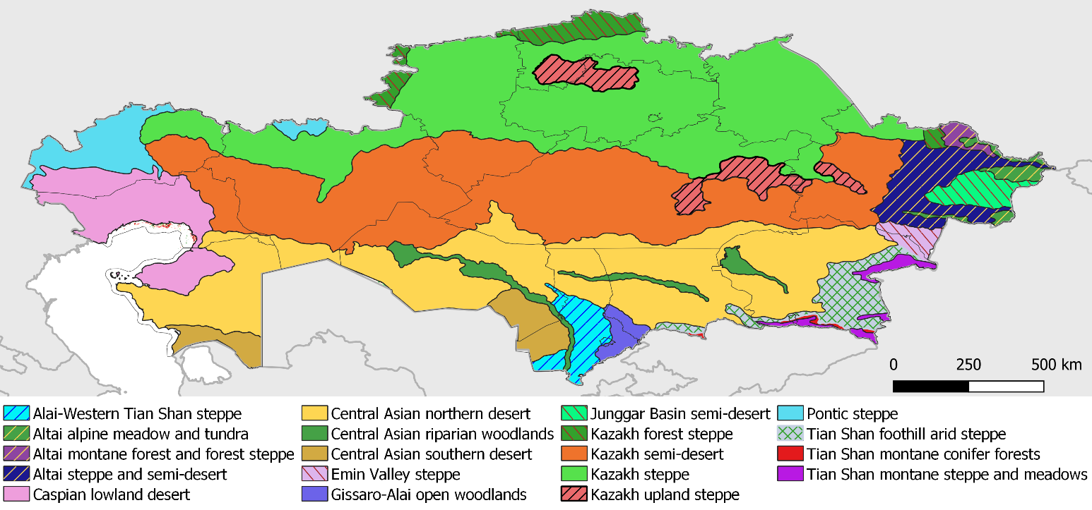
Figure 1: Ecoregions of the Republic of Kazakhstan (FAO 2020).

For the LDN indicator sets (land cover, land productivity (LP) and soil organic carbon (SOC)) land cover under the United Nations Convention to Combat Desertification (UNCCD) classifications for the majority of the national territory was ‘Grassland’, and was therefore not essential for selection criteria. SOC trends also were marginal and its use as an essential criterion was impractical. LP showed more variation and distinguishable trends, though as discussed in Annex E, caution must be applied when interpreting the results given the bush encroachment process ongoing in the more humid areas of the northern and eastern parts of the country. Figure 2 shows a map created through the consensus of six different LP methods (Teich et al., 2019 and FAO, 2020).

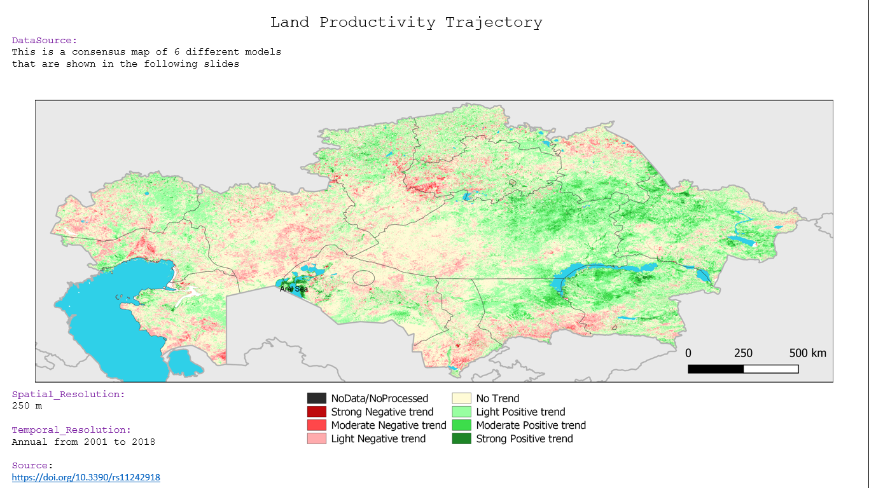
Figure 2: Land Productivity consensus map combining the findings of the 6 different maps and models

These LP models show areas of concern in the northern and western areas of the country. The translation of LP figures into LD processes is complex, though areas of both negative and positive trends should be questioned and researched. The trends seen in the LP models also correlate to a certain degree with the CC models developed to locate changes in precipitation at national scale. The maps developed all show decreases in precipitation in the western oblasts and increases in the eastern-central areas. Figure 3 is provided to support this claim.

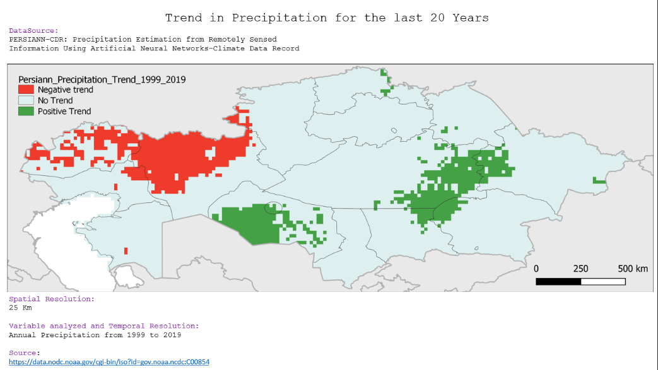

Figure 3: Trends in precipitation over last 20 years for Republic of Kazakhstan (FAO 2020).

For LD trends an aggregation map produced through Trends. Earth was considered the most direct method to calculate SDG 15.3.1 indicator: “Percentage of Degraded Land”. Again, there are clear signs for concern under this map scenario with significant LD processes identified for the larger north-western part of the country (Figure 4). 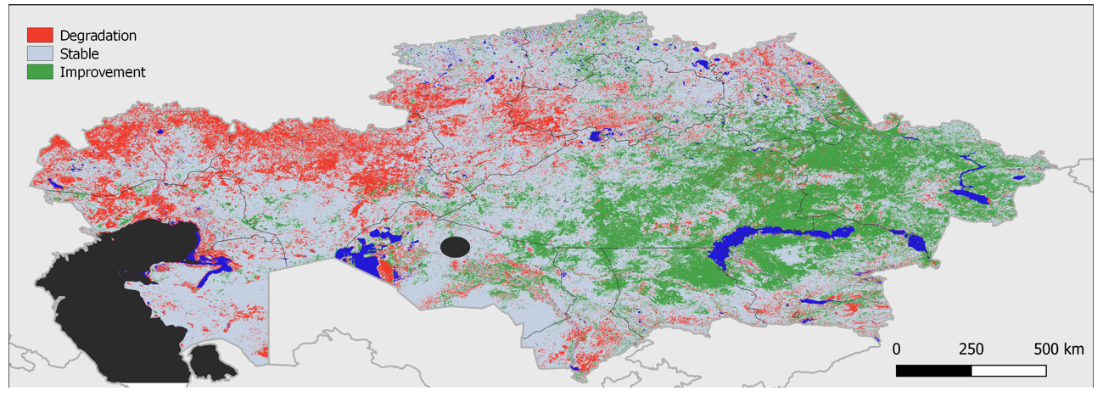
Figure 4. Land Degradation processes at work in Kazakhstan according to Trends. Earth modelling (FAO 2020)

The area burnt under cropping and grassland areas was a good indicator of land management approaches and quite surprising given the awareness that exists among most farmers on the negative effects on soil fertility and the global backlash that has been associated with the use of fire to clear land of unwanted biomass. In Figure 5 one can appreciate the potential GHG emissions associated with this practice and the negative trends seen in nitrogen and carbon soil stocks.

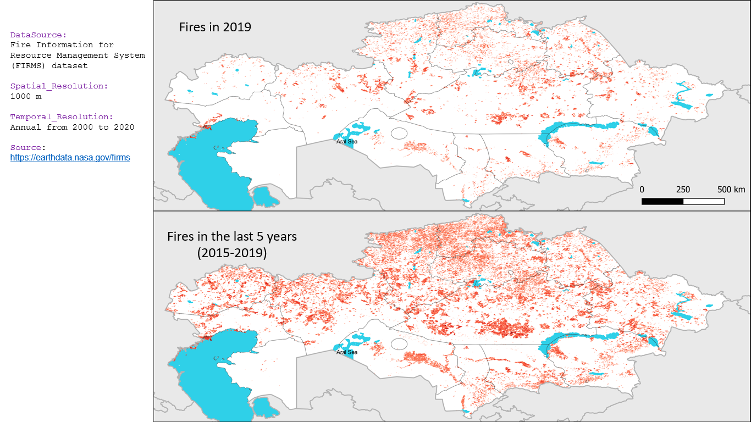
Figure 5. Presence of fire in 2019 and over period 2015-2019 (FAO 2020).

The full series of maps and supporting content are available in Annex E. This report, plus the other stakeholder produced and validated materials allowed for a more priority-based approach to defining and selecting landscape systems for initial LDN work and activities. It also allowed for exchange between SDG 15.3.1 indicators and models with stakeholder consultations and experience.

Socio-economic analysis of the target beneficiaries defined at the baseline

The project preparation team initially planned to conduct a household survey, which will serve as a basis for the baseline socio-economic assessment. However, the plans were reconsidered because of the COVID-19 pandemic. Therefore, it was agreed that the deskwork socio-economic analysis on available oblast-level data would be undertaken at the project preparation stage to define the key socio-economic parameters of the target beneficiary, the importance of rangelands in livestock value chains in targeted areas, and the socio-economic drivers that lead to pastureland degradation. It is strongly recommended to conduct the household survey at the very beginning of the project implementation to zoom in the project oblasts to select the project beneficiaries and to ensure the proper monitoring and evaluation process.

The beneficiaries of the project are small-scale cattle, horse and small ruminants farmers in Aktobe and Pavlodar oblasts. Additionally, the project will also reach some medium-scale livestock breeders. Project investments in pastureland restoration and SLM will result in multiple social, economic and environmental benefits and target disadvantaged groups in particular.

The characteristics of households. While initial consultations were able to be held with government officials, the more detailed household and farmer level analysis was not possible due to the emergence and spread of Covid-19. The initial analysis relies on census data. There have been two censuses in Kazakhstan’s contemporary history — in 1999 and 2009. The census scheduled for 2019 was postponed until October 2020. There are four types of households: nuclear, extended, composite, and one-person.

A nuclear household consists of one married couple with or without children, or one parent with their unmarried children. An extended household consists of: a single-family nucleus and other persons related to it; two or more family nuclei related to each other without any other persons; two or more family nuclei related to each other and other related persons; and persons related to each other, who do not constitute a family nucleus. Composite households are households consisting of non-related persons.
According to the 2009 census, nuclear (2,321,978 or 52.9%) and extended (1,311,265 or 29.8%) households accounted for the largest shares of all households (4,391,759). One-person (639,890) and composite (118,626) households comprised 14.6% and 2.7% of the total, respectively. The average household size was 3.6 persons in both 1999 and 2009. The size of rural households (4.4) also remained unchanged, while that of urban households increased from 3.1 to 3.2 person. he average family size was 3.5 people; 72% of children under the age of 18 live with both parents, 15% — with only their mother, 6% — with only their father and 6 per cent — without either parent. Some 1,209,000 households (29%) include people 60 years of age or older, and 395,000 households (9.5%) consist solely of people 60 years of age or older. These households total more than 545,000 people, including 191,000 men (35%) and 354,000 women (65%).
Table 5 provides census statistics for Aktobe and Pavlodar oblasts. While growth has been generally inclusive, a series of economic shocks, mentioned earlier, revealed structural vulnerabilities. Continuing to ensure that social protection programs, including those for families, people with disabilities, and households headed by women, will require that such programs are targeting those most in need.
Income. The average income level varies among the oblasts. If the average salary level in the first quarter of 2020 in Kazakhstan was KZT 199 thousand (US$474), the salary that is possible to receive in the agricultural sector was almost half and averaged KZT 105 thousand (US$250). The average salary in Aktobe and Pavlodar oblasts were lower than the countrywide average by 15.5% and 12.0%, respectively. The wage gap between women and men demonstrates that gender inequalities persist despite women’s strong presence in the labor market. In 2015, women paid workers earned only 65.9% of what men earned, a figure that is less than it was in 2012, when women earned 69% of what men earned. Since the start of the government’s gender equality strategy in 2006, the wage gap between women and men has only decreased 3.7%, when women’s earnings were 62.3% of men’s. When comparing only those incomes below $75,000 per year, women earn only 57% of what men earn based on 2017 data from the World Economic Forum.

Poverty. The poverty level varies significantly by oblast, as well as among urban and rural areas. The poverty level in rural areas was 2.68 times higher than in cities in 2018. In the two target oblasts the difference in the share of people living in urban and rural area with an income below the required subsistence level is as follows: in Aktobe oblast – 1.9% vs 4.7%, while in Pavlodar oblast – 2.1% vs 5.3%, respectively. The poverty rate is slightly higher for women at just above 2.7% compared with 2.6% for men.

Employment. In 2019, the total employment in Kazakhstan constituted almost 8.8 million or about 47% out of the total population. The share of employment in agriculture, fishery and forestry in 2019 was 13.5% (almost 1.2 million people). Despite this, the share of agriculture, fishery and forestry in total GDP did not exceed 5% over the last five years. Women comprise 49% of the total workforce. Women and men occupy 43.1% and 56.9%of jobs in the agriculture sector, respectively. Moreover, in the past five years, women have become significantly more active in small and medium-sized enterprises. As of 1 January 2019, 43.2% of all registered active entrepreneurs were women.

Gender. Gender-based discrimination in Kazakhstan derives from deeply engrained social norms – including gender norms – which have resulted in entrenched traditional beliefs in prescribed gender roles for both women and men. The norms, and subsequent gender roles and stereotypes influence all aspects of women’s and girls’, boys’ and mens’ choices – from their levels of educational attainment to their fields of study; to their career opportunities; to the age at which they marry and the number and timing of the children they have; and to the roles they play in their homes. Women are underrepresented in key positions in the collective farm systems, they are less likely to gain management positions in the restructured corporate farms or gain access to individual farms. In a subsequent phase of land reform, the Land Code passed in 2003 provided that “land plots shall be granted to the citizens of the Republic of Kazakhstan as a private property or as a temporary compensated land use (lease) for the management of household or agrarian economy. While “citizens” should include women, no specific mention of women’s rights was made. The law also stipulated that land can only be granted to individuals with special agricultural knowledge or qualifications, or practical agricultural experience. Due to gender stereotypes along with unpaid domestic care work responsibilities prescribed to women, district officials tended to reject registration by women, on the grounds that they were not competent professional farmers or entrepreneurs. Such grounds ignored women having had previous professional positions, specialized training, or years of work experience on state or collective farms. One study completed a few years after the 2003 land reform found that many women felt their inferior bargaining power relative to men had caused them to receive more remote or poorer-quality land plots. Women were also less likely to obtain shares in agricultural enterprises when these state-owned or collective entities were transformed into private companies. By 2016, women represented only 12.9% of owners of registered agribusinesses. People living with disabilities, youth and elderly people often lack various health, education, employment, and financial opportunities along with absence of childcare facilities in rural areas.

Land ownership.
Both state and private ownership of land is recognized in Kazakhstan, where the Land Code is the main law governing land relations. As of 1 November 2018, the total agricultural lands (including pastures) occupied 105.3 million ha of all types of lands in the country. Despite the existence of the institution of private ownership of agricultural land, at present only a little more than 1% of the land used by farmers has been transferred to private ownership. The dominant form of land relations is based on the right of temporary long-term land use (land lease) for up to 49 years. In 2016, after the President imposed the moratorium, the sale of agricultural land by the state was suspended until 31 December 2021.

Table 2 highlights the composition of economic entities in the agricultural sector by target oblasts as of 1 November 2018 These numbers include both owners and renters of agricultural lands. The prevailing economic entities presented in Aktobe and Pavlodar oblasts are household farms, which tend to be small to medium-scale farmers.

Table 2. Economic entities in target oblast by types and areas farmed (‘000 ha).
Oblast name | Household farms |  | Non-governmental enterprises |  |  |  |  |  | Government enterprises
Oblast name |  |  | business partnerships and joint-stock companies |  | agricultural cooperatives |  | other non-governmental enterprises
 | quantity | area, ‘000 ha | quantity | area, ‘000 ha | quantity | area, ‘000 ha | quantity | area, ‘000 ha | quantity | area, ‘000 ha
Aktobe oblast | 4,322 | 7,789.8 | 246 | 2,274.2 | 78 | 320.5 | 93 | 76.3 | 22 | 36.6
Pavlodar oblast | 3,076 | 3,237.1 | 235 | 1,509.3 | 21 | 88.0 | 1,965 | 595.6 | 17 | 470.4
Total (country) | 213,528 | 62,619.7 | 7,708 | 37,459.6 | 1,631 | 2,677.9 | 3,087 | 1,025.3 | 649 | 1,489

The priority beneficiaries of the project will include single-headed households and women-led households (de jure and de facto), which typically consist of micro or small-scale plots used by rural families for subsistence-oriented farming, in addition to extensive livestock grazing on peri-urban communal pastures. This production system is the most common in the country and are the main livestock producers in the country. They use their land plots for producing household (HH) crops for self-subsistence and sometimes profit from selling the surplus at the nearby bazaars and markets.

The smallholders usually do not take any action to improve or preserve the pasturelands productivity, except for rural areas where the local communities try to follow PMPs and implement rotational grazing. There are various challenges related to the pastureland productivity in the targeted oblasts: the nearby pastures used by the communities are are already overgrazed; often pastures are leased out to HH farms/other private entities; remote pastures are affected by water accessibility issues; and in some cases, it is impossible to pass through the fenced private farms which are located between the remote pastures and the villages.

The importance of communal rangeland resources for rural livelihoods

Smallholders produce almost 70% of the gross output of livestock production in the country. This statistic is also applicable for Aktobe and Pavlodar oblasts – the share of gross livestock production by smallholders is 72% and 59%, respectively. These smallholder producers are reliant on communal pastures, since they do not have their own.

The local communities are highly dependent on the agro-climatic conditions and pasture health in their region of residence, and changes in socio-economic conditions or extreme climatic events can have significant impacts on their livelihood and income. The more favorable conditions in the region in the village location, the more productive is the livestock. Also, the warmer the region, the longer the period animals can graze on pastures and the less hay is needed. This is especially important given that feed constitutes the major share of the overall cost of animal production (between 60 and 90 percent).

The GoK is actively promoting crop diversification to secure greater feed supplies for the growing livestock sector and is taking measures to regulate the grazing mechanisms in different oblasts in accordance with the agro-climatic conditions. For instance, the Order of the Minister of Agriculture of Kazakhstan (dated 14 April 2015) clearly established the maximum permissible load rate on pastures throughout the country. The average number of allowed grazing days in Aktobe oblast is 200-210, while livestock breeders in Pavlodar oblast can graze their cattle only 160-180 days a year.

Most cattle and their calves depend on hay during the winter. Moreover, hay is necessary for other animals during periods of bad weather and for semi-intensive forms of sheep production. The main sources of hay are hayfields and meadows on low-lying wetlands. In 2018, there were 4.9 million hectares of hayfields registered in Kazakhstan, while 456,000 ha and 302,000 ha out of this amount were registered in Aktobe and Pavlodar oblasts, respectively.

The high importance of pastures in the livestock value chain for HH farms has been also revealed by the analysis by the Land Resources Committee Management of the Ministry of Agriculture. The analysis considered one of the basic indicative pasture improvement approaches that would be supported by the project – directed grazing (‘the animals at the right place, at the right time, for the right reasons’). This typically requires a mobile grazing support system (fencing, water, shelter), or investment in more permanent infrastructure (permanent fencing, earthworks, dams, roads, permanent shelters, etc). One probable economic scenario is provided in the Table 3.

Table 3: Analysis of a typical beef cattle outfit managing/accessing 400 ha of land

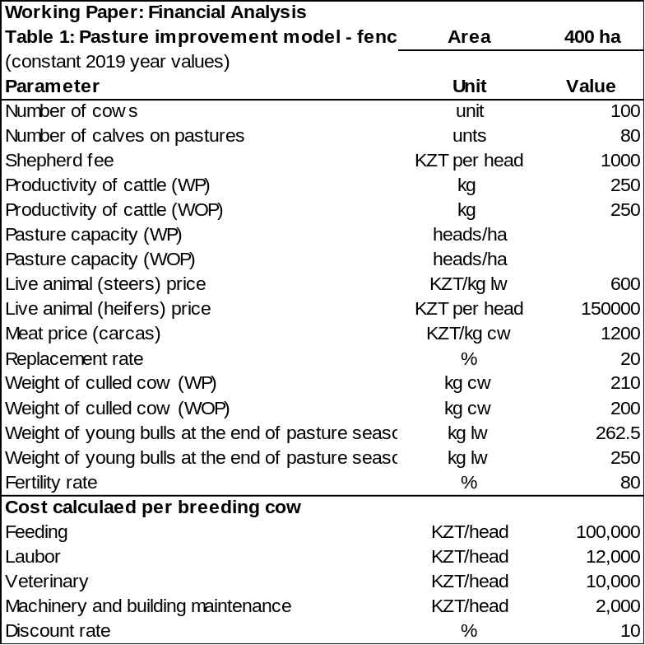

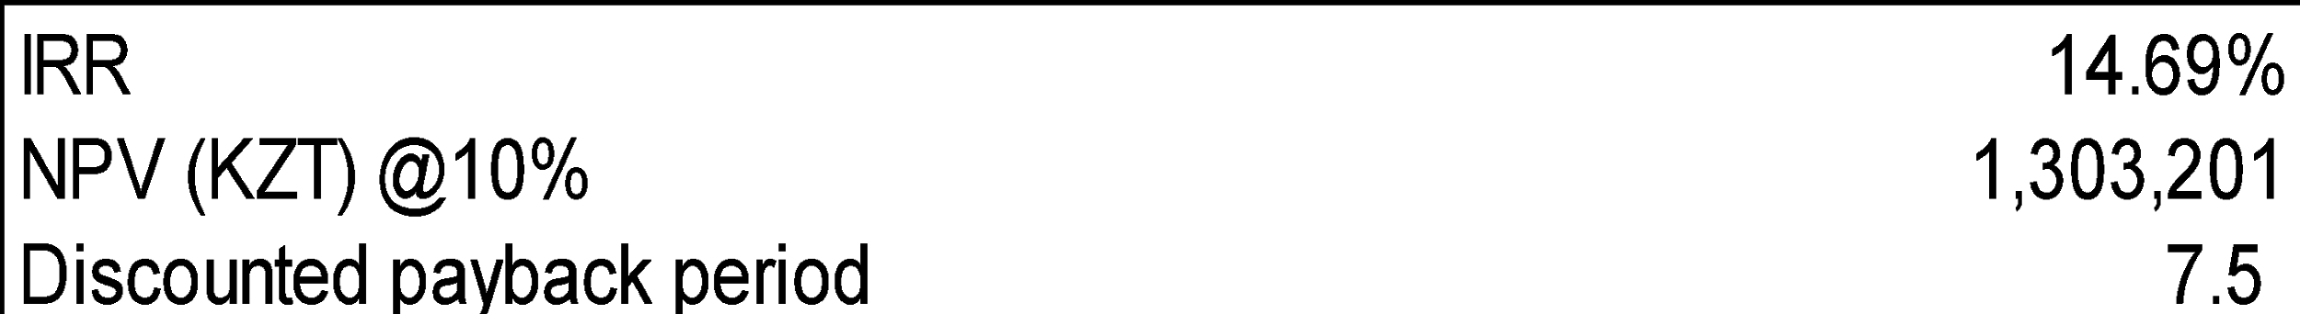

The financial model in Table 3 represents a household farm with 400 hectares of pastures. The farmer has 100 head of cows and 80 head of calves. It is assumed that in with project scenario, at the end of grazing season, the weight of young bulls will be 5% higher than in the without project scenario. The increased productivity in the liveweight of bulls is reached due to the improved pasture rotation, which is associated with an investment in the electric fence.

The period taken for the analysis is 10 years. The anticipated main benefit is increased meat production due to the higher productivity of bulls and savings on shepherd costs. The model shows a financial Net Present Value of KZT 1.33 million and a financial Internal Rate of Return of 14.69%, which is financially viable.

The above-mentioned model has been tested for sensitivity associated with pasture capacities in different agro-climatic zones of the country. The higher the carrying capacity of the pasture, the higher the financial return, but management must be focused on increasing land productivity while maintaining adequate nutritional intake for the livestock. The 100 head of cattle graze 400 ha, giving an average of 4ha per head. When grazing is open or in large paddocks or grazing cells, the animals will spread out, grazing will be highly selective, trampling of ground cover will occur, and camping at water sites and overgrazing of the more productive areas will follow. When the number of grazing cells reaches 10 or more, it is possible to target grazing not only to allow recovery times of palatable vegetation, but the grazing process can begin to incorporate other ecological/financial objectives. How this is accomplished often depends on the context and the materials available, but typically mobile fencing (electric), or a larger permanent fence grid and adapted systems to further concentrate and pinpoint grazing (electric fencing, use of dogs/shepherds, siting of salt blocks, water points, feeding areas, mobile shade structures, etc) is needed. The details for one such cost scenario are presented in Table 4.

Table 4. Estimation of grazing intensity for Kazakhstan (Hankerson et. al 2019).
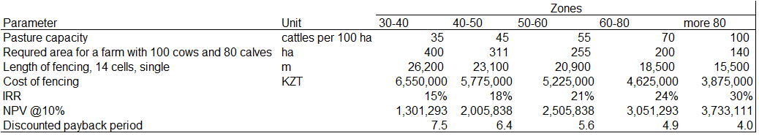

Beneficiaries outreach

The beneficiary’s outreach will be carried out in two ways, depending on the legal status and features of the individual/entity, and in accordance with mandatory gender and social inclusion standards of FAO. The individuals in the target areas will be reached by the training and capacity building of 4 facilitators (1 per rayon). The facilitators will support the creation, organization and capacity building of the different beneficiaries, but will also ensure that awareness is raised on key issues and will facilitate participatory approaches to PMP development. The work carried out on commune pastures will be coordinated by local rayon akimats under the facilitators’ guidance. The target rayons will be selected with the support of the Land Resources Management Committee of the Ministry of Agriculture of Kazakhstan. Capacity interventions will include sessions on gender norms, gender relations and women’s empowerment.

The rayons in each oblast will be selected during the initial implementation phase based on the following criteria: (i) the population of the rayon that meet the beneficiary criteria; (ii) the total area of rangelands under communal management in the rayon; (iii) the extent of pasture listed as ‘degraded’; (iv) the strategic importance of the livestock value-chains in the oblast; (v) the in-kind contribution and sustainability of the rayon to run the project activities when the project ends; (vi) the physical and human resource availability in the rayon; and (vii) the readiness of the rayon akimat to take a direct responsibility for the demonstration sites and to guarantee its physical safety. The list of rayons in Aktobe and Pavlodar oblasts among which the target rayons will be selected are provided below.

 | Aktobe oblast
# | Rayon name
1 | Aktobe city
2 | Aytekebi rayon
3 | Alga rayon
4 | Baiganinsky rayon
5 | Irgiz rayon
6 | Kargaly rayon
7 | Kobdinsky rayon
8 | Martuk rayon
9 | Mugalzhar rayon
10 | Temir rayon
11 | Oiyl rayon
12 | Khromtau rayon
13 | Shalkar rayon

 | Pavlodar oblast
# | Rayon name
1 | Pavlodar city
2 | Aksu city
3 | Ekibastuz city
4 | Aktogay rayon
5 | Bayanaul rayon
6 | Zhelezinsky rayon
7 | Irtysh rayon
8 | Terenkol rayon
9 | Akkuly rayon
10 | May rayon
11 | Pavlodar rayon
12 | Uspensky rayon
13 | Shcherbaktinsky rayon

The Land Resources Management Committee will play a crucial rule by analyzing together with Operational Partner Implementing Modality (OPIM) and FAO partners those rayons/rural districts that meet the criteria and that have sufficient capacity and motivation to be key stakeholders in the project. The project facilitators will also reach out to the HH farms and agricultural cooperatives to ensure a coordinated land use process of the different segments/strata of local communities in the target areas. The work of the project facilitators will be coordinated by National Pastureland experts who will be hired by the executing agency. These experts will play a leading role in revising the PMPs and prepare the information on the nature, extent and constraints, including socially constructed constraints inherent in their pasture areas that should be shared with local communities by project facilitators.

The use of FAO’s Rural Invest methodology and ‘tool-kit’ to prepare and evaluate small- and medium-size agricultural and rural investment will also allow for project coordinators to target activities and investments in HH value chains. This tool aids users in determining where investment will have the most impact, contribute to the sustainability of the enterprise and ensure that local priorities are addressed in a gender-sensitive manner.

For the livestock gender-responsive value-chain analysis, especially meat livestock production, the role of having local “anchor enterprises” in the project area is crucial. When a key element in the chain (fattening and processing) already exists in the oblast and serves as an “anchor cooperation”, it is much easier to develop the “cow-calf” concept. For instance, in Aktobe oblast, one of the factors that can ensure the sustainability of the project is the presence of Aktep LTD, one of the biggest meat processing enterprises in the country. Since 2012, AkTep company (city of Aktobe) is making enormous efforts to develop sustainable and profitable system, regarding beef production. The company focuses on the production of quality meats for both national and export markets. It has its own fattening units and purchases the livestock from local smallholders and household farms at reasonable prices. The entire idea is based on imported beef breeds (Angus & Hereford) and improvement of local bovine population, by using better genetics and herd management. In addition to that, AkTep company made a very effective and brave business decision regarding involvement of local farmers into the business. Practically, by taking huge risk, the company dispersed a very valued herds to selected farms, located across the territory way beyond the “oblast”. By doing this AkTep made a great contribution to the rural development and built capacities necessary to for wellbeing of families and sustainable agriculture. For the first time in Kazakhstan, small farms and firmest have got opportunity to get advanced genetic, without asking the banks for the loan, and with no cash paid up front. Socio-economic information will be complemented and validated for the two target regions through the household survey during the initial stages of project implementation.

Each Oblast is briefly described below.
Table 5 provides census statistics on Aktobe and Pavlodar oblasts and compares them to the overall national situation for selected indicators. In both oblasts the proportion of the rural population has declined, the household size has remained steady and the share of resident population since birth has declined. Both oblasts also show a declining population between 1-14 years but increasing for those aged 65 and over.
Table 5: Census statistics for Aktobe, Pavlodar and national level 1999 and 2009

Indicator | Aktobe Oblast |  | Pavlodar Oblast |  | National
 | 1999 | 2009 | 1999 | 2009 | 1999 | 2009
Population
Total (‘000) | 682.6 | 757.8 | 806.9 | 742.5 | 14.981 | 116.009
Rural (%) | 44.7 | 39.2 | 36.6 | 32.0 | 43.6 | 45.9
Average household size
Total | 3.8 | 3.6 | 3.1 | 3.0 | 4.4 | 4.4
Rural | 4.4 | 4.4 | 3.7 | 3.6 | 4.4 | 4.4
Demographic burden (per 1,000 people)
Below working age (1-14) | 473 | 333 | 370 | 268 | 442 | 350
Above working age (65 and over) | 58 | 86 | 61 | 127 | 104 | 103
Population density (per 1 km²) | 2.3 | 2.5 | 6.5 | 5.9 | 5.5 | 5.9
Share of population resident since birth (%)
Total | 3.8 | 3.6 | 3.1 | 3.0 | 3.6 | 3.6
Rural | 4.6 | 4.2 | 3.7 | 3.6 | 4.4 | 4.4
Source: The Agency on Statistics of the Republic of Kazakhstan. 2011. “The Results of the 2009 National Population Census of the Republic of Kazakhstan” Analytical Report I. Astana.

Aktobe Oblast

The Aktobe Oblast has an estimated population of between 850,000 to 900,000 (51% of whom are women and 49% men). Over 250,000 people in Aktobe oblast were registered in rural areas, of whom 18.9% of women and 81.1% of men owned HH and farm enterprises. With an area of 306,000 km², being the second largest oblast in Kazakhstan after Karaganda. It borders Russia to the north, Uzbekistan to the south, as well as sharing a border with six other Kazakh Oblasts. The Ilek River, a principal tributary of the Ural River, flows through the region and is an important feature of the biophysical composition of the larger landscape.

LD is active in the area according to official reports and was identified using UNCCD protocols to map SDG 15.3.1 indicators. Literary and stakeholder sources have identified selective grazing, over-extraction of natural resources and improper land management as responsible for degradation in Saxual forest and Steppe grasslands. Overgrazing of palatable plants has led to exposure of soil to wind and water erosion, reductions in soil fertility and losses in soil organic carbon. The inability of the landscape to reach its Land Potential (Orr et al 2017) has decreased energy capture by reducing leaf surface area, increased soil temperatures and evapotranspiration rates and made landscapes less resistant to human and climate impacts. While palatable plants receive constant grazing pressure, grazing patterns and livestock loads are not sufficient to break down dry, oxidised material and reduce invasive or unpalatable species encroachment.
When land productivity decreases under these drivers, reactions of land users in the area are typically to use (i) fire to ‘reset’ ecological successions with the many negative impacts this has when repeatedly used as a management tool (Wright & Bailey 1982), or (ii) abandonment or reduced use of the landscape which then increases grazing pressure on stable landscapes, creating cycles of increasing land degradation which is reinforced by the CC impacts observed in the area.
Pavlodar Oblast

The Pavlodar Oblast has an estimated population of between 750,000 to 800,000 people (51% are women and 49% men) and an area of 124,800 km², being the ninth largest region of Kazakhstan after Karaganda. It borders Russia to the north and shares borders with four other Kazakh Oblasts. The Irtysh River and the Bayanaul National Park are central features of region.

Over 221,000 people in Pavlodar oblast were registered in rural areas, of whom 16.9% of women and 83.1% of men owned HH and farm enterprises. The oblast’s location and the presence of large river systems and their smaller tributaries contribute to a more humid, productive environment and allow for a wider diversity of crops and more intensive production systems, as well as more opportunities for integrated livestock and cropping systems. Livestock production systems in this region are typically more focused on beef and milk production, are less reliant on livestock mobility and utilise continuous grazing systems (paddocks grazed consistently during the year or with limited spatial and temporal movements). Livestock health and nutrition are paramount, and decisions are made to maintain it at a maximum with little regard or planning to improve pasture health or production.

The project demonstration sites and pastureland restoration activities are to be selected by stakeholders through participatory methods during the early stages of project implementation. This allows for more flexibility and adaptive processes based on local contexts and recent global events which may have altered priorities in the region (COVID-19; drastic fall in oil prices).

1.1.3. Barriers

In terms of pastureland degradation-related issues, there are a number of barriers that were identified by stakeholders as important for implementation of Component 3 of the project, including:
Gaps in the legal framework (to be covered under Component 1);
Lack of financing or credit for agricultural investments (to be covered under Component 3);
Lack of sustainable livestock-based business models to guide investment (to be partially covered under Component 3);
Lack of scientific information and data on the actual conditions of pastureland (participatory methodologies to be introduced under Component 3);
Lack of skills and knowledge on sustainable use of pasturelands (to be covered under Component 3);
High perceived costs and risks associated with new technologies and practices (to be covered under Component 3); and
Marginal land-user consultation or participation process in place regarding development of PMPs or natural resource management approaches (participatory methodologies to be introduced under Component 3).
Gaps in the legal framework
The Land Code, Forest Code, Ecological Code and recently created Law ‘On Pastures’ (2017) establish overall frameworks for the rational use of natural resources and the ways in which privately owned entities can retain control over land and water resources and obtain benefits. They attempt to create enabling environments that promote economic activity through sustainable resources use. There have been clear benefits due to the adoption of these codes and bylaws, though gaps have been identified in the capacity to enforce or create incentives for these laws and regulations that address the rational use of pastures, maximum carrying capacity loads per ha, desertification and monitoring of water use, etc. and measure and provide support systems which drive sustainable use and development.
One clear policy concern is in the way the PMPs required under art. 13 of the Pastures Law operate. Gaps in this law have included the following:
PMPs are developed at a Rayon level. This is a very large scale to approach such programmes;
Lack of participation of local users in the process, and especially women-led households;
Lack of informed botanical or LD inputs into plans;
PMPs lack integration at larger landscape levels as well as clear objectives for each land-unit;
Actions or decisions made in efforts to halt LD are often arbitrary and lack stakeholder inputs and real time land data;
Reduced capacity to address LD drivers and conditions;
Reduced capacity to create or enforce measures and decrees; and
Little focus on sustainability within the PMPs, which also limits options for future investment and maintenance of basic infrastructure.
Lack of access to financing or credit for agricultural investments
While the country prepares to develop its under-utilised pastoral resources, lack of financial services and credit are seen as one of the most substantial barriers to realising its full potential. From the point of view of economic efficiency, it is very important to use such a resource as pasture to the maximum extent, since the stable maintenance of livestock takes much more resources, both monetary and labour. Usually, small farms do not have the opportunity to invest in these technologies, which is due to their small amount of income and the inability to provide stable cash flows to cover the investment. Between 2011 and 2016, 13,000 women received microcredit under the Employment Roadmap. However, a total of 29,000 people started a business under this programme, indicating that while rural women’s participation was a priority, they were not the majority of programme beneficiaries.
Women face more barriers to accessing commercial credit through banks, and such challenges include lack of assets or undervaluing of their property. While preferential microcredit programmes for rural women enhance their economic opportunities, the benefits are only realized if they know how to access the programmes and are accompanied with support to balance work and family tasks as their business grows. There is a need to offer business advisory support and finance that goes beyond start-ups so that women move beyond informal subsistence activities to developing viable and sustainable enterprises.
Lack of sustainable livestock-based business models to guide investment
Sustainable development and growth of a land-based enterprise requires more than access to information and experience with SLM techniques and practices. There must be an enabling environment that takes into account and applies SLM techniques and practices within financial and environmental context. When producers hear of SLM, they often can’t envision how this small technical change needs to be incorporated within a wider context and how the whole production system, including the wider social and economic markets, needs to be focused toward precise goals and objectives that adapt to both land and market indicators. Lack of such holistic, regenerative business models also mean other projects and initiatives operating in the area see livestock and overgrazing as threats to ecological integrity and work to reduce their presence in the landscape, with the effects this can have for livelihoods. The lack of more contextual, holistic models is also partly a cause of the lack of credit and investment opportunities described above.
Lack of real time data on land condition or decision-support systems
Given the size and difficulty of the terrain, data on the ecological condition of large parts of the country are lacking and those that exist lack a more systematic framework for both collection and analysis. National data on LDN indicators is scarce though other baseline projects, such as the Central Asian Countries Initiative for Land Management (CACILM-II) are gathering spatial and other information on degradation, soil types, productivity, etc. Monitoring of pasture health and productivity is also an important concept for the land leased to private entities. The condition of the land going into the contract and its condition at the end of the contract as well as contractual obligations related to ecosystem service maintenance are unclear.
Lack of knowledge on sustainable pasture management practices
Although many traditional pastoral cultures of the region had in place social customs that maintained pasture health and productivity, these models are often non-existent or obsolete in today’s modern rural communities. When attempts are made to introduce improvements on the land, most are done without holistic context and fail to act on the original management approaches that were the root-cause of the degradation (seeding of grass plants in areas of continuing overgrazing). Current administrations at rayon level have limited experience in designing and implementing sustainable pasture management with the adoption of relevant gender-sensitive approaches and mechanisms to improve women’s access to knowledge, resources and services.
High perceived costs and risks associated with new technologies and practices
Even when producers are aware of how their livestock and land management practices impacts natural resources, often the perceived risks of changing their practice is considered too high. Given that agriculture has always had high associated risks, producers often go to great lengths to reduce risks and over time become risk averse. Convincing them to change long-term practices can prove a significant barrier to the introduction of SLM or other innovations.
Marginal land-user consultation or participation process in place regarding development of PMPs or natural resource management approaches
The fact that the PMPs are being designed and in theory implemented at a rayon level with little involvement or consultations with land-users is an identified gap both in policy and practice that has been identified through the stakeholder engagement.
COVID-19
The COVID-19 pandemic has become a great challenge for the global economy, including the economy of Kazakhstan. Fortunately for the agriculture, this sphere appeared to be one of the top sectors that have been least affected by the state of emergency and other quarantine measures. Among the self-employed representatives working in the agricultural sector around 57% were able to continue working after the spread of the COVID-19 in Kazakhstan. However, a half of them report significant reduction of their profit and around 40% notice reduction in prices on their goods and services. Those seeking for help from the side of the government, almost a half from small and medium-sized agricultural businesses received a refusal during the quarantine period. This data becomes a sign of possible risks during the implementation of the project on the recovery of degraded lands connected with the time limits, financing, documents management, etc.
The situation with the COVID-19 provides risks as well as opportunities for future development of agriculture. Among the general risks are the following:
- More potential zoonotic disease outbreaks;
- Climate change;
- Environment pollution due to the massive usage of chemicals and disinfecting remedies;
- Threat to the food security;
- Market volatility;
However, the lesson from the fight with the spread of the COVID-19 in Kazakhstan gives more opportunities for future development of agriculture. FAO advocates a comprehensive systems approach in tackling this challenge, under which:
- Economic activities, and the management of the landscapes in which they are carried out, minimize the risks of future spillover of zoonotic diseases into livestock and human populations;
- Local, regional and global food systems, and their ability to sustain food supply and economic development, are more resilient to the direct and indirect implications of similar crises in the future;
- Countries have access to the tools for informed decision-making and land use planning needed to ensure that economic activities are sustainable, that impacts on globally-important environmental values are minimized, and acceptable trade-offs are achieved among the interests of different stakeholders.
In addition to that, the COVID-19 has taught many companies to keep a constant record of the health condition of their employees. For the agricultural sector this gives better opportunities to make sure that not infected people with stable health condition are working in the sphere of food production, whose final product is consumed by the country’s population. Therefore, we are given with the opportunities to improve the observation of agricultural workers’ health by following the principles of the quarantine measures: social distancing, temperature check, constant use of sanitizers, etc.
This is the example of “The One Health” approach. The One Health approach means recognizing the connection between humans, animals, plants, and their shared environments in an integrated effort to reduce disease and pest threats and ensure safe food supply. It is well known that diseases circulate in animals and the environment, some of which can spill over and affect human health. FAO works continuously to support countries to prevent, detect and control diseases and related health threats wherever they emerge. This includes monitoring the emergence of antimicrobial resistance as well as active programmes to combat and eradicate animal diseases such as peste des petits ruminants and African swine fever, as well as diseases that pass from animals to humans including avian influenza and rabies.

1.2 Baseline scenario and associated projects.
Against this background, livestock production through development of the Kazakhstan grasslands represents a potential driver to pull the growth of the agriculture sector and promote jobs and income opportunities in rural area. However, the barriers and other issues described above constitute challenges to the export-oriented livestock production objectives outlined by the GoK in its National Livestock Programme 2018-2027. They include low productivity of natural grasslands, high feed costs, outdated subsidy programmes, poor animal genetics, lack of veterinary or product traceability systems that meet global standards, underdeveloped export markets and infrastructure and low capacity of producers to understand and implement SLM techniques and approaches.
The World Bank Sustainable Livestock Development Programme currently coming in line with an investment portfolio of US$500 million represents its current relationship with the GoK and the World Banks’s influence on issues concerning the establishment of key pillars for a successful export-oriented meat industry. Likewise, the recently developed Livestock Sector Investment and Policy Toolkit provides a framework for controlling emission growth and increasing the inclusive nature of livestock value chains.

The World Bank has several key roles in its support of the GoK in developing its livestock sector. Namely, these are to: (i) help the GoK and the sector meet international certifications and market standards by installing product traceability mechanisms, inspection services, export infrastructure and marketing strategies; (ii) support interventions that allow for the sector to meet its growth potential while providing environmental and social benefits in the form of reduced GHG and increased rural development and job opportunities; and (iii) aid and assist the GoK in decision-making and policies that enable transformation and sector development.

To achieve this, the financing instrument proposed for the Kazakhstan Sustainable Livestock Development Programme is the ‘Program-for-Results’, which is an instrument used to attempt to influence the entire sector rather than individual components through unconnected financial interventions. This programme is also well suited to the country context and will allow for improved efficiency from GoK investments and use of its own resources, to ensure elements such as the ‘farmer-centric approach and zero GHG emissions result from the sector transformation. The World Bank Program-for-Results tool also seeks to act as a supporting agent and liaison between the private sector, instilling trust and an economic basis on which to invest. The GoK’s wishes to set the stage for the development of both the early stages in the value chain (sunlight to raw materials, conversion of raw materials to base products) and in the later stages of the value chain (processing, logistics, and distribution), possibly through multinational players in their respective industries.

Therefore the goals of the World Bank Sustainable Livestock Development Programme include: (i) allow for sector growth and development yet maintains GHG at current baseline levels, through a mix of mitigation and off-setting measures; and (ii) increased income over the baseline for small to medium cattle farmer beneficiaries (gender inclusive); and (iii) expanded market access for high-value Kazakhstani beef exports.

Another associated work is GEF 7 FOLUR project “Promotion of sustainable food systems and improved ecosystems services in Northern Kazakhstan Landscape” under the United Nations Development Programme (UNDP). One of the main areas of development in the project is sustainable pasture management. In specific, the project has selected 10 demonstration sites in the four target oblasts of Northern Kazakhstan Landscape of total coverage of 152,117 ha to showcase integrated approaches to sustainable livestock management. The goal of the demonstration site for Pavlodar oblast is to organize the integrated use of pastures on floodplain and dry lands for sustainable production of livestock products and better living conditions of the rural population on the Irtysh land in Pavlodar, Aktogay district, Zholboldy rural county. The Aktogay region has the potential to increase the productivity of arable land, floodplain meadows and pastures in arid lands. Nowadays, the question of the effective and rational use of current lands is very important for the development of livestock farming as a main income source for the rural population.

The main demonstration activities that are planned to be conducted in this exact part of the GEF 7 FOLUR project include a development of the Integrated plan for the natural resources use of the Aktogay district with prior assessment of its current state, improvement of the anti-erosion pasture rotation and implementation of control over the movement of livestock by chipping GPS collars on an area of 15,000 hectares. These activities require the application of advanced technologies and facilities, such as drilling a well, equipping a watering point with a wind lift in remote areas of pastures, acquiring a residential cabin for a shepherd, a solar generator, creation of a livestock slaughtering and processing plant with a refrigerator, the usage of mobile veterinary service point. This will also imply the conduction of necessary educational workshops and trainings.

It is important to note that “Kazakhstan Resilient Agroforestry and Rangeland Project (Component 3)” does not consider any duplications of the mentioned activities conducted by the UNDP in their associated project. On contrary, during the implementation the FAO component will ensure joining the efforts with the UNDP GEF-7 FOLUR project in order to achieve the expected results in sustainable pasture management of Pavlodar oblast.

From the developing LDN position on Targets implementation, systematic planning procedures at landscape levels to address LD and other environmental or socio-economic concerns are relatively new to the country’s legislation. There has always been means and operational capacity to assess and monitor wider national ecological trends through GoK agencies with the mandate to do so. This legacy from former Soviet times is well established in those countries that once formed part of the Soviet Union. However, much of this information was gathered at national level and links and information flows between the more scientific data and observations and land managers was minimal. Therefore, the GoK has been proactive in adopting laws and regulations in order to better understand and address LD and ecosystem service flows and curb unsustainable management practices. Table 6 presents the baseline regarding monitoring and assessment of pastoral resources and planning procedures that have been introduced by the GoK:

Table 6: Planning processes and procedures for the Republic of Kazakhstan

# | Title of process or framework | Scale | Overview
 | Planning processes/frameworks
1 | The Law of the Republic of Kazakhstan “On Pastures” | The Law applies to the entire territory of the Republic of Kazakhstan. | The Law establishes the social interactions and legal framework under which grazing can take place, as well as establishing the rights and obligations of the different types of land uses. Oblast and rayon authorities are responsible for ensuring rational use of pastures, improving pastoral resources and infrastructure and preventing LD. The PMPs, which are the pasture usage planning tools, are the normative legal acts within the framework of this law (Article 13 of the Law).
 | Monitoring processes/frameworks
2 | Order of the Minister of Agriculture of the Republic of Kazakhstan on the Rules for the rational use of pastures | The Order applies to the entire territory of the Republic of Kazakhstan. | The Order concerns the issue of pastures. It regulates the monitoring procedures of agricultural lands throughout the country. If the monitoring reveals that an agricultural land plot is not used for its intended purpose or not used at all, this land plot will be withdrawn.
3 | Order of the Minister of National Economy of the Republic of Kazakhstan on the Rules for conducting land monitoring and using its data in the Republic of Kazakhstan | The Order applies to the entire territory of the Republic of Kazakhstan. | It is said in the Order, that to get information on land monitoring the following materials are used: remote sensing (surveys and observations from spacecraft, high-altitude aircraft, using small aircraft); ground surveys (soil, geobotanical, soil-reclamation, soil-erosion); and observations at points of the territorial-zonal network (Paragraph 16).
4 | State program for the development of the agro-industrial complex of the Republic of Kazakhstan for 2017-2021 | The Program applies to the entire territory of the Republic of Kazakhstan. | According to the Program, the responsible entities for conducting the geobotanical surveys are the Ministry of Agriculture and the non-profit joint-stock company “State Corporation “Government for Citizens”.
5 | Annual consolidated analytical report on the state and use of lands of the Republic of Kazakhstan prepared by the Land Resources Management Committee of the Ministry of Agriculture of the Republic of Kazakhstan | The data is presented oblast-wise and according to official land classifications. | The Report contains basic information about the country's land fund, its distribution by category of land, land and forms of ownership, and changes in the quantitative and qualitative state of land.
Sub-national processes/frameworks
 | Planning processes/frameworks
6 | PMPs | The development of PMPs is within the competence of the local executive body at oblast level (oblast and Municipality). However, the PMPs are prepared at rayon level by rayon akimats and consolidated at oblast level. | The PMPs must include land use boundary maps, proposed pasture rotations, legal watering points, distant pasture usage and terms and conditions of transhumance movements. In order to be approved, PMPs must also contain geobotanical information on pasture sites, the number and type of animals, and all veterinary and sanitary considerations.
 | Monitoring processes/frameworks
7 | Geobotanical surveys of agricultural lands, including pastures | The geobotanical surveys are carried out by the branches of the non-profit joint-stock company “State Corporation” “Government for Citizens” at the rayon level and the information is consolidated at both the oblast and national level. | The oblast level results of surveys are presented in the Annual consolidated analytical report on the state and use of lands of the Republic of Kazakhstan prepared by the Land Resources Management Committee of the Ministry of Agriculture of the Republic of Kazakhstan.

The baseline scenario thus includes a number of important elements to build upon and to implement the LDN targets. However, under the business-as-usual scenario: the pasturelands will continue to be unmanaged, under maintained and underinvested: the gaps in the policy and institutional framework that enables sustainable pasturelands management will remain; and the farmers will practice inefficient pastureland management approaches, leading to further land degradation, loss of economic returns and biodiversity, and decreased carbon stocks. Incremental GEF funding is required to pave the way for Kazakhstan to implement LDN targets in a timely, coherent, and consistent way to ensure the scaling up.

1.3 Proposed alternative scenario, expected outcomes, project components and Theory of Change.
The World Bank Sustainable Livestock Development Programme and other on-going projects and initiatives described in this document establish a strong baseline in terms of feasibility and risk assessments.

1.3.1 Alternative scenario
The Dryland Sustainable Landscapes (DSL) Program is a US$106 million GEF 7 Impact Program comprising 11 countries in Africa and Asia, implemented in collaboration with the World Bank, IUCN, and WWF. The Program takes an innovative and comprehensive approach to addressing the combined challenges of land degradation, sustainable production, improved livelihoods through private sector engagement, and restoration at landscape scale. The Program will also support countries in the development and implementation of their LDN strategies under the UNCCD. Over the course of implementation, it is expected that implementation of the DSL Program will directly result in the restoration of 1.3 million ha of degraded land and forest, and bring a further 18 million ha of land under sustainable management, while sequestering 75 million metric tons of CO2e. The Program will support the development of effective governance systems, including improved coordination across sectors and strengthening of land/resource tenure. In addition, the DSL Program will develop a comprehensive knowledge management and outreach platform at regional and global level, supported by recent innovations in spatial assessment tools and management practices. Finally, and perhaps most importantly, the Impact Program will mobilize key private sector partners to strengthen important dryland value-chains, leverage new investments, and generate new sources of long-term sustainable financing for dryland communities.
Box 1: Dryland Sustainable Landscapes Impact Program

They also provide a rich, enabling environment on which to build alternatives that allow for improved global environmental benefits (GEBs) and other key GEF principles, such as gender equality and transparency concerning natural resource management. It will do so by:
Introducing gender-sensitive innovative, regenerative pasture management models;
Involving stakeholders and beneficiaries in planning and decision-making processes that directly affect their livelihoods and productive resource base, involving women beneficiaries under special quotas and conditions;
Introduce participatory ecological and economic gender-sensitive monitoring systems that provide cost-effective means of gathering real-time data on landscape condition;
Work to build agri-business models that meet the farmer-centric, export-oriented producer profiles while introducing SLM and regenerative practices; and
Introduce holistic gender-sensitive financial planning and value chain support mechanisms that establish a basis for sustainability of project outcomes.
Sustainable pasture management approaches have been introduced into Kazakhstan through other projects and private initiatives. However, they are often based on Euro-centric thinking that does not take into account local context or the complexity or dynamics of dryland systems. To restore these areas to their ‘Land Potential’ as defined by Orr et al. (2017), it is necessary to reconsider them from a more holistic, integrated-landscape approaches. Private sector involvement will be sought to improve and add value to productive activities, create stable revenues with dryland products and services, and introduce sustainable supply chains through green bonds and private resources (banks, impact investors and philanthropists) mobilized under the future World Bank Central Asia RESILAND and ECA30x30 Initiative.
Kazakhstan has also expressed interest in bringing transformative projects to the LDN Fund. The proposed project will look at private investments facilitated by the LDN Fund to help achieve the country’s voluntary LDN targets. The project will also analyse options to involve the local and regional banking sector, including micro-lending institutions, to provide financial support to smallholders and pastoralists in carrying out SLM and sustainable forestry management (SFM) interventions.
Current livestock management approaches have been based on a paradigm that is static, assumes equilibrium conditions, and does not consider scaling issues, neither in time nor in space. Therefore, the management systems and policies designed typically attempt to limit movement, land carrying capacity and the interaction of livestock within specific areas (protected reserves) or land classes (forestry, cropping, and wetlands). However, this does not take into consideration the evolutionary links between grasses/plants and their herbivore counterparts, the role of manure and droppings in nutrient cycles or the significant biomass loads that these pastures and forest systems once carried.

“Novel concepts and tools to promote progress in grazing science and management need to incorporate heterogeneity and nonlinear scaling of spatially and temporally distributed ecological interactions such as diet selection, defoliation, and plant growth.”
Beer et al. (2020) puts herbivore biomass during the Pleistocene at approximately 10 ton per km² for much of the Eurasian steppes. These systems would of course have had complex feedback mechanisms, such as Predator-Prey relations, that would have maintained animal loads appropriate for conditions and kept animals from abusing the more productive wetland areas as these are used as ambush locations by prey. A good example of this are the changes seen in Yellowstone National Park in the United States where the reintroduction of the wolf has pushed elk and deer grazing to higher altitudes, radically changed riparian vegetation structure and stream bed composition and ‘generated temporal and spatial variation in the expression of trophic cascades’ (Boyce 2018). Likewise, similar work in Yellowstone National Park with North American bison has shown that they graze ‘so intensely’ that they push grass species into a ‘constant spring growth’ which maintains protein and productivity levels consistent over longer time periods than the control sites (Geremia et al. 2019). The large herds of mega-beasts, predators, herbivores and their earth-burrowing counterparts would have had tremendous impacts on their environment, and created dynamic, mosaic patterns within the landscape.
From a CC perspective, the mega-beast and large herbivore herds would have also produced significant quantities of methane. To explain how GHG exchange worked within these systems some studies point to the high presence of methanotrophic bacteria typically associated with healthy grassland ecosystem soils, which when present in sufficient quantities, can oxidise as much methane per hectare as produced ‘by 162 cattle per year’. Other studies have supported these links between sustainably-managed grasslands and GHG, stating that the amount of carbon sequestered through improved pasture biomass loads outweighs the impacts of the methane produced within the grass-fed beef sector in the U.S.

The dynamic processes at work in the project’s target landscapes are driven by erosion and fire, with biological interactions reduced to small, divided herds of wandering livestock that consistently overgraze palatable plants in the lower reaches of the water catchments with little outside pressure or control over their grazing patterns or behaviour. It produces a low energy environment that is fragile and easily influenced by climatic events. This process coincides with consistent calls by the global community to lessen the presence of livestock within all land cover types in order to reduce their impact in the name of ecological integrity.
The project is expected to follow the principles of soil management applied according to the ongoing GEF-6 project in Kazakhstan, in specific its part dedicated to Biosaline Agriculture Prospects. Those soils suffering from high levels of salinity in the drylands near Caspian Sea, Aral Sea, and Balkhash Lake are currently explored for the planting of draught-resistant plants used for more effective waste-free feeding of livestock and also for their future processing into food products for the population of Kazakhstan and Uzbekistan. The examples of such plants are artichoke, mung bean, amaranthus, sorgum, quinoa, millet. Thus, by teaching agricultural specialists unique methods of irrigation and planting of these lands, for instance, mixed strip planting with the usage of halophyte, it is possible to increase biomass production, reduce feed production costs, maintain a forage base for livestock in drought conditions, improve soil organic matter and reduce soil salinity.
Therefore, the landscapes that occupy the Aktobe and Pavlodar oblasts are expressions of human decision-making and management choices, dating from prehistoric to modern times. To consider them ‘natural’ is to disregard centuries of change and impact, including prehistoric losses of key species that maintain the vital connections needed in arid to semi-arid environments. This is not an argument for a return to a landscapes and ecosystems similar to that of the Pleistocene, but it does invite for a rethink how we approach rangeland and extensively managed lands at larger landscape scales and the role that livestock can ultimately play in restorative management approaches.
Another clear gap identified under previous and current and for future projects is the systematic participation of land-users and other civil society organization (CSO) stakeholders, including those, who work on rural women’s empowerment in the planning processes surrounding the PMPs or activities to reduce LD. Of course, LDN principles demand that these concepts be systematically approached by bringing the different stakeholders and specifically the most disadvantaged groups such as rural women to the discussion table to decide on collective actions and management. Drivers of unsustainable actions can be identified, and measures taken to ‘avoid, reduce and restore’ LD processes. This also reinforces ownership of the process and improvements in how local resources are viewed and cared for, as land users gain a voice and the system increases transparency, bringing to light possible gender-related injustices in relation to pastoral resources (appropriation of pastures, water resources, etc. by more powerful community members). So, the systematic participation approach not only brings in technical options and considerations but sets the stage for equal access to resources and brings social issues to the agenda, such as gender equality principles and sustainable development.
The project will also introduce participatory ecological and LD assessment and monitoring systems. This will reinforce and give more practical weight to the LDN implementation and negotiation, as well as solidify ownership of the issues and processes. Among the options available are the FAO developed Land Degradation Assessment in Drylands (LADA) project, together with World Overview of Conservation Approaches and Technologies (WOCAT) tools and Participatory Rangeland and Grassland Assessment (PRAGA) methodology.
The financial observations, results and lessons learnt from the agri-business models and value-chain activities outlined in Annex B also support the holistic approach being promoted throughout the project design. This is highly necessary given the baseline described in the earlier sections. Official plans clearly promote a transition to a ‘Green Economy’ while at the same type foresee massive investment and increases in livestock and other agricultural products over the coming years. Indeed, numerous authors and studies have supported the Government’s claims of underutilised potential, especially when considering the scale of agricultural resources within the country and current use and management inefficiencies.
SLM practices and techniques applied within the proper context have also shown to be more productive, profitable and sustainable. Therefore, the proposal of increasing ecosystem services, biodiversity and landscape resilience while at the same time doubling livestock productivity and providing sustainable land-based livelihoods to rural populations, is theoretically viable. However, it needs to be done in an enabling environment and this project aims to bring this about through a holistic and gender responsive approach and established conceptual frameworks linking policy, practice and economics.
Perspectives and initiatives around carbon trading schemes is part of the project outcomes given the GoK’s interest in capitalising on its vast reserves in land that are currently idle and underutilised. The country’s potential as a carbon sink could be worth study if the conditions and global context were appropriate. In this sense the project is well-positioned to act as a timely platform for supporting the government to achieve these multi-sectoral objectives in a coordinated manner.

1.3.2 Theory of Change

As described in the proceeding sections the project will provide a contextual backdrop and supporting mechanisms designed to provide GEF-endorsed technical and socio-economic options and alternatives for the planned baseline investments of the World Bank-financed Aral Sea Development and Revitalization Project and the Sustainable Livestock Development Project. The Aral Sea Development and Revitalization Project will restore water and environmental functions in the North Aral Sea and delta and catalyze revitalization of economic activities, while the Sustainable Livestock Development Project will enhance the Government’s programmes to facilitate a safe, sustainable and inclusive livestock sector by improving the quality of public services, increasing the sustainably managed pasture area and developing the sector along the value chain. In addition, the baseline comprises parallel financing of Deutsche Gessellschaft fur Internationale Zusammenarbeit (GIZ) financed feasibility studies for afforestation pilots of fast-growing plantation as tools to support decision making on afforestation activities in Kazakhstan, and climate risk assessments carried out by GIZ to inform sub-national adaptation planning.

Component 3 will provide gender-sensitive innovative pastoral models based on restorative and sustainable management practices that take into account the contextual realities in Kazakhstan’s rural communities and changing market demands, while increasing awareness of the LDN Framework and exploring options for carbon trading. It will build capacity at key levels throughout the stakeholder array and provide inclusive decision-support systems and frameworks that allow for clarity and prioritisation of investments and resources. It will provide adapted and tested tools and models for pasture-based livelihoods and work within established institutions to increase the number of hectares under SLM principles, as well as support LDN adaptation and carbon market initiatives, supporting a range of private and public stakeholders and beneficiaries, and focusing on women farmers at the field level.

Specifically, regarding the barriers identified in section 1.1.3 above, Component 3 will address:
Gaps in the legal framework: Pasture related policy issues and options for improvement identified through the design and implementation phases of Component 3 of the project will be approached jointly with the World Bank through Component 1.
Lack of access to financing or credit for agricultural investments: This will be approached in Component 3 through the demonstration of profitable best practices and models (see Annex A), and also by encouraging the support of gender-responsive value chain development, framing all assessments and value chain development by the FAO guiding framework and guidelines, and by selecting value chains, among others, based on the opportunities for resilient livelihoods of women and men, including the most vulnerable. Working with financial institutions to ensure their approval of the conclusions and recommendations that the project ultimately puts forward as next steps.
Lack of sustainable livestock-based business models to guide investment: Underutilised natural resource potential is not in itself a guarantee of economic prosperity or sustainable livelihoods. Therefore, Component 3 will work to build ‘farmer-centric’ business models for different production approaches and scales, with special attention to communal pasturelands and small to mid-size livestock ‘family farms’ that work with the meat and dairy sector to adapt production towards their needs and market demands. This can be done through close collaboration with the oblast and rayon authorities who are responsible for the rational use of community pastures and the development of gender-responsive Sustainable Pasture Management plans. At the same time, the demonstration sites or landscapes can act to inform and educate women and men farmers and herders working on private lands or leases in best practices and adaptive field-based pasture management and monitoring. These models can also inform possible investors on priority investments and economic thresholds under different market scenarios.
Lack of real time data on land condition or decision-support systems: Component 3 includes FAO developed and sponsored monitoring and assessment methodologies specifically aimed at increasing LD knowledge at national and local landscape levels and for assessing the ecological health of large areas of rangelands. National capacity will be built around these methodologies and local land-users will be introduced to different land management monitoring systems that take account of economic, social and ecological indicators, including those that relate to gender issues.
Lack of knowledge on sustainable pasture management practices: The immensity of the areas in question often rule out technological options for restoring and improving land. Integral Landscape Management is often the only tool at hand that can have impact at these large scales. Fortunately, the concepts behind Integral Landscape Management are quite basic and can be rapidly learnt by those with pastoral experience, as is the case for the oblasts chosen for Component 3. Experience with communities in other parts of the world such as Armenia, Kenya and Kyrgyzstan have shown that collective action by communities can also rapidly restore grassland areas as grasslands are typically more dynamic and responsive to changes in management than other more stable systems such as forests. However, it should also be said that in all these cases improvements in grassland productivity were supported by work on appropriate drivers of LD, value chains and gender-sensitive capacity building of local stakeholders.
High perceived costs and risks associated with new technologies and practices: Demonstrations are an important part of influencing producers, but even so producers can resist putting in practice what they have observed to work and prove more profitable. Once again, the holistic approach is essential in creating both social and economic conditions for this shift in production types, with special attention to cross-cutting issues such as gender. The different economic scenarios and value chain work under Component 3 will establish beneficial drivers for change, not only punitive ones as developed under the various laws and by-laws at work within the administrative landscapes.
Marginal land-user consultation or participation process in place regarding development of gender-responsive PMPs or natural resource management approaches: Component 3 will provide support to rayon authorities to introduce participatory gender-sensitive methodologies for landscape monitoring and decision-making, in order to build transparency and trust in mutually agreed land management strategies that take into account different land management and ecological contexts.
The project’s theory of change for Component 3 is in Figure 6, followed by a description of Component 3’s outcomes and outputs.

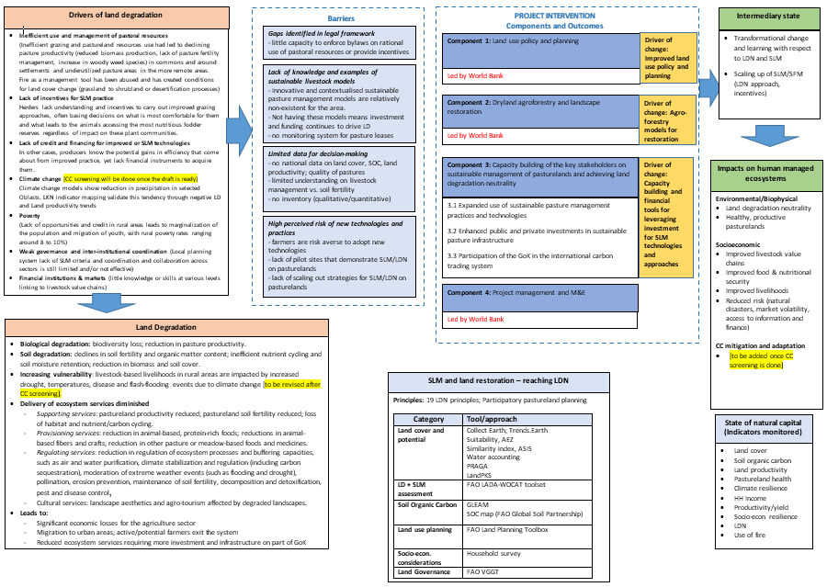
Figure 6: Theory of Change model addressing barriers, LD indicators and proposed Components
1.3.3 Project (Component 3) objectives, outcomes and outputs
The project objective is to restore land productivity in targeted degraded landscapes in the Republic of Kazakhstan. It will be achieved through four components with related outcomes and outputs:

Component 1.

Component 1 to be developed by World Bank

Component 2: Dryland AgroForestry and

Component 2 to be developed by World Bank

Component 3: Sustainable Pasture Management

Outcome 3.1: Expanded use of sustainable pasture management practices and technologies

Output 3.1.1: Training on sustainable pasture management practices

Based on the related past and ongoing projects and investments, a gender-sensitive Capacity Needs Assessment will be conducted during the first 3 months of project implementation to determine the results of past interventions and how they can be optimised and furthered within relevant State institutions and local beneficiaries. This follows on from stakeholder inputs and changing global trends, as well as a need to ensure innovative gender-sensitive pasture management methods are properly adapted to local contexts and needs.

This assessment will provide a basis to design a training and capacity building programme (Output 3.1.1). The capacity building programme will also focus on the application of the LDN as an integrated landscape approach to incorporate SLM technologies, build resilience, increase productivity (ecological+economic) and increase rural HH income. It is expected that as a result at least 2,700 farmers/farm employees/cooperative members (51% women) will be trained in: the application of the SLM/LDN technologies and practices on pastures; in product selection and positioning; and basic economic considerations for small farm businesses. The project will apply a “no one left behind” approach by ensuring inclusive and gender-sensitive participation of beneficiaries, especially in order to provide certified training to women to allow them access land given that the Land Code stipulates that land can only be granted to individuals with special agricultural knowledge or qualifications, or practical agricultural experience.

Regarding the Planned Grazing component of the training, the smallholders will be trained on developing calendars to optimize seasonal resources, balancing the livestock diet over grazing cycles, increasing and maintaining optimum leaf surface area for conditions (increasing energy flows and GHG sequestration), creating drought reserves and other failsafe measures, and learning how to use grazing animals to restore ecosystem services. Under this approach, the project will contribute to revival of adapted traditional breeds and work with producers to incorporate modern breeding theory and practice to better meet market demands, as well as incorporate traceability mechanisms and animal health safeguards. As much of this requires basic data management (can be done with paper and pencil), this will be included in the training curriculum in addition to field-based ecological monitoring and context-based decision support systems.

Following the results from the gender-sensitive Capacity Needs Assessment, the training curriculum and materials will be prepared by the core International and National Pastureland experts (please see project budget in Annex A2), and overseen by the Agro-Pastoral Master Trainer, with inputs provided by other international and national project staff. The curriculum should be tailored according to beneficiary needs, types of target administrations, organisations and enterprises, in addition to the climate-smart/SLM business models and value chains that are considered and researched in the initial stages of implementation under outcomes 3.2 and 3.3.

On the subject of beneficiaries and operationality of project activities, it is worth mentioning the existence of various initiatives within the private, public and non-government organization (NGO) stakeholders that should be considered for inclusion in other outputs but especially training. They include but are not limited to:

- Farmer Field Schools in the Aktobe and Pavlodar Oblasts with the focus on women-led households.
- Network of beneficiaries and student practicians of the SLM practices and approaches promoted by CACILM II) and other previous pasture or livestock projects and initiatives.
- Tassay base station, South-Western research institute of livestock and plant science.
- Experimental site of the Kazakh Research Institute of Animal Husbandry and Fodder Production (KazRIAHFP):

Other capacity building activities and exercises will include the Kazakhstan Government agencies such as:
- Land Resources Management Committee of the Ministry of Agriculture of the Republic of Kazakhstan; and
- Forestry and Wildlife Committee of the Ministry of Ecology, Geology and Natural Resources of the Republic of Kazakhstan

The work will include the following:
- Capacity Needs Assessment at the national, regional, and local levels; and
- Farmer training via Agro-Pastoral Field Schools, through district authorities (PMPs), cooperatives/clusters, NGOs, etc. on sustainable livestock production from a holistic approach. Beneficiaries will meet requirements on gender needs established in this document.
Specifically, farmers need to learn and understand the importance of:
- Artificial Insemination and animal health
- Pasture management and feeding strategy
-Genetics and herd management as the key factors regarding farm efficiency and profitability.

Therefore, it is essential to note that the improvement of the quality of the land itself is not enough for its sustainable management. Following the integrated approach, the project is also raising the importance of training farmers on herd management. One of the major roadblocks identified and recognized as the very critical point concerning further development, is related to the skills and knowledge at the farm level. This is not the only reason that prevents Kazakhstan business to invest even more aggressively, but it appears as the one of the risks associated to food safety, food traceability and environmental issues. Ultimately, less skills and knowledge, will bring down competitive component of the Kazakhstan beef and dairy industry, and could seriously damage rural development, as one of the most vital elements concerning country development. Kazakhstan is already fighting with very low density (3.2 person / sq.km) and without providing solutions for population located in rural and remote areas, the situation will get even worse.
Well-trained farmers would be able to look after they own herds, but skills learned (for example, bovine artificial insemination training), could be successfully applied across rural communities where farmers live. Needless to say, overall, a positive impact will be extended to the animal health issues, dairy and beef herd capacity improvement and food traceability & safety standards. Very similar to what has been mentioned already, by improving skills and knowledge concerning pasture management, farmers will directly contribute to rationalization and optimization of the natural resources use, environment protection and efficiency of beef / milk production. Certainly, awareness regarding importance of genetic would help to decrease cost of the final products (meat, milk), by improving efficiency and the quality. The final result would be a creation of a self-sustainable agriculture model, replicable across the country.

Output 3.1.2: Demonstration of pasture/SLM rehabilitation and technologies

As discussed in the introduction to this section, there exist evolutionary thresholds and patterns that can be reproduced through management techniques that allow for grassland/shrubland regeneration while producing valuable livestock-based goods and services. However, they depend on planning and systematic approaches to determine plant recovery times while at the same time guaranteeing adequate levels of nutrition for livestock.
Rotational grazing has been introduced to the Republic of Kazakhstan and produced successful results both in the country and the wider region. This system can be a good tool for introducing basic concepts, but ultimately movements must be based on field conditions and not calendar dates or fixed rigid approaches. Likewise, local context and stakeholder support must be the deciding factor when applying technologies; for example, electric or fixed fencing of smaller pasture units may be an interesting and eye-catching option, but improved road and water access can often do more to improve grazing patterns and recuperation grassland recovery times. Therefore, there must be an established stakeholder base of understanding and trust when investing the funds marked for these ‘demonstration landscapes’ and investments must be transparent and address priority issues that concern and benefit the largest number of beneficiaries or vulnerable social groups.
In order to properly select districts or communities for investment, the group of national experts identified in the budget (Annex A2) must work with the trained facilitators to find those communities that have the correct criteria and motivation for intervention. Most importantly, those administrative areas selected should meet the following:

- Amount to the minimal number of hectares identified for rehabilitation and SLM implementation in the core indicators for this project, optimally being comprised of community managed pastures;
- Strictly comply with beneficiary and socio-economic gender-responsive criteria;
- Have shown collective initiative and capacity to work together at broad community levels;
- Have the autonomy and authority to intervene on the pasture areas identified for intervention (basis for administrative scale of intervention); and
- Have shown experience and innovation in managing and maintaining pastoral infrastructure as operational (sustainability issue).
The existence of a dynamic community facilitator with a strong understanding of LD and land management issues is necessary to maintain a presence and ensure funding and investments are transparent, targeted to beneficiary needs and especially women’s needs, and meet other GEF requirements in terms of gender, sustainability and awareness around LD and LDN goals. There are a total of 5 facilitators budgeted. Their tasks will include continuous training of the agro-pastoral field school (APFS) or similar informal ‘schools’ of thought and practice based around the PMPs, and to act as rayon level focal points to oversee the implementation and management of the demonstration sites, ensure community engagement and supervise investments in infrastructure and pasture materials. They will also be essential in sex and gender disaggregated data collection and support services for the international and national consultant teams, and vice versa.
Techniques and practices will be contextualised and appropriate, though the following approaches will be considered as options for land rehabilitation:
- Directed grazing: also referred to as ‘rotational grazing’, describes the use of domestic grazing animals as tools to complete a variety of tasks, including suppressing weed growth, reducing biomass in fire prone areas, improving soil fertility and nutrient cycling, increasing pasture or forest biodiversity and maintaining historic landscapes to name a few. It often requires a change in how we see domestic animals and the roles they play within the landscape. Materials for this approach include, but are not limited to, fencing (electric/wire), water storage and distribution materials, mobile livestock infrastructure, predator deterrents (dogs, fencing/housing, noise-makers), plus other equipment to support the shepherds in managing the flocks (global positioning system ([GPS], mobile veterinary kits, holding pens, portable milking stations, etc).
- Weed Control: following grazing applications, manual or mechanical weed control measures can be taken to maintain pasture productivity. These could require the purchase of specialised machinery (tractors, brush cutters, tractor implements), manual tools, specialized clothing and gear and other supporting materials.
- Pasture fertility works and direct seeding: although the improved grazing rotations will more effectively distribute manure and urine across the pasture surface and these deposits can be concentrated to certain sites through shade and water placement, there will most likely be key areas which have been poorly managed and are in need of restoration works. This could include soil preparation works (ripping, ploughing, raking), seeding with local or improved pasture species, fertilizer and soil amendment applications, irrigation, etc. Of special interest are direct seeders which maintain pasture cover yet introduce crop or forage species into the pasture space with minimal impact.
- Earthworks and water harvesting: if done properly, focused earthworks and water harvesting structures can greatly improve water capture, retention and distribution through the grazing space. They often require heavy machinery, water distribution and storage infrastructure and fencing if animals are to be excluded from the area. These works can and most likely should include roadworks to improve access and movement of goods.
- Creation of wetlands and other diverse landscape areas as pasture support components: the increasing frequency of droughts was of vital concern for project stakeholders. Pasturelands cannot always provide adequate forage in times of drought, and backup measures should be incorporated into the grazing landscape. This can include a variety of options: for instance, drought reserves on marginal lands or boundaries are planted with deep rooting shrubs and trees that can be cut as green feed in times of emergency; and low quality hayfields not cut and ‘harvested’ by directed grazing at the end of the dry season. Wetlands should also be identified in the planning process and be grazed as individual units. Their recharge areas should maintain more biomass than their surroundings so as to improve moisture capture and retention. This excess biomass can then be intensely grazed during times of drought, as it will often be the only green material available.

The lessons learned and costs of the application and use of these techniques will be a vital component of the PMPs required under art. 13 of “Law on Pastures”. 185 of these plans have so far been developed and approved, yet the gaps and challenges identified above will need to be addressed through participatory approaches.

The project will also promote the "neutrality” within the project landscapes. Through participatory assessment and evaluation of the different land uses and systems, an agreed division and analysis of the ecological state of each area of the landscape can be reached and plans can be discussed to conserve those that are deemed healthy, and improve those areas showing degradation. Involving communities in this “neutrality” discussion also allows them to visualize and understand how ecosystem services flow through the different land tenure systems, and how this consequently leads to the need for a holistic approach to larger landscape issues.

To address the restoration of the 4,000 ha quoted in the core project indicators, a range of different combinations of the above described technologies are possible as seen below and provided in more detail in Annex K. The described combinations and options fall within the budget provided to address restoration works on the 4,000 ha. Taking into account the fact that the actual project activities identified during the implementation may vary both in features and total costs, the investments were budgeted with a rather high degree of contingencies (25%, i.e. 5,200ha instead of 4,000ha). Due to these reasons some overachievement in physical target might be expected. It should be noted that the restoration practices will be carried out by the Operational Partner (see the budget, line 43).

Rehabilitation activity | Pasture type (by beneficiary) | Area, ha | Unit cost, KZT | Unit cost, US$ | No. of sub-projects | Total area, ha | Total cost, KZT | Total cost, US$
Pasture cropping with perennial grass + fence | commune pastures/private land | 200 | 13,612,200 | 32,410 | 8 | 1,600 | 108,897,600 | 259,280
Pasture rotation using electric fencing | commune pastures/private land | 400 | 9,625,413 | 22,918 | 6 | 2,400 | 57,752,478 | 137,506
Pasture watering: water well + wind pump | private land | 1,200 | 12,186,300 | 29,015 | 1 | 1,200 | 12,186,300 | 29,015
Total: |  |  |  |  |  | 5,200 | 178,836,378 | 425,801

Another core indicator on the area of landscapes under improved practices can be achieved with the help of PMPs that will be prepared within the project. Besides the districts that will be engaged in pasture restoration activities, the project will prepare the PMPs in four different districts for sustainable use of communal pastures. In 2018, there were 20.9 million ha of communal pastures in the country, (3.6 million ha) of which are located in Aktobe oblast, while (1.7 million ha) - in Pavlodar oblast. It was estimated, that the PMPs developed within the project will cover about 15% of this area, or about 816,000 ha.

Outcome 3.2: Enhanced public and private investments in sustainable pasture infrastructure

Output 3.2.1: Demonstration of climate smart agricultural practices

The results of the socio-economic assessments revealed ‘limited access to credit or financial services for livestock/pastoral resource development’ and ‘high perceived costs and risks associated with new technologies and practices’ as among the principal barriers and obstacles to improved pastureland development and management. Pasture-based business models developed under Output 3.2.2 address this issue by developing Best Practice models that are contextually adapted to the biophysical and economic realities of the selected rayon management areas, demonstrating in clear economic terms the benefits that SLM provides when closely linked with financial and landscape planning. The models will also explore administrative, marketing, value-adding and logistical issues that must be overcome to achieve financial sustainability within complex social contexts.

Business model design under this output will be achieved by:

- Assessing the biophysical and material resources and current management systems operating within the boundaries of Pasture Management Plans developed or improved on through project activities;
- Assessing the different social and economic contexts at work at the household, community and regional levels, employing FAO endorsed territorial market mapping approaches, nutritional and gender mapping and CC screening on principal VC operating in the area;
- Assessing production costs scenarios to determine economic thresholds/ benchmarks under different market and CC conditions and locating production logjams and gaps to identify investment opportunities and improved production calendars for principal production systems operating in area.
- Developing two Best Practice business models, being i) a ‘Family or Household’ model as described in the National Livestock Programme and ii) a collective model (i.e. cooperative) which clearly outlines how a collective marketing and/or management approach can be established within a communal land tenure system governed by a stakeholder-endorsed Pasture Management Plan, as stipulated under art. 13 of the ‘On Pastures Law’. Both models will outline production and economic aspects, financial planning and ROI for different investment options. They will also clearly demonstrate other environmental and social benefits in addition to the economic benefits and compare cash-flows and profitability with other non-SLM practices.
- Promoting Best Practice business models through the FFS, regional rayon administrations, financial institutions and through linkages and collaboration with other project activities and outputs.

This outlined approach will also provide data and opportunities to develop and provide funding support for the value chains needed to sustain the Best Practice business models and eventual up-scaling of SLM practices within the larger area. Criteria for value chain selection will therefore include aspects related to national policy priorities, contribution to household and regional economies, contribution towards LDN objectives, extent of ha under production, contribution to ecosystem services and overall size and stability of value chains, with special importance to those value chains with gender and socially sensitive aspects, improved nutrition capacities and CC considerations. Since the project areas, selection process is planned for implementation stage and was not done during the PPG stage, the value chain analysis and associated business models will be developed during the implementation stage.

Target beneficiaries: 30,000 people of which 14,000 male and 16,000 female with enhanced capacity in LDN at national and sub-national levels and comprising:
SLM/SFM technologies and approaches at the targeted landscape up-scaled to achieve LDN:
- Number of hectares under SLM that meet LDN criteria (816,000 ha)
- 4,000 ha of land restored (half forestland, half grasslands)

Criteria | Definition |  | Source of info
Sex | Overall project target = 16,000 women, with specific targets for certain outcomes/ outputs as above, so preference for landscapes where it will be possible to achieve them |  | Define during partner consultation and stakeholder consultations and at LADA transect level
Age | 18 – e.g. 45 years and interested in sustainable agriculture, targeting at least 30% HHs led by people aged up to 45 years |  | Define during stakeholder consultations
Access to productive resources
Physical access
Land tenure | Clearly established access to land for at least 5 years after project end  Not necessarily via ownership but e.g. communal access to pastures contiguous to each other in the two regions.  Preference for sites with larger numbers of women farm owners/ female HH heads (in law/de jure) and secondly, where women are effectively managing farms as men migrate or other reasons (de facto HH heads)  - Possibly also contiguous to with other projects working on SLM in order to maximize GEBs: (i) 4,000 ha restored (ii) SLM and SFM cover 816,000 ha of land, and (iii) sequestration of 1,271,505 metric tons of CO2e over 20 years thanks to SLM/SFM within an LDN framework  Also ideally proximity to areas with interventions on sustainable value chains so as to boost socio-economic outcomes.  Poor/unsustainable access to water for livestock watering points that can be improved through Project intervention or avoiding land/water degradation, while ensuring water sustainability (including access) |  | Step 1. Define through data matrix on rayons.  Step 2. Define during partners consultation  Step 3. Define during stakeholder consultations.  Step 4. To be confirmed with FAO REU Land Tenure Officer
Labour | HHs will have some access to labour (family, neighbours, hired from loans etc)  Likely to have under-employed adults in HH  Project could contribute labour-saving technology and facilitate support, especially to women headed households, for whom the requirement for some access to labour should be waived. |  | Step 1. Define during partners consultation  Step 2. Define during stakeholder consultations.
Capacities
Extension services | Some access  Project can propose improvements including by private sector, but some ongoing support would be important given long-term nature of LDN |  | Step 1. Define through analysis of the existing extension network  Step 2. Define during partners consultation  Step 3. Define during stakeholder consultations.
Markets | Access to big enough markets for proposed value chains after value has been added (distance, roads, transport etc.) |  | Step 1. Define priority value chains and map them to propose to partners consideration  Step 2. Discuss and define during partners consultation  Step 3. Define during stakeholder consultations.
Technology/ machinery | Few/ obsolete tools at HH level  Project may contribute better/ clean SLWM technologies and assets at both HH and community levels. |  | Step 1. Define during partners consultation  Step 3. Define during stakeholder consultations.  Note: available machinery is considered co-financing
Policies and Institutions
Priority based on the national policies/programs |  | Based on the priority of the state policies/programs of the Committee of Land Management of the Ministry of Agriculture on land resources, cartography and state cadastre. | Step 1. Based on the LDN policy analysis  Step 2. Discuss and define during partners consultation
Supportive local government |  | Open-minded and willing to support changes for LDN, to provide project support with enabling environment | Step 1. Define during partners consultation  Step 3. Define during stakeholder consultations.
Access to common interest groups e.g. pasture groups, women’s and other inclusive small producers organizations etc. |  | Ideally the project location may already have some, possibly supported by other projects, with regard to delivering on the 2 planned sustainable VCs | Step 1. Define through analysis of the existing groups on the ground  Step 2. Define during partners consultation  Step 3. Define during stakeholder consultations.
Landscapes and LDN
Existence of the multiple typical problems regarding natural resource management |  | Such as land degradation due to natural conditions (wind or water erosion) and unsustainable use, complexity of terrain and geographic features, soil conditions, patterns of the local agricultural activities and lack of regulatory mechanisms leading to land degradation | LADA report
The importance of the agricultural sector to the region |  | GDP share of livestock sector in rayon and share of the population employed
Complementarities with baseline projects |  | Please see the list of baseline projects in the PIF | Step 1. Avoid rayons where a lot of investments already are happening, or where GEF projects already took place/on-going  Step 2. Discuss with the partners vis-à-vis the baseline projects listed in the PIF
Contribution to the National LDN targets |  | Based on the LDN TSP report | Confirm during partners consultation
Diversity of land tenure governance |  | This will be important to compare the final rayons. | As per above
Established linkages to the SDGs |  | For demonstrating co-benefits | N/A
Potential for replication in other municipalities |  | Based on DS-SLM results | Based on the similarity criteria (economic, social, economic)

Given the objectives of the GoK to increase investment in pasture-based production systems, the project seeks to provide investment guidelines for public-private entities and will work with micro-financing organizations to improve access to credit for both women and men farmers and pastoralists who wish to adapt components of the project developed business models, while at the same time developing an enabling market environment conducive to SLM up-scaling.

To resume, the work under this output will include the following:
- Development of 2 Best Practice business models that are contextually adapted and economically viable within the framework of the rayon Pasture Management Plans, preferably a ‘Family-Farm’ and a collective or private model;
- Promotion of Best Practice models through links and collaboration with other key project activities;
- Livestock value chain strengthening and funding in the two target regions; and
- Improvement of smallholder market access to financial services through Business model and value chain development.

Outcome 3.3: Participation of the GoK in the international carbon trading system

Output 3.3.1: Economic assessment of investments in carbon sequestering projects in the agricultural sector

A conservative estimate using the Ex-Ante Carbon-balance Tool (EX-ACT) methodology of FAO on, shows the 4,000 ha restored and 816,000 ha under sustainable pasture management practices under this project has a potential CO2 sequestration capacity of 1,271,505 t-CO2 equivalent mitigated over 20 years, the large majority of which from carbon sequestered by rangelands. Indeed, the sparse population and vast areas of land which receive little human activity increase the country’s potential as a potential global carbon sink. This not only has potential economic benefits under a Carbon trading scenario, but also would lead to increases in ecosystem services, soil fertility and water retention capacities of Kazakhstan’s landscapes.

The project design team has worked closely with GoK stakeholders and institutions to understand the status quo of Carbon Trading legality and practice to date. Emission Trading commenced in 2013 and after suspensions (2016-2017) and amendments, the Environmental Code’ in 2017 introduced benchmarking. 2019 saw a return to trading of allowances though the system has until now only considered energy and centralized heating (2013), plus extractive industries and manufacturing (2018; oil and gas mining, metallurgy, chemical and processing industry). Study on the potential of the agricultural sector in this aspect has been limited.
From this baseline, this project output will lead to:

- A stakeholder-endorsed policy brief on the current legal status regarding carbon trading within Kazakhstan;
- Viability study on potential Carbon market options and private/public partnerships, including calculations and analysis under different CC scenarios;
- A concise roadmap for the involvement and access of the agriculture sector to international carbon markets;

Output 3.3.2: Training on the international Carbon trading system
While the previous output centres on market potential and policy issues surrounding the involvement of the Kazakh agricultural sector in global Carbon markets, Output 3.3.2 lays the groundwork for capacity building and inventory assessment of Carbon stocks within in the country and the design of a standardised SOC monitoring system. This monitoring system would be designed to provide data and estimate the compliance of the national LDN targets, in addition to providing data for Output 3.3.1.
Capacity building of key officials and private sector stakeholders on the carbon cycle to landscape processes, options and methods for SOC monitoring and evaluation and an introduction the international carbon markets will be carried out through workshops.

Training and support will be provided by the international and national consultants. Links to this output will also come from the livestock and related SLM value chains and business models studied under outputs 3.2.1 and 3.2.2.

If carbon sequestration rates for the farmer-centric family farms envisioned in the National Livestock Programme 2018-2027 are not sufficient to be economically viable as an income source or if global carbon markets continue in the current state of disarray, then collective actions at rayon and other community levels could allow for some form of payment or benefits through the LDN Framework approach (i.e. communal lands improve carbon sequestration rates by % over the baseline and the rayon receives payment which is reinvested in the PMPs, see Figure 7).

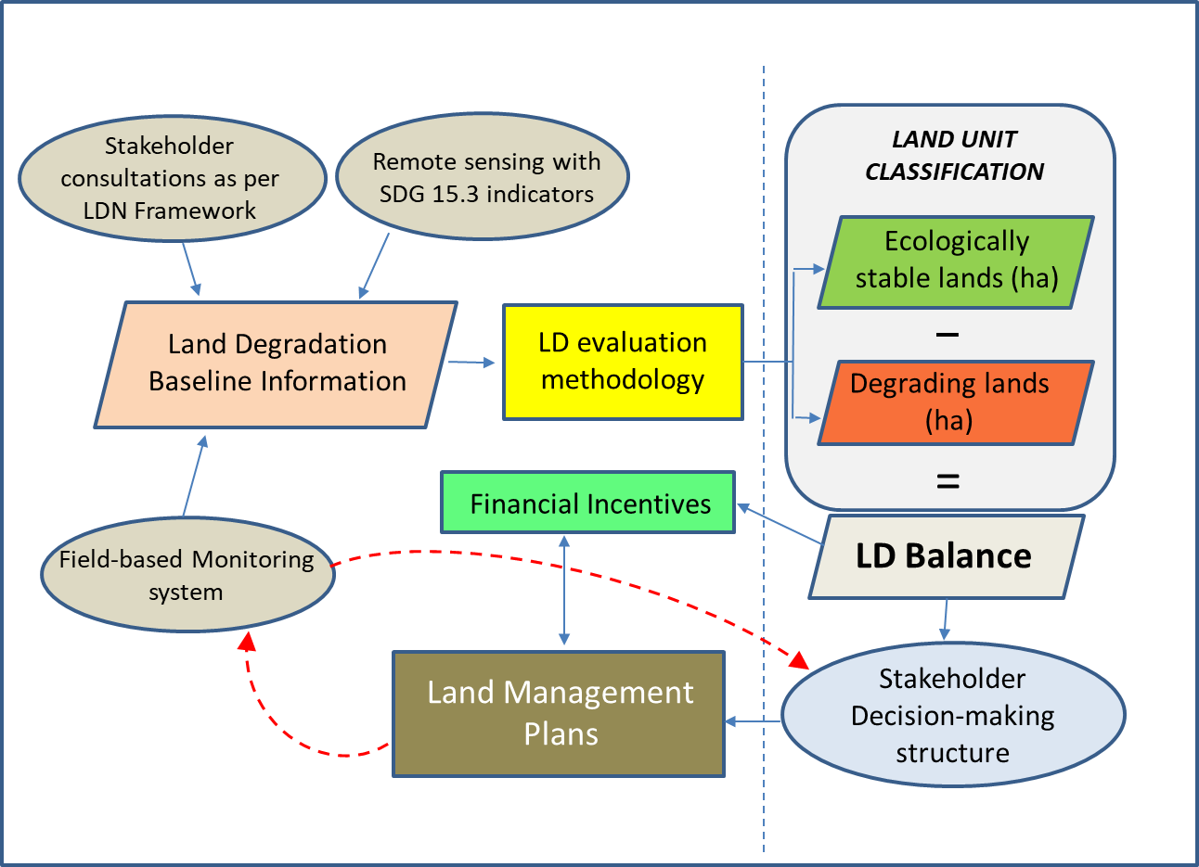

Figure 7: Simplified overview of options for results-based financial incentives within an LDN approach.

Component 4: Project Management and M&E

Component 4 to be developed by World Bank

1.4 Alignment with GEF focal area and/or Impact Project strategies;

The project will contribute to: (i) the LD focal area objective 1 to support on-the-ground implementation of SLM activities to achieve LDN; (ii) the priority LD-1-1 to maintain or improve the flow of agro-ecosystem services to sustain food production and livelihoods through SLM; and (iii) LD-1-4 to reduce pressures on natural resources from competing land uses and increase resilience in the wider landscape.

The project will also contribute to: (i) GEF LD objective 2 to create an enabling environment to support voluntary LDN target implementation; and (ii) its priority LD-2-5 to create an enabling environment to support scaling up and mainstreaming of SLM techniques and approaches, and by collecting baseline data and indicators to inform decision-making processes and priorities regarding use of resources, with clear links to integrated landscape planning and monitoring as expressed in the LDN Framework.

1.5 Incremental/additional cost and expected contributions
Under component 3 GEF incremental financing will allow for sustainable pasture models to be developed based on previous interventions, as outlined in the baseline section of this document, as well as act as a support mechanism for current or future interventions, such as the WB-financed Aral Sea Development and Revitalization Project and the WB-financed Sustainable Livestock Development Project. Both projects will be implemented in parallel to the proposed GEF-financed project and reinforce restoration activities in the dry Aral Seabed and sustainable rangeland investments.
Apart from developing viable, contextualised business models and options for scaling SLM techniques and approaches from a pastoral perspective, the GEF investment will establish an enabling environment in terms of improved landscape planning processes through the PMPs and LDN, gather participatory inputs on LD and pasture health and productivity, work with private sector stakeholders to understand and intervene in livestock related value chains and increase knowledge on rangeland management. It will also present lessons learnt on the use of planned livestock grazing as a restorative tool.

1.6. Global environmental benefits (GEFTF) and/or adaptation benefits (LDCF/SCCF);
The project will contribute to global environmental benefits through:
- Healthy, productive pasturelands (4,000 ha restored and 816,000 ha under SLM); and
- Increased pastureland biomass and water and nutrient cycling (increase in GHG sequestration and ecosystem services in the amount of 1,271,505 metric tons of CO2e over 20 years).

1.7 Innovativeness, sustainability, potential for scaling up and capacity development .
SLM innovations in pasture management are not new to Kazakhstan. As described in the baseline assessment there are local and national initiatives and experiences to build on. Component 3 will endeavor to consolidate all these results and findings into holistic innovative management measures (community based management, modern pasture management approaches and technologies, integrated landscape approaches) for the conservation and management of the selected native pasture areas in order to: (i) combat existing threats and barriers, (ii) support cooperation and collaboration among existing stakeholders, and (iii) increase the capacity and supporting services provided to the targeted areas.
The main innovation in the project is in its focus – on tackling LDN in the pasturelands of central and north Kazakhstan through stakeholder validated economic models that utilise regenerative practices. Pasturelands represent over 60% of Kazakhstan's 76.5 million ha of agricultural land and extensive livestock production is the main income source of rural livelihoods. Scaling out has potential given the size of this resource base. Through participatory means, the root causes of degradation have been identified, and land management will be planned to meet land degradation neutrality hierarchy of responses for the pastoral landscapes. The strategic focus on pastureland will allow the mobilization of additional national and international investment resources expected to be mobilized in the coming years.
Specifically for the scaling up, the project will work with the stakeholders at all levels, from local to national and international. The project rationale is grounded in the results and lessons learned of the regional FAO CACILM-2 regional project. The project will develop a dedicated strategy and action plan for mainstreaming, scaling up and out of SLM. For this purpose, further grounding of the relevant previous activities, the existing data and information on different SLM practices, including their implementation details, and the socio-economic analysis (based on a targeted household survey in two project regions) will be conducted in the early stages of project implementation.
To ensure the success of the resulting SLM mainstreaming mechanism at the landscape level, the ecological, institutional, socio-economist, and cultural conditions will further aligned in the early stage of project implementation to support informed decision-making. The project may also deploy a combination of the similarity and/or suitability analyses. To scale out, the project may also deploy, among other tools, a Cost-Benefit Analysis (stemming from the household survey analysis) to assess the returns to land management practices of major land use types, namely rangelands and pasturelands.
SLM practices will be mainstreamed in the local land use planning processes. SLM dissemination will feature is the capacity building programs that will be developed. The guidelines on SLM practices will be developed and reproduced for small producers, tested, and widely disseminated through local channels the CACILM-2 regional project platform. The project will rely on FAO’s relevant platforms (Pastoralist Hub, and others) to disseminate project results and lessons learned to increase the replication potential internationally.
The project will also introduce a number of gender-sensitive innovative participatory methodologies designed to increase stakeholder involvement, ownership and ultimately build capacity. Through Component 3, this capacity will be distributed at different administrative levels, among private and public entities and in diverse areas of society. It will remain within the country at the project’s end adding value to future funding and initiatives.

Summary of changes in alignment with the project design with the original PIF

1.b Project map and geo-coordinates.
Please describe the project sites and provide geo-referenced information and map where the project interventions will take place.

OBLAST | COORDINATES
Aktobe | 48.7797° N, 57.9974° E
Pavlodar | 52.2878° N, 76.9733° E

The location of these two Oblasts can be seen in Figure 10. An extensive mapping component at national scales was conducted in accordance with LDN indicators and processes and shared with stakeholders as part of the stakeholder engagement. The results are available in Annex E.

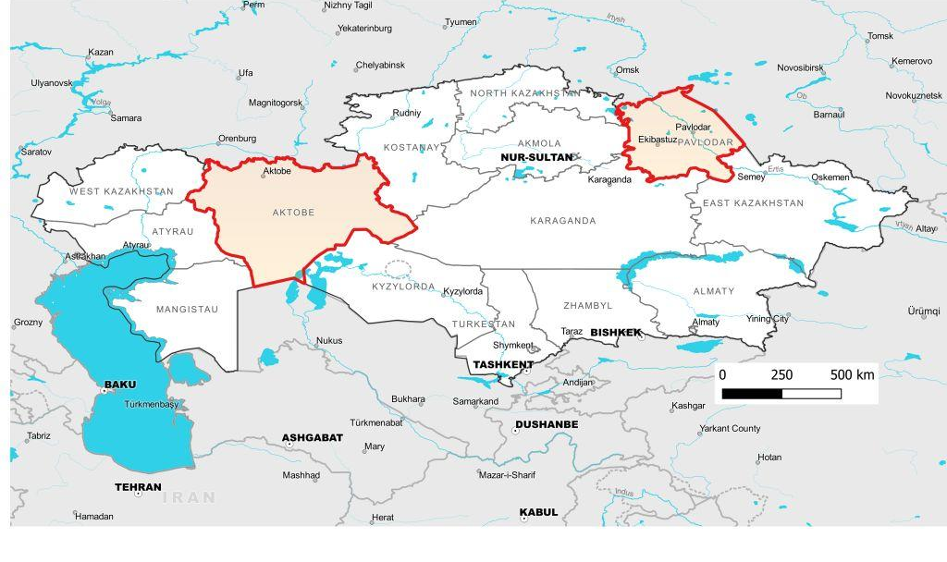
Figure 8. National context of selected Oblasts for Component 3 (FAO 2020)

2. Stakeholders.

Please provide the Stakeholder Engagement Plan or equivalent mapping/assessment. (Type response here; if available, upload document or provide link) In addition, provide a summary on how stakeholders will be consulted in project execution, the means and timing of engagement, how information will be disseminated, and an explanation of any resource requirements throughout the project/program cycle to ensure proper and meaningful stakeholder engagement. Please identify disadvantaged or vulnerable groups/individuals that may be affected by the project for appropriate consideration in the stakeholder engagement plan and in the risk matrix or environmental and social management plan.
Select what role civil society will play in the project:
☐Consulted only;
☒Member of Advisory Body; contractor;
☒Co-financier;
☒Member of project steering committee or equivalent decision-making body;
☐Executor or co-executor;
☐Other (Please explain)
The project will work with a wide range of stakeholders, from international, central government, to sub-national and local levels. The main stakeholders and their roles are summarized below in Table 7.

Table 7: Stakeholder groups, mandate and potential roles in project

Stakeholder (group) | Mandate (or activities) | Potential role in Project
THE MINISTRY OF AGRICULTURE OF THE REPUBLIC OF KAZAKHSTAN | It is the central executive body that manages the agro–industrial complex, irrigated agriculture and land reclamation, as well as inter–sectoral coordination of state bodies in the sphere of activities within its mandate. The Ministry of Agriculture is the main counterpart of FAO in the country. | Overall project coordination.  Provide technical and logistical support.  Identification of demonstration sites.  Will benefit from capacity building activities.  Part of coordination unit/working group at horizontal level.
THE MINISTRY OF ECOLOGY, GEOLOGY AND NATURAL RESOURCES OF THE REPUBLIC OF KAZAKHSTAN | It is the central executive body, carrying out leadership in the areas of formation and implementation of state policy, coordination of management processes in the fields of environmental protection, development of the "green economy", waste management (excluding municipal, medical and radioactive waste), protection, control and supervision of the rational use of natural resources, state geological study mineral resources, reproduction of the mineral resource base, use and protection of the water fund, water supply, sanitation, forestry, conservation, reproduction and use of the animal world and specially protected natural territories. | Participate in project coordination.  Provide technical and logistical support.  Identification of demonstration sites.  Will benefit from capacity building activities.  Part of coordination unit/working group at horizontal level.
THE LAND RESOURCES MANAGEMENT COMMITTEE OF THE MINISTRY OF AGRICULTURE OF THE REPUBLIC OF KAZAKHSTAN | It is the government body, which performs strategic, regulatory, implementation and control and supervisory functions in the field of land management, including pastures. The committee is the main government counterpart of the project, which can represent the position of the Ministry of Agriculture. It will be supporting project implementation to completion. | Play a key role in the scientific and technical back-up of the project.
THE DEPARTMENT OF CLIMATE POLICY AND GREEN TECHNOLOGIES OF THE MINISTRY OF ECOLOGY, GEOLOGY AND NATURAL RESOURCES OF THE REPUBLIC OF KAZAKHSTAN | It is responsible for the formation and implementation of a unified state policy and the organization of the development of a program in the field of climate protection and the earth's ozone layer. In addition, the department is working on implementation of the ultimate goal and provisions of the UNFCCC and other international agreements and protocols in the field of climate change. The project sub-components on carbon trading system and climate-smart technologies should be done in close cooperation with the department. | This department will play a supporting role in the scientific and technical back-up of the project with regards to SLM approaches and a lead role in carbon policy brief development and carbon related initiatives
THE ORGANIZATIONS OF THE NON-PROFIT JOINT-STOCK COMPANY "NATIONAL AGRARIAN SCIENCE AND EDUCATIONAL CENTRE" (NASEC) | NASEC is an umbrella organization for 3 agricultural universities, 3 research centers, 13 research institutes (with 31 branches), 18 agricultural experimental stations and experimental production farms and 3 service companies. In particular, the NASEC includes the Kazakh Scientific Research Institute of Forestry and Agroforestry, the Kazakh Scientific Research Institute of Animal Husbandry and Forage Production, the Kazakh Research Institute of Soil Science and Agricultural Chemistry named after Uspanov, specializing in sustainable agroforestry and rangeland management. | NGOs will take part in training, act as liaison agents between project and pastoral communities and scale up SLM technologies and approaches.
THE NON-PROFIT JOINT-STOCK COMPANY “STATE CORPORATION “GOVERNMENT FOR CITIZENS” | The Department of Land Cadastre is the provider of geobotanical and soil analysis maps in the country. The maps representing the soil health and geobotanical characteristics of pastures provided by this entity might be used to zoom in project areas at rayon level to determine the direct project beneficiaries and to monitor progress. | This department will take part in training, participate in LDN mapping and monitoring and provide information and data for project needs.
THE ASSOCIATION OF ECOLOGICAL ORGANIZATIONS OF KAZAKHSTAN | This NGO focuses on unifying the environmental organizations throughout the country and jointly solving specific environmental problems. It is a potential operating partner of the project. | NGOs will take part in training, act as liaison agents between project and pastoral communities and scale up SLM technologies and approaches. This group will also benefit from learning about the LADA and Participatory Rangeland assessment methodologies for their land and pasture monitoring programmes.
THE COALITION FOR GREEN ECONOMY AND DEVELOPMENT “G-GLOBAL” | The mission of the Coalition is to consolidate the efforts of NGOs, business, science and government to promote the implementation of the principles of "green" growth, integrated development of territories based on an ecosystem approach, "green" innovation infrastructure, and the creation of legal and institutional foundations for the transition to a "green" economy. It is a potential operating partner of the project. | NGOs will take part in training, act as liaison agents between project and pastoral communities and scale up SLM technologies and approaches, especially from financial management viewpoints. This group will also benefit from carbon trading initiatives and training events.
The national chamber of entrepreneurs of the republic of kazakhstan "atameken" | This NGO works on protecting the rights and interests of business and ensuring broad coverage and involvement of all entrepreneurs in the process of forming legislative and other regulatory rules for business, including agricultural enterprises and household farms. | NGOs will take part in training, act as liaison agents between project and pastoral communities and scale up SLM technologies and approaches, especially from financial management viewpoints. This group will also benefit from value chain work and development, carbon trading initiatives and other capacity building activities.
THE FOUNDATION «CENTER OF APPLIED RESEARCH «TALAP» | It has strong capacity and competency in developing different analytics and assessments related to pasture management, and extensive experience in the organization of workshops and conferences. | This foundation is of central importance given its experience with applied research and the innovative approach being introduced through this project. This entity can act to ensure approved applied research protocols are followed to improve M&E procedures, validate and promote conclusions, recommendations and lessons learnt for scaling of results.
THE ASSOCIATION OF INDIVIDUAL ENTREPRENEURS AND LEGAL ENTITIES “KAZAKHSTAN GROWERS UNION” | It has an extensive experience in carrying out different field activities related to livestock management and organization of workshops and conferences. | This foundation is of central importance from a technical viewpoint and will need to validate field approaches and help to scale results.
THE ASSOCIATION OF INDIVIDUAL ENTREPRENEURS AND LEGAL ENTITIES “SHEEP BREEDERS UNION” | It has an extensive experience in carrying out different field activities related to small ruminants management and organization of workshops and conferences. | This entity will act to validate and promote conclusions, recommendations and lessons learnt for scaling of results.
Subnational stakeholders
AKTOBE OBLAST AND KYZYLORDA OBLAST AKIMATS (REGIONAL MUNICIPALITIES) | They perform regulatory, implementation and (or) control functions that ensure the solution of local issues within the relevant administrative-territorial unit. | Coordination of project activities within oblast limits and facilitation of resources and communications with relevant oblast agencies.
THE REGIONAL CHAMBERS OF ENTREPRENEURS OF THE REPUBLIC OF KAZAKHSTAN "ATAMEKEN" IN AKTOBE AND PAVLODAR OBLASTS | This NGO works on protecting the rights and interests of business and ensuring broad coverage and involvement of all entrepreneurs in the process of forming legislative and other regulatory rules for business, including agricultural enterprises and household farms. | NGOs will take part in training, act as liaison agents between project and pastoral communities and scale up SLM technologies and approaches.
THE RAYON AKIMATS IN AKTOBE AND PAVLODAR OBLASTS | These are part of the direct beneficiaries of the community-based pasture management system. The rayon akimats will play a crucial role in hosting demonstration sites and scaling up technologies on the larger scale. | The rayons will be selected and respective capacity needs will be identified during project implementation. This is due to the changing priorities surrounding COVID-19 and its effects. Criteria have been provided in this document for their selection.
THE RAYON LEVEL AND OBLAST LEVEL AGRICULTURAL UNITS AND DIVISIONS (LOCATED IN AKIMATS) | They will support the project by providing the district and regional level agricultural data and by participating in field activities. | As those responsible for development and implementation of the Pasture Management Plans, this stakeholder will be key to accessing land, resources and having the autonomy and authority to work with land-users and owners/leasers to halt LD processes, within LDN application. Their importance has also been identified as a possible risk in 5. Risks section.
THE RURAL DISTRICT LEVEL AKIMATS | Smallest administrative unit that will participate in project implementation. | The rural districts inside each rayon will be selected and respective capacity needs will be identified during project implementation and their situation and role within each PMP.
REGIONAL NGO | NGOs that operate within the selected rayons and communities with clear links to project outcomes. | NGOs will take part in training, act as liaison agents between project and pastoral communities and scale-up SLM technologies and approaches.
REGIONAL FINANCIAL INSTITUTIONS | Financial institutions operating within selected areas with capacity and motivation to invest or develop SLM or carbon-based initiatives | Financially support project proposals or models.
Private sector
MEAT AND MILK PROCESSING INDUSTRIES AND THEIR SUPPORTING SUPPLY CHAINS | Of special interest are the existing and planned feedlots, slaughterhouses and the transport chains they supply. The AkTep LTD fattening unit – with capacity of 14,000 head was identified through stakeholder consultations as a key player in achieving project outcomes. | These entities will be essential for the value chain development by providing information on traceability and animal health requirements, optimal breed characteristics and body conditions, and other market considerations.
LARGE FAMILY OR CORPORATE FARMS | The demonstration landscapes will showcase not only how physical farm improvements can lead to increased socio-economic and ecological benefits but how to identify weak links and log-jams in production cycles and prioritise investments. This process and approach will be of interest for larger farms that look to professionalise their staff and improve on farm efficiency and productivity.  The value chain work will also support their transition to more export-oriented products and globally certified production systems | These entities will benefit from various project lines, from training, to climate-adapted agro-silvo-pastoral business models, to VCs and possibly the carbon trading initiatives if large enough.
ENERGY SECTOR | The work on carbon trading schemes will open the door for the larger players in the energy sector to participate, but also the smaller collectives, such as the rural district (сельский округ) -> village (село) to get involved in solar or other alternative energy schemes or carbon sequestration programmes through either ‘avoided deforestation payments’ or improved rangeland management that increases carbon cycling and sequestration over the original project baseline conducted through LDN implementation. | Within this context, the potential opportunities and legal requirements for participation of the GoK and private project stakeholders in carbon trading schemes and markets will be supported and will interact with SLM and LDN activities and initiatives throughout the project implementation process.  The project may also involve the local and regional banking sector, including micro-lending institutions, to provide financial support to smallholders and pastoralists in carrying out SLM/SFM interventions.
FINANCIAL SECTOR | Numerous sources utilised for project design and development have identified access to financing or credit as one of the major barriers to development. | Work with project coordinators to validate business models and VC conclusions and if possible, fund results of the project.
AGRARIAN COOPERATIVES | Cooperatives are often vital players in rural economies and act as a focal point for introducing innovative technologies and approaches. | Act as collective access point for producers and replicate production practices or marketing strategies developed by project.
BENENFICIARIES | The 30,000 beneficiaries targeted by the project represents a large potential group of the private sector. | Participate actively in capacity building exercises.  Implement SLM and work towards LDN.

3. Gender Equality and Women's Empowerment.
Provide the gender analysis or equivalent socio-economic assessment. If available provide document in annex and/or provide link.
3.1 Background
Widespread and unprecedented rapid degradation of land threatens food production, water availability, biodiversity and energy security worldwide. LD contributes to climate change, deepens poverty and induces displacement and migration, while those forces in turn worsen LD. When land is degraded and usable land becomes scarce, women are uniquely and differentially affected given their substantial role in agriculture and food production, greater vulnerability to poverty, and typically weaker legal protection and social status. Women constitute the majority of farmers in many of the regions most severely affected by desertification, land degradation and drought. While they often serve as environmental stewards, women tend to be excluded from conservation and management of land, lack access to agricultural extension services and institutional credit and encounter barriers to participation in development, planning and policymaking processes. Unlike men, women often have less access to information, resources and legal rights to land, natural and productive resources. Unequal power relations and gender-based discrimination in legal and customary systems in many societies deny women even user rights to plant trees, control soil degradation and enhance soil fertility. Gender-responsive LDN projects and programmes strategically contribute to the achievement of LDN and address the needs of the most vulnerable groups, such as small farmers, rural communities and indigenous peoples, with a dedicated focus on women.

The project considers gender mainstreaming as central to its successful achievement because of the reasons put forward above and in key international agreements relating to LD and gender equality (see below).
This Project Gender Action Plan (GAP) is informed by relevant international and national frameworks and policies related to the environment and gender equality as set out below, and is designed to meet the mandatory requirements of the new GEF Policy on Gender Equality (2017). This GEF policy aims to ensure equal opportunities for women and men to participate in, contribute to, and benefit from GEF-financed activities in support of the GEF’s efforts to achieve global environmental benefits. Principles include requirements that stakeholder engagement and analysis be conducted in an inclusive and gender responsive manner, so that the rights of women and men and the different knowledge, needs, roles and interests of women and men are recognized and addressed. In addition, GEF-financed activities must be conducted, designed and implemented in an inclusive manner so that women’s participation and voice are, regardless of their background, age, race, ethnicity or religion, reflected in decision-making, and that consultations with women’s organizations, including indigenous women and local women’s groups, are supported. Furthermore, a gender-responsive approach must be applied throughout the identification, design, implementation, monitoring and evaluation of the project.
Table 8. Project contribution to objectives of FAO Policy on Gender (2013)
1. Women participate equally with men as decision-makers in rural institutions and in shaping laws, policies and programmes. | Community and district level: women will participate as active stakeholders and decision-makers in issues relating to the PMPs drafted or acted upon.
2. Women and men have equal access to and control over decent employment and income, land and other productive resources. | Women’s and men’s better access to decision-making and pastoral resources is a key goal of the project.
3. Women and men have equal access to goods and services for agricultural development and to markets. | Project support to strategic/operational PMPs as well as inclusive business models that prioritize clean technologies, gender-sensitive services and infrastructure will promote better access to pasture lands and related economic incentives.
4. Women’s work burden is reduced by 20 percent through improved technologies, services and infrastructure. | Project will contribute to FAO global goal by supporting pasture management policy, legislation and strategic/operational plans as well as inclusive business models that prioritize clean technologies, gender-sensitive services and infrastructure that reduce drudgery and save time for women.
5. The share of total agricultural aid committed to projects related to women and gender equality is increased to 30 percent | Project will track contribution of financing related to women and gender equality in Project and report on contribution to global target of 51%.
The GAP is also framed by the FAO Regional Gender Equality Strategy for Europe and Central Asia (2019), which includes a focus on minimizing gender-related risks and safeguarding rural women’s rights in all actions to achieve sustainable and equitable food systems and rural development. It will also be compliant with FAO’s Environmental and Social Management guidelines (2015).
The project also aims to contribute to the gender policies of the Government of Kazakhstan by responding to the creation of equal access to financial services, productive resources including land, trade and entrepreneurship, equal access and control over clean water, energy, transport infrastructure, and equitable engagement in their management, as well as equal rights to participate in and influence decision-making processes on climate and environmental issues.
Key policies and frameworks framing this Project GAP
SDGs of Agenda 2030 (UN, 2015). The main development framework against which countries are held accountable, SDG 5 relates to gender equality and women’s empowerment. One of the most relevant targets is Target 5.A calling on countries to undertake reforms to give women equal rights to economic resources, as well as access to ownership and control over land and other forms of property, financial services, inheritance and natural resources, in accordance with national laws. In this regard, the project will promote women’s equitable access to pastures as well as related economic incentives and services through policy/ regulatory reform, PMPs and inclusive business models for LDN and SLM.
The Convention on the Elimination of all Forms of Discrimination Against Women (CEDAW, 1979). This is the UN convention focused on gender equality and women’s empowerment and sets out requirements for States in all areas of life. The CEDAW Committee has noted progress in many areas but with regard to rural women it has called for the government to ensure that rural women have adequate access to economic opportunities and equal opportunities to participate in in decisions relating to the agricultural sector. It also sets out the concept of temporary special measures to tackle gender inequalities e.g. quotas. In this regard, the Project will consult women and men through a household survey that will include women and women-headed households in its sample, as well as ask questions about intrahousehold decision-making so as to better target project services. The project will see additional consultations at the sub-national level including about the Project’s GAP. The project implementation phase will ensure a participatory approach to developing laws and policy related to pastures, including women and women heads of households. Although largely male-dominated, women do need access to quality pastures and related inputs conducive to LDN targets, as heads of household (including if males migrate or die) and the project will also explore entry points for women’s economic empowerment in related environmental services or alternative livelihoods.
UNCCD, 1994. The UNCCD, the main Multilateral Environmental Agreement (MEA) on LD, has a GAP (UNCCD, 2017). Its relevant objectives for this project are to: (i) enhance women’s role as agents of change by addressing the gender inequalities they face (ii) build the capacities of women and girls to access the resources they need to improve their livelihoods, manage land sustainably and become resilient to drought (iii) develop a baseline on gender-related issues in LD and desertification, and monitor, report and regularly review progress in the implementation and achievement of objectives; and (iv) mobilize adequate resources to achieve these objectives. Key principles to guide action on the ground are that (i) interventions do not increase women’s burden but decrease it; and (ii) women not only contribute to, but also benefit from, the interventions. The UNCCD GAP emphasizes equal participation in decisions taken during the design, planning, implementation and evaluation of initiatives to implement the UNCCD. In this regard, the project will address all the objectives stated above, and meet all the key principles through GAP.
The UNCCD’s LDN principles apply to this project and they also highlight the importance of integrating a gender perspective, which are set out in the publication “Scientific Conceptual Framework for Land Degradation Neutrality. A report of the Science-Policy Interface” (UNCCD, 2017). Broadly speaking, they touch on the importance of ensuring gender differences and inequalities between women and men are addressed for LDN. In this regard, the project, including through its GAP, will ensure that the gender dimensions of LDN principles inform all policy/regulatory development as well as sub-national planning.
Voluntary Guidelines on the Responsible Governance of Tenure of Land, Fisheries and Forests in the Context of National Food Security (VGGT). FAO. 2012. These guidelines are particularly relevant given the project’s focus on SPM and confirms that States should ensure that women and girls have equal tenure rights and access to land, independent of their civil and marital status. The VGGT call for States to “monitor the outcome of allocation programmes, including the gender-differentiated impacts on food security and poverty eradication as well as their impacts on social, economic and environmental objectives, and introduce corrective measures as required” – this is very relevant to the project’s intended support to national and sub-national policy, regulations and incentives for pasture access and management. In this regard, the project will ensure that all policy, regulatory and programming related to land, including pastureland, is informed by the VGGT
GEF-7 Land Degradation Focal Area Strategy. This confirms “gender roles have impacts on both farming and livelihood systems, but the contribution of women smallholder farmers often goes unrecognized. Women farmers often have less access to land, decision making processes, labor, credit, information, technology, and extension”. The strategy commits to mainstreaming gender "by including (i) practical gender needs – improving the conditions of women through access to resources, services and opportunities, and (ii) strategic gender interests – empowering women to take decisions and be better represented in various decision making bodies.” Project response: the project will meet practical gender needs through operational PMPs targeting poor women heads of household as well as ensuring that all operational and strategic PMPs, as well as sustainable business models, take into account women’s and men’s different needs and priorities with regard to access to resources, services and opportunities. In terms of strategic gender interests, the project will target women for capacity development and awareness raising in SLM/LDN at national and sub-national levels, so that they are better positioned to contribute to decisions.
3.2 Country context
Since independence in 1991, state policy has aimed to provide legislative support to women. Kazakhstan was the first Central Asian country to establish a national entity to promote gender equality (the National Commission on Women, Family and Demographic Policy). Adopted in 2009, the Law on State Guarantees of Equal Rights and Opportunities for Men and Women governs gender policy. Kazakhstan’s Strategy of Gender Equality for 2006-2016 set practical targets to measure progress in attaining gender equality in policy, the economy, education, family affairs, access to healthcare and the prevention of violence against women and children. It approved in 2016 the Concept of Family and Gender Policy up to 2030, which seeks to ensure equal rights for all and prevent gender-based discrimination and gender imbalances. However, the major challenge of existing policies and laws is that it lacks integrating gender equality across laws, policies, and programs. This will be an important condition to achieving the country’s long-term goals for a sustainable and inclusive economy and promoting the well-being of the entire population. Current administrations have limited experience in designing and implementing climate smart land-use initiatives, and they have even less experience with the adoption of relevant gender-sensitive approaches and mechanisms to improved access to knowledge, resources and services. For the sustainability of the project, it is essential to develop capacities of administrations on gender-responsive, socially-inclusive and pro-poor approaches, as well as on the linkages between social protection and rural resilience and food security in the context of a changing climate.
Moreover, Kazakhstan has ratified several major international treaties, including the the Beijing Declaration and Platform for Action, the Convention on the Political Rights of Women, the Convention on the Nationality of Married Women, and the 2030 Agenda SDGs.
A recent gender assessment by various international institutions identifies some prevailing gender roles, gaps and opportunities at the national level in agriculture and in the livestock sector. These are summarized below:
Women in Kazakhstan play an essential role in agricultural production and make up a substantial part of the agricultural labour force. In some areas, agriculture is the only labour market available to rural women and they are represented in greater numbers than women working in other sectors. However, despite women’s important contributions to agriculture, they face a number of disadvantages as compared to men. Rural women typically work as unpaid family workers, performing tasks both within their households and on family farms or household plots. Their contribution is invisible in official statistics and is often undervalued by women themselves as they perceive it as a continuation of their ‘natural’ role. Women also work as hired employees on smallholder farms, undertake much of the day-to-day farm work, they are generally not recognized as key decision-makers and often have very limited access to information and knowledge concerning farming practices.

Many women face the consequences of gender stereotypes: early in life they did/could not focus on developing the skills to earn their livelihoods and were raised as a women based on the stereotype that a man must earn the family’s living, and it is not necessary for a women to learn. Due to the lack of livelihood opportunities, women have to work as day-laborers at weeding and harvesting. This leads to unstable income, lack of development opportunities and weak health. In most places, men and women equally contribute in the production and harvesting of products, yet there are many men engaged in the sale of agricultural products rather than women. This can be explained by the existence of gender stereotypes, where men are associated with the process of making money. Men predominate in use of machinery and fertilizers, which results in increased productivity and, of course, in higher revenues to men.

Unpaid work and gender pay gap: Among 12,993 agricultural producers registered in the country, 12% are headed by women. Out of 7,991 acting agricultural producers, 11.9% are headed by women. Out of 185,533 acting farms, 18.6% are headed by women. There are 1.6 million people employed in agricultural production of whom 736,300 are women..

The Asian Development Bank (ADB) reports that deficiencies in basic services and the burden of household work on rural women are considerable obstacles to their economic engagement. ADB observed that women in rural areas of Kazakhstan face greater discrimination than women in urban areas, suffering from a higher incidence of domestic violence, limited education and employment opportunities, limited access to information, and discrimination in their land and property rights. Living standards in Kazakhstan’s rural areas are significantly lower than in cities, in part, due to lack of infrastructure and social services. For example, access to water remains an issue for some rural households. Although government programs claim to have improved access to clean drinking water in rural areas, the World Health Organization and the United Nations International Children’s Fund found that nearly 15% of rural households did not have access to improved water sources in 2015, compared to 11.5% in 2000. Meanwhile, only 28% of the rural population have access to water piped into their homes. In turn, a survey conducted in Aktobe region showed that women living in small and more remote villages with high female unemployment and limited supplies of gas and water spend 90-100% of their time on household chores. A large part of their time is spent collecting, transporting and treating water (i.e. for cleaning, laundry, bathing, cooking, drinking and livestock), and collecting fuel to use for home heating.

While 66.1% of women in Kazakhstan participate in labor market compared to 77.0% for men. While an increasing number of women are working in small and medium enterprises, women are mainly self-employed, and lack decent working conditions and social security benefits such as pensions. Women represent 70% of all employees in sectors that are traditionally feminized, where the prevalence of low-paying wages is high. In 2016, the agriculture sector employed approximately one-fifth of the population, comprising 714,400 women and 839,000 men, while accounting for only 4.8% of GDP. The majority of labor is concentrated in the small-farm sector, which produces 46% of agricultural output. Yet, the extent of women’s work in the agriculture sector could be underreported given that women are less likely to hold wage-earning positions, hold land, or have agribusiness shares in their name. Women’s work on family farms is often not viewed as an economic contribution and so remains underreported. Overall, women earn only 77% of what men earn in the agriculture sector.

Women’s political participation has improved significantly in the last ten years, however women are still underrepresented in public and political life and in decision-making positions, including in Parliament, local representative bodies, the executive bodies, local government, as well as in diplomacy. In decision-making, women comprise most civil servants and are underrepresented at higher-level decision-making positions. Women comprise 21.9% of Parliament members, but only 11.7% of the political-level civil servants. They are less likely to be political and business leaders and are more prescribed to the roles associated with the family due to glass ceiling, stereotypes and discrimination which results in 1 out of 17 regions of Kazakhstan that has the only woman mayor.

The government reports that between 2011 and 2016, 13,000 women received microcredit under the Employment Roadmap. The government also reports that a total of 29,000 people started a business under this program, indicating that while rural women’s participation was a priority, they were not the majority of program beneficiaries. While such a measure supports women to generate income, the number of beneficiaries for microcredit programs is smaller than under infrastructure investment job creation. The microcredit application procedures and requirements do not specify what measures are in place to facilitate access and ensure women’s equal access. Decisions on approvals of microcredit loan applications are left to local employment offices. In addition, the program beneficiaries remain among the self-employed in the labor market. In general, the government programs target a reduction in self-employment due to its instability and lack of benefits. Consequently, no strategies are developed to extend more social benefits to the self-employed or develop incentives that offer more stability to those who decide to take up microenterprises. While preferential microcredit programs for rural women enhance their economic opportunities, the benefits are only realized if they know how to access the program and are accompanied with support to balance work and family tasks as their businesses grow. In addition, such programs need to offer business advisory support and finance that goes beyond start-ups so that women move beyond informal subsistence activities to developing viable and sustainable enterprises. Additionally, there is a lack of participation by women in the local community, despite women having a decisive role in the household and in subsistence farming, remain significantly under-represented in local assemblies, and also have very little involvement in areas of the value chain that are outside of the household.

Knowledge and capacities. Men, women, youth, elderly, and people with disabilities are not well informed about their rights and opportunities to access all economic, social and environmental instruments. There is no existing quota in higher education on engaging more women in “non-traditional” academic subjects, women are underrepresented in science, technology, engineering, and mathematics areas. In rural areas, women and young girls drop out of school due to early marriage or from the burden of domestic care work. Creating more development opportunities, such as educating people regarding their land rights, using technologies and obtaining microcredits would substantially affect their development.

Limited access to ownership of land and other property. Since the end of the Soviet era, Kazakhstan has introduced a series of reforms to restructure all landownership, including agricultural land. While women have equal rights to benefits of land reform, they often have less information on how the policy changes affect them and even more limited capital and legal channels.. In the initial phases, the state-maintained ownership of collective land and allocated shares to corporate farms, individual farms, commercial farms, and other entities. During this process, more farmland became concentrated in larger corporate enterprises. As women were underrepresented in key positions in the previous collective farm systems, and as they were not engaged at decision-making procedures, they were less likely to gain management positions in the restructured corporate farms or gain access to individual farms. Yet, the latest reform exhibits that the Land Code passed in 2003 stated “land plots shall be granted to the citizens of the Republic of Kazakhstan as a private property or as a temporary compensated land use (lease) for the management of household or agrarian economy”. Ideally “citizens” are supposed to include women as well, but specific mention of women’s rights was not made. The law also stated that land can only be granted to those with competency in agricultural knowledge or qualifications, or practical agricultural experience. In such cases, gender stereotypes encouraged district officials to reject registration by women, on the grounds that they were not competent professional farmers or entrepreneurs. Such requirements ignored women having had previous professional positions, specialized training, or years of work experience on state or collective farms.

Does the project expect to include any gender-responsive measures to address gender gaps or promote gender equality and women’s empowerment? (yes ☐ /no☐) If yes, please explain and upload/annex Gender Action Plan or equivalent.
If possible, indicate in which results area(s) the project is expected to contribute to gender equality:
☒ closing gender gaps in access to and control over natural resources;
☒ improving women’s participation and decision making; and or
☒ generating socio-economic benefits or services for women.
Does the project's results framework or logical framework include gender-sensitive indicators? (yes ☒ /no☐)

4. Private Sector Engagement
Currently, some lack of dialogue between the private sector and local governments can be seen. The pasture management plans are prepared using the top-down approach, without proper engagement of local communities and private farmers. In some places, there are good examples of Public-Private-Partnerships (PPPs), however this would be scaled up within the project. From an operational viewpoint, the private sector will be engaged through the following outputs and activities described within Component 3. They are primarily:
Training on SPM;
Demonstration landscapes and investments;
Climate-smart agro-forestry and livestock models;
Value chain development processes;
Carbon trading initiatives and trainings; and
SPM professionals who develop from project outcomes.
Stakeholder consultations and focal points in the region have also highlighted areas of potential collaboration between smallholder groups or collectives and export-oriented VCs and operators. The presence of the AkTep LTD fattening unit with capacity of 14,000 head is an opportunity to further develop the producer characteristics outlined by the GoK in their National Livestock Programme 2018-2027 by linking the groups and helping producers to meet the traceability standards and carcass weights and conditions needed for export markets.
The demonstration landscapes will showcase not only physical improvements in infrastructure but how to identify weak links and log-jams in production cycles and prioritise investments to address these. The climate-smart agro-forestry business models will strengthen this component by offering models that work within both communal and privately managed contexts and how integration of livestock within agro-forestry or dryland systems can increase productivity of both activities. VC development is to act as an economic motor and stimulant to the landscape planning processes and business models in order to consolidate stakeholder group efforts to improve productivity and profitability while improving the land’s productive base.
Within this context, the potential opportunities and legal requirements for participation of the GoK and private project stakeholders in carbon trading schemes and markets will be supported and will interact with SLM and LDN activities and initiatives throughout the project implementation process.
The project will also seek to involve the local and regional banking sector, including micro-lending institutions, to provide financial support to smallholders and pastoralists in carrying out SLM/SFM interventions
Lastly are the 100,000 target beneficiaries who form part of the private sector. Improvements in their livelihoods will be the ultimate objective of the project given that smallholders and private farms form the base of livestock production in the country.

5. Risks
Risk management is a structured, methodical approach to identifying and managing risks for the achievement of project objectives. The risk management plan will allow stakeholders to manage risks by specifying and monitoring mitigation actions throughout implementation. Part A of this section focuses on external risks to the project and Part B on the identified environmental and social risks from the project.

5.1 Risks to the project
In the section below, elaborate on indicated risks to the project, including climate change, potential social and environmental risks that might prevent the project objectives from being achieved, and, if possible, the proposed measures that address these risks at the time of project implementation.
Table 9: Legal Framework regulating Pastures and Grazing

Description of risk | Impact | Mitigation actions
Continuation of COVID-19 pandemic into 2021. | L | Risks associated with this are considered low as it would affect in theory the early phase of the project. A contingency plan would allow for project preparation activities to continue even under hypothetical temporal lock-down scenarios.
No alignment of views and priorities between institutions and the main beneficiaries of current land and water resource use systems, with limited political support to advance women’s and men’s equal voice and access to resources and services in rural areas. | M | The establishment of mechanisms for INRM planning and SLM scaling up that incorporates the full range of land-use trade-offs, will inevitably reveal some initial divergence of views. FAO will provide a neutral and distributed platform for multi-stakeholder and cross-sectoral dialogue with project partners to reach consensus on key issues, and provide guidelines, extension materials, etc. The enabling environment for INRM will be strengthened to promote joint decision making across sectors. It will facilitate cooperation between national institutions and local communities, and strengthen the relevance, efficiency and effectiveness of institutions to adopt gender-sensitive approaches and promote gender-sensitive technologies.
The enabling legal and institutional framework is not sufficiently conducive to the Project Objectives and is not modified/adopted in a timely way. | M | Component 1, under the World Bank, addresses weaknesses in the legal and institutional framework and will ensure that all issues related to the suitability or adequacy of policies related to SLM will be identified and raised through the proper administrative channels. Progress with strengthening the enabling environment will be continuously monitored by the Government and FAO, and strategic changes to the project approach will be identified and implemented if necessary.
CC impacts on land resources and management systems makes land degradation assessment and INRM/SLM best practices knowledge platforms quickly outdated. | L | CC resilience measures will be approached through various project outputs and supported by analysis and feedback from core indicator achievement, adaptive field-based monitoring systems and market access through VC and work with the private sector. This will allow for goals and activities to be reassessed during project implementation.
Lack of access to landscapes or land management decisions. | M | Have clear criteria prepared for selection of demonstration and rehabilitation landscapes and build relations and capacity in candidate districts.
Limited capacities of the implementing partner/s to manage the investment | M | The project will revise the selection of implementing partners prior to distribution of activities among them; identifying other potential implementing partners from the pool of potential candidates in the country.
Incorrect selection of business models and VCs. | M | Stakeholder engagement within the different stakeholder groups and along the VCs combined with contextualised approaches and indicators will act as corrective feedback measures.
Internal conflict around investment strategies and location of interventions | M | Stakeholder engagement and transparency in selection criteria and priorities, supported by LD and pastureland health assessments and LDN processes, will allow for objective results.
Lack of coordination or integration of the actions of the State Agencies working with pasturelands under different land tenure systems and legal basis | M | Develop effective working contacts and method for active communication and networking with the State agencies.
Climate change | Mod. | Harsh climate conditions during project implementation can reduce project impact and demotivate stakeholders. This needs to be addressed with stakeholders early in the project implementation process and mitigation actions agreed.

5.1 Environmental and social risks from the project

This section is based on the risk matrix obtained during risk screening in the concept note (in FPMIS) and based on further update and revision by the PTF under the responsibility of the LTO.
Complete the information corresponding to each of the risks identified during concept note. The result will be an environmental and social risk management plan that will be monitored during project implementation and regularly reported upon through the project progress reports. Please note that:
- For low risk projects, this section is not required.
- For moderate and high-risk projects, the following information should be included as part of an environmental and social risk management plan.
- Climate Risk Screening

Project phase | Project Design
Project title | Kazakhstan Resilient Agroforestry and Rangeland Project (Component 3)
Country | Kazakhstan
Region | Aktobe and Pavlodar regions
Screening completed by | Anara Jumabayeva, Senior Investment Support Officer
Date of the screening | 15/07/2020
Climate risk classification | MODERATE
Climate risk screening

Kazakhstan - Overview

The overall climate risk of the “Kazakhstan Resilient Agroforestry and Rangeland Project” to be implemented in the Aktobe and Pavlodar regions is rated moderate (on a scale of low, moderate, substantial and high).
Kazakhstan is the ninth largest country in the world. It has a diverse continental climate with strongly contrasting summer and winter temperatures. Nur-Sultan, the capital, is the second coldest capital in the world.
Kazakhstan is classified into four biomes: deserts and xeric shrublands, montane grasslands and shrublands; temperate conifer forests and temperate grasslands, savannas and shrublands. There are 19 designated ecoregions of which the largest are the Kazakh Steppe, the Kazakh Semi-desert and the Central Asian northern desert.
Temperatures historically (1901-2016) have been increasing in winter months by an average 0.44⁰C and in the western part of Kazakhstan up to 0.65⁰C. The average annual temperature has increased 0.31⁰C 2007-2016. Temperature projects indicate that mean temperatures will become warmer during December to February and June to August. By 2050 the mean annual temperature is expected to increase by 2.9⁰C. The number of “cold” days is estimated to decrease by 35 days per year by 2050.
Precipitation, both annual and seasonal, historically (1901-2016) shows no definite trends. Projections indicate decreased precipitation by 2%-5% in December-May and 1%-4% in June-November by 2050. Annual precipitation is also expected to decrease by 2060. Russell et. Al (2018) e
Increasingly climate change is manifesting itself through increased and more volatile extreme weather events. In 2017 Kazakhstan exposure and vulnerability to such extreme events was 66.83 and was ranked 67th out of 181 countries, based on data 1998-2017.
A study of the impacts of global warming (3⁰C) on the change in GDP consistently shows negatives effects except for a few countries. In the case of Kazakhstan GPD is estimated to decline by 0.031 (2027), 0.058 (2037), 0.089 (2047), 0.173 (2067) and 0.820 in the long-run.
Project target area
The target regions of Aktobe and Pavlodar are different and diverse:
- Aktobe is the second largest region comprising 11% of the area (300,629 km²) whereas Pavlodar 4.5% of the area (124,800 km²⁾ is the 10th largest area.
- Both regions experience harsh climate conditions.
- Trends in temperature ??
- Trends in precipitation over the period 1999-2019 show no clear trend for Pavlodar but a clear positive trend for most of Aktobe oblast.
- Pavlodar is predominantly in the Kazakh Steppe while Aktobe encompasses the Kazakh Steppe in the north, Kazakh semi desert in the center and Central Asian northern desert in the south. In addition, in the far north of Aktobe is the Pontic Steppe
- The temperature and precipitation patterns produce temperate grasslands, savannas and shrublands in Pavlodar while Aktobe includes both temperate grasslands, savannas and shrublands and desert and xeric shrublands.
- Pasture classification:
Pasture Classification | Share of total (%) |  |  | Area (‘000 ha)
 | Aktobe | Pavlodar | National | Aktobe | Pavlodar | National
Improved | 0.0 | 67.9 | 3.1 | 0.0 | 5,624.7 | 5,766.9
Water-logged | 37.5 | 11.8 | 56.2 | 9,488.8 | 981.4 | 103,795.8
Natural | 42.5 | 20.3 | 40.7 | 15,805.3 | 1,682.8 | 74,868.3
- Land classification: As the following table shows there is a clear difference between Aktobe and Pavlodar oblasts. While Aktobe is predominantly grassland, Pavlodar has grassland but substantially more cropland, which is mostly in the north.
Land Classification | Aktobe  (%) | Pavlodar  (%) | National  (%)
Tree | 0.2 | 1.9 | 2.0
Grassland | 87.6 | 56.9 | 64.5
Cropland | 4.7 | 38.4 | 18.3
Wetland | 0.0 | 0.0 | 0.4
Artificial | 0.1 | 0.3 | 0.2
Otherland | 7.0 | 0.2 | 11.5
Water | 0.5 | 2.3 | 3.2

- Land productivity: analyses shows Pavlodar to show a more positive trend than in Aktobe which has strong declining productivity trends.
- Land degradation: this reflects the incidence and levels of productivity as show in the following table. Aktobe has significant degraded land, twice the national average, and the second highest level after West Kazakhstan. Aktobe and Pavlodar have similar levels of stable land, but Pavlodar has significantly more improved land equal to the national average.

Land Degradation | Aktobe  (%) | Pavlodar  (%) | National  (%)
Degraded | 32.0 | 13.0 | 15.0
Stable | 63.0 | 62.0 | 61.0
Improved | 5.0 | 24.0 | 24.0

The identified increase in land productivity in the southern steppes of Pavlodar could be associated with the increasing trend in precipitation, while in the north of Pavlodar the negative land productivity trends in the croplands could be mostly due to land use/land cover changes during the last 18 years. As for Aktobe oblast, the negative land productivity trends may be mostly related to climate, but it also reflects the need for climate resilient grazing management to compensate for recurring droughts.
The increase in land productivity is also reflecting areas where grasslands are being underutilized, with the majority of these areas having ‘off-take rates (utilization of fodder reserves) at under 10%. This underutilization has been attributed to the concentration of livestock around settlements, the lack of water and road access, and the difficulties small producers, especially households, have in moving their livestock to distant pastures.
- Fires as a means of land management to remove unwanted vegetation and crop residues are significant across many parts of Kazakhstan including both Pavlodar and Aktobe.
- Vulnerabilities: While overall Kazakhstan is susceptible to all possible hazards, Aktobe and Pavlodar are both vulnerable to floods and wildfires.
Hazard | Hazard level
Hazard | Aktobe | Pavlodar | National
River flood | High | High | High
Wildfire | High | High | High
Urban flood | Medium | High | High
Extreme heat | Medium | Medium | High
Water Scarcity | Low | Low | High
Earthquake | Low | Medium | High
Landslide | N.A. | N.A. | High

Impact of climate change

Recommendations
Component 3: Sustainable Pasture Management
Outcome 3.1: Expanded us of sustainable pasture management practices and technologies
Output 3.1.1 Training on sustainable pasture management practices
Output 3.1.2 Demonstration of pasture/SLM rehabilitation and technologies
Outcome 3.2: Enhanced public and private investments in sustainable pasture infrastructure
Output 3.2.1: Demonstration of climate smart agricultural practices
Outcome 3.2: Participation of the GoK in the international Carbon trading system
Output 3.3.1: Economic assessment of investments in Carbon sequestering projects in the agricultural sector
Output 3.3.2: Training on the international Carbon trading system

Results climate risk screening checklist:
Existing Hazards Guiding Questions: | Yes | No | TBD
Observed climate and weather hazards in the project area:
Extreme temperature (above 35°C/below 0°C) | ☒ | ☐ | ☐
Extreme precipitation (flooding) | ☒ | ☐ | ☐
Lack of precipitation (agricultural droughts and/or dry spells) | ☒ | ☐ | ☐
Storms (Tropical storms, snowstorms, hailstorms, dust storms, etc.) | ☐ | ☒ | ☐
Winds (Typhoons, Cyclones, Hurricanes, Tornadoes, Harmattan) | ☐ | ☒ | ☐
Sea level rise (from global warming and storm surges) | ☐ | ☒ | ☐
Other natural hazards observed in the project area:
Landslides or avalanches | ☐ | ☐ | ☒
Wildfires | ☒ | ☐ | ☐
Salinization | ☐ | ☐ | ☒
Ocean acidification | ☐ | ☒ | ☐
Pests and diseases | ☒ | ☐ | ☐
Projected Hazards Guiding Questions | Yes | No | N/A
Do future climate scenarios foresee an incremental increase of potential hazards and climate change compared to the baseline that may affect the project over its lifetime?
Extreme temperature (above 35°C/below 0°C) | ☒ | ☐ | ☐
Extreme precipitation (flooding) | ☒ | ☐ | ☐
Lack of precipitation (agricultural droughts and/or dry spells) | ☒ | ☐ | ☐
Change in temperature | ☒ | ☐ | ☐
Change in rainfall | ☒ | ☐ | ☐
Climate variability | ☒ | ☐ | ☐
Exposure Guiding Questions | Yes | No | N/A
Is the project located in high exposure areas?
Low-lying areas (valleys or coastal zones) | ☐ | ☒ | ☐
Arid and semi-arid zones | ☒ | ☐ | ☐
Mountains zones and permafrost areas | ☒ | ☐ | ☐
Are the agricultural systems (crops, livestock, fisheries, forests) targeted by the project affected by climate related hazards?
Is crop productivity affected by rainfall variability, changes in temperature or pests and diseases? | ☒ | ☐ | ☐
Is livestock productivity affected by rainfall variability, changes in temperature or parasites and diseases? | ☒ | ☐ | ☐
Is fisheries productivity affected by ocean acidification, changes in sea temperature or variation of water salinity? | ☐ | ☐ | ☒
Is forest productivity affected by wildfires, diseases, rainfall variability or changes in temperature? | ☒ | ☐ | ☐
Is any stage of the agricultural value chain (production, storage, processing and marketing) exposed to climate related hazards? | ☒ | ☐ | ☐
Vulnerability Guiding Questions | Yes | No | TBD
Are the livelihoods of the target population sensitive to climate change? | ☒ | ☐ | ☐
Is the target population income predominately from agriculture? | ☒ | ☐ | ☐
Is population displacement being exacerbated by the impacts of climate change? | ☐ | ☐ | ☒
Are there sensitive groups (indigenous people or other marginalized groups) that are likely to be affected by climate change in the project area? | ☐ | ☐ | ☒
Is climate change impacting certain groups more than others in the project area? | ☒ | ☐ | ☐
Is climate change affecting the composition or nutritional content of diets in the target population? | ☐ | ☐ | ☒
Is the Human Development Index in the country below 0.6? | ☐ | ☒ | ☐
Is the Multidimensional Poverty Index in the country above 0.1? | ☒ | ☐ | ☐
Is the access to markets and availability of food affected by natural hazards? | ☒ | ☐ | ☐
Adaptive Capacity Guiding Questions: | Yes | No | TBD
Are there any early warning systems (early warning systems, access to climate information, etc.) in the project area to anticipate and respond to climate-related events and disasters or climate-driven pest and diseases? | ☐ | ☐ | ☒
Does the government or other institutions support the target population/communities with the necessary social and economic resources to prepare for or respond to climate-related events? | ☐ | ☒ | ☐
Is the target population already carrying out adaptation practices? | ☐ | ☐ | ☒
Do policies/mechanisms exist that make financial credit, loans and agricultural insurance available? | ☐ | ☐ | ☒
Project Modulation of Risks Guiding Questions: | Yes | No | TBD
- Policies and planning
Does the project support the integration of climate into national policies and planning? | ☐ | ☒ | ☐
Does the project support the increased use of climate data and information in national long term and strategic planning? | ☐ | ☒ | ☐
- Capacity building, training and outreach
Would the project invest in institutional development and capacity-building for national institutions involved in climate related activities? | ☒ | ☐ | ☐
Would the project invest in increased information and dissemination of climate-related information to target groups? | ☒ | ☐ | ☐
Does the project have opportunities to strengthen rural and indigenous climate risk management capabilities? | ☒ | ☐ | ☐
Does the project support capacity of target groups to utilize and apply climate services at the farm level? | ☒ | ☐ | ☐
- Data gathering, monitoring and information management
Will the project support the infrastructure and technology necessary to monitor climate variables and collect data required from climate impact assessment and modelling? | ☐ | ☒ | ☐
Will the project support the national institutions to develop the skills required to monitoring and collect climate related information? | ☐ | ☒ | ☐
Will the project support development of databases and repositories of climate information? | ☐ | ☒ | ☐
- Mitigation
Will the project invest in measures that will reduce or mitigate emissions of GHGs from the energy sector? | ☐ | ☒ | ☐
Will the project invest in measures to reduce or mitigate emissions of GHGs from livestock or agricultural production (e.g. rice production) | ☐ | ☐ | ☒
Will the project invest in measures to reduce or mitigation emissions of GHGs through reforestation or land use change? | ☒ | ☐ | ☐
Will the project invest in renewable energy and green technologies? | ☐ | ☒ | ☐
Will the project invest in other measures to reduce or mitigate GHG emissions? | ☐ | ☐ | ☒
- Adaptation
Will the project invest in climate smart agriculture activities? | ☒ | ☐ | ☐
Will the project promote climate resilient practices for crops, livestock and fisheries? | ☒ | ☐ | ☐
Will the project promote sustainable natural resources management? | ☒ | ☐ | ☐
Does the project support Nature-based Solutions for climate change and disaster risk reduction? | ☒ | ☐ | ☐
Will the project invest in agricultural insurance? | ☐ | ☒ | ☐
*TBD: To be defined

6. Institutional arrangements and coordination.

6.1 Institutional arrangements for project implementation

The Ministry of Agriculture of the Republic of Kazakhstan will have the overall executing and technical responsibility for the project’s Component 3, with FAO providing oversight as GEF Agency as described below. The Association of legal entities "Association of Environmental Organizations of Kazakhstan" will act as the lead operational partner (OP) and will be responsible for the day-to-day management of project results entrusted to it in full compliance with all terms and conditions of the Operational Partnership Agreement signed with FAO. As OP of the project the Association of Environmental Organizations of Kazakhstan is responsible and accountable to FAO for the timely implementation of the agreed project results, operational oversight of implementation activities, timely reporting, and for effective use of GEF resources for the intended purposes and in line with FAO and GEF policy requirements.
Moreover, in accordance with the letter-request GEF OFP of Kazakhstan, the FAO will be executing some activities of the project, where it has an exceptional institutional experience and value-added to the project. These activities would include: overseeing the entire Project Implementation and funds management; contracting of the executing partner (holds overall accountability for the entire project, including spot checks and audits of the executing partner); recruitment of international consultants to provide technical assistance related to the project activities; contracting of Service Providers and purchase of goods in accordance with annual work plan budgets (AWPBs); financial management and reporting; contracting independent evaluators for the Mid-Term Review and Final Evaluation; development of project terminal report.
The project organization structure is as follows:
The government will designate a National Project Director (NPD). The NPD will be responsible for coordinating the activities with all the national bodies related to the different project components, as well as with the project partners. S/He will also be responsible for supervising and guiding the National Project Manager (see below) on the government policies and priorities.
The NPD (or designated person from lead national institution) will chair the Project Steering Committee (PSC) which will be the main governing body of the project. The PSC will approve Annual Work Plans and Budgets on a yearly basis and will provide strategic guidance to the Project Management Team and to all executing partners. The members of the PSC will each assure the role of a Focal Point for the project in their respective agencies. Hence, the project will have a Focal Point in each concerned institution. As Focal Points in their agency, the concerned PSC members will: (i) technically oversee activities in their sector; (ii) ensure a fluid two-way exchange of information and knowledge between their agency and the project; (iii) facilitate coordination and links between the project activities and the work plan of their agency; and (iv) facilitate the provision of co-financing to the project.
The PSC will meet at least twice per year to ensure: (i) oversight and assurance of the technical quality of th4e outputs; (ii) close linkages between the project and other ongoing projects and programmes relevant to the project; (iii) timely availability and effectiveness of co-financing support; (iv) sustainability of key project outcomes, including up-scaling and replication; (v) effective coordination of government partner work under this project; (vi) approval of the six-monthly Project Progress and Financial Reports, the Annual Work Plan and Budget (AWP/Bs); and (vii) making by consensus, management decisions when guidance is required by the NPM.
A Project Management Unit (PMU) will be co-funded by the GEF and established within the Land Resources Committee Management of the Ministry of Agriculture. The main functions of the PMU, following the guidance of the PSC, are to ensure overall efficient management, coordination, implementation and monitoring of the project through the effective implementation of the AWP/Bs. The PMU will be composed of a NPM who will work full-time for the project lifetime. In addition, the PMU will include technical experts of the Ministry of Agriculture, Project Assistant and other part-time technical experts recruited by the project.
The NPC will be the Secretary to the PSC and in charge of daily implementation, management, administration and technical supervision of the project, on behalf of the OPs and within the framework delineated by the PSC. S/he will be responsible, among others, for:
- coordination with relevant initiatives;
- ensuring a high level of collaboration among participating institutions and organizations at the national and local levels;
- ensuring compliance with all Operational Partner Agreement (OPA) provisions during the implementation, including on timely reporting and financial management;
- coordination and close monitoring of the implementation of project activities;
- tracking the project’s progress and ensuring timely delivery of inputs and outputs;
- providing technical support and assessing the outputs of the project national consultants hired with GEF funds, as well as the products generated in the implementation of the project;
- approve and manage requests for provision of financial resources using the provided format in the OPA annexes;
- monitoring financial resources and accounting to ensure accuracy and reliability of financial reports;
- ensuring timely preparation and submission of requests for funds, financial and progress reports to FAO as per OPA reporting requirements;
- maintaining documentation and evidence that describes the proper and prudent use of project resources as per OPA provisions, including making available this supporting documentation to FAO and designated auditors when requested;
- implementing and managing the project’s monitoring and communications plans;
- organizing project workshops and meetings to monitor progress and preparing the AWP/B ;
- submitting the six-monthly Project Progress Reports (PPRs) with the AWP/B to the PSC and FAO;
- contribute to the preparation of the first draft of the Project Implementation Review (PIR);
- supporting the organization of the mid-term and final evaluations in close coordination with the FAO Budget Holder and the FAO Independent Office of Evaluation (OED);
- submitting the OP six-monthly technical and financial reports to FAO and facilitate the information exchange between the OP and FAO, if needed; and
inform the PSC, World Bank, and FAO of any delays and difficulties as they arise during the implementation to ensure timely corrective measure and support.
FAO together with the World Bank, serving as the lead Implementing Agency (IA) will be the GEF co-IA for the project, specifically responsible for Component 3 and providing project cycle management and support services as established in the GEF Policy. As the GEF co-IA, FAO holds overall accountability and responsibility to the GEF for delivery of the results of Component 3. In the IA role, FAO will utilize the GEF fees to deploy three different actors within the organization to support the project (see Annex J for details):
- The Budget Holder, which is usually the most decentralized FAO office, will provide oversight of day to day project execution;
- The Lead Technical Officer(s), drawn from across FAO will provide oversight/support to the projects technical work in coordination with government representatives participating in the PSC; and
- The Funding Liaison Officer(s) within FAO will monitor and support the project cycle to ensure that the project is being carried out and reporting is done in accordance with agreed standards and requirements.
FAO responsibilities, as GEF agency, will include:
Administrate funds from GEF for Component 3 in accordance with the rules and procedures of FAO;
Oversee Component 3 project implementation in accordance with the project document (World Bank PAD), work plans, budgets, agreements with co-financiers, OPs Agreement and other rules and procedures of FAO;
Provide technical guidance to ensure that appropriate technical quality is applied to Component 3 activities concerned;
Conduct at least one supervision mission per year; and
Reporting to the GEF Secretariat and Evaluation Office, through the annual Project Implementation Review, the Mid Term Review, the Terminal Evaluation and the Project Closure Report on project progress; and
Financial reporting to the GEF Trustee.

6.2 Coordination with other relevant GEF-financed projects and other initiatives.

As mentioned in other parts of the document, the World Bank and FAO will act as joint implementing partners with the World Bank responsible for development of Components 1, 2 & 4 and FAO for Component 3 directed at SPM. FAO will therefore ensure the operation and administration responsibilities associated Component 3, as well as ensure all data and information required for the monitoring and evaluation (M&E) activities is provided.
Global and regional projects and initiatives of interest for the project are Dryland Program through its Global Coordination Project and the PSC, in which the World Bank will participate. It will take part in the various knowledge exchange mechanisms, global initiatives and platforms the Program will make available to the child projects, and disseminate its own acquired and generated knowledge products, tools and lessons learned.
In addition, the World Bank is committed to assisting the countries to implement the 2018 Astana Resolution by developing a program, the Central Asia RESILAND, with a mix of IDA, IBRD, GEF, WAVES, PROFOR, SDG TF and private sector funds. RESILAND will begin with a World Bank-financed Programmatic technical assistance (TA) which will to strengthen the capacity of a select number of Central Asia countries, Kazakhstan among them, to reduce the vulnerability of their drylands and mountains and to promote climate resilient integrated landscape management. The TA will support projects’ activities by generating relevant data, conducting sectoral and economic analyses and supporting the national and regional policy dialogues to promote the adoption of resilient, sustainable and integrated landscape restoration practices in the drylands and mountains of Central Asia. Finally, the World Bank will support the launch of the ECA30x30 Initiative in support of increasing even more the targets of the Astana Resolution. The participation of Kazakhstan in the Sustainable Forest Management Impact Program on Dryland Sustainable Landscapes is a first step toward RESILAND/ ECA30x30.
Also, worth mentioning is the links between the National Livestock Programme’s focus on increasing the number of ‘family farms’ to over 100,000 and the United Nations Decade of Family Farming (2019-2028).

7. Consistency with national priorities.

Describe the consistency of the project with national strategies and plans or reports and assessments under relevant conventions from below:
UNCCD: The national voluntary LDN target of the Republic of Kazakhstan has been formulated as follows: “The Republic of Kazakhstan strives to achieve land degradation neutrality by 2030.” The time limits are defined - until 2030, the implementation of LDN should lead to the ultimate goal - to prevent, minimize, and reverse the process of LD.
Among the complex tasks related to the country's development, the Republic of Kazakhstan is supposed to increase the efficiency of land use. Within 5 years, irrigated land areas will be increased by 40%, thus their area will be brought up to 2 million hectares.
The State program for the Development of the Agro-industrial Complex of the Republic of Kazakhstan for 2017-2021 provides the following specific measures to achieve the LDN target: -(i) measures will be taken to include fallow and abandoned lands in the turnover; (ii) KZT277 billion will be directed to restore 610,000 ha of irrigated land; (iii) measures will be developed to create woody and shrub plantations to protect the land from water and wind erosion, create a microclimate, improve soil fertility, snow and moisture retention; (iv) the water fund will be increased to maintain water bodies in proper condition and the woodenness of the adjacent territories of the lands; and (v) KZT39 billion will be allocated to restore collector-drainage systems, of which KZT32 billion is planned to be received through the Islamic Development Bank. Also, within the framework of the State program, it is planned to restore the land of liman irrigation with a total area of 368,000 ha; soil surveys will be carried out on an area of 33 million ha of agricultural land, as well as geobotanical surveys on an area of 33 million ha of pasture land. Work on determining the soil bonitet on agricultural land for an area of 30 million ha will also be undertaken. This is to improve land relations and rational use of agricultural land and to prevent their degradation. In addition, information on the state of land resources in electronic format will be generated. We consider these goals and measures as voluntary commitments of the country towards achieving a neutral balance of LD.
UNFCCC: The Republic of Kazakhstan is fully committed to the UNFCCC negotiation process with a view to adopting a global legally binding agreement applicable to all parties at the Paris Conference in December 2015, with the ultimate aim of ensuring that global temperature rise does not exceed 2°C. The Republic of Kazakhstan wishes to communicate the following Intended Nationally Determined Contributions (INDC) and intends to achieve an economy-wide target of 15% reduction in GHG by 2030 compared to 1990. Kazakhstan ratified the Paris Agreement in November 2016 and committed itself to the fulfilment of the proposed target as its first INDC. In line with the Lima Call for Climate Action, the following quantifiable information is hereby submitted:
Intended Nationally Determined Contribution
Party | Kazakhstan
Unconditional target | A 15% reduction in GHG emissions by 31 December 2030 compared to the base year.
Conditional target | A 25% reduction in GHG emissions by 31 December 2030 compared to the base year, subject to additional international investments, access to low carbon technologies transfer mechanism, green climate funds and flexible mechanisms for a country with an economy in transition.
Type | Economy-wide absolute reduction from base year emissions Base year 1990.
Gases covered | • Carbon Dioxide (CO2) • Methane (CH4) • Nitrous Oxide (N2O) • Hydrofluorocarbons (HFCs) • Perfluorocarbons (PFCs) • Sulphur hexafluoride (SF6)
Period | 1 January 2021 – 31 December 2030
% of emission covered | 100%
Net contribution of international market-based mechanisms | Kazakhstan supports inclusion of market-based mechanisms in the 2015 agreement, and the opportunity to use carbon units recognised by the UNFCCC. Kazakhstan retains the option of using market-based mechanisms under the UNFCCC. Kazakhstan will consider adequately discounting international units for compliance to ensure a contribution to net global emission reductions.
Planning process | Kazakhstan’s long-term objectives is to become one of the 30 most developed countries in the world by 2050. Following a path of low carbon economy growth Kazakhstan adopted Laws "On energy saving and energy efficiency", and “On Supporting the Use of Renewable Energy Sources” aiming at greater use of renewable energy sources. In order to emphasize its commitment to low carbon growth, Kazakhstan has adopted a Concept on transition to a «Green» Economy. For the implementation of the Concept, an action plan is developed, under which government programs on waste management, modernisation of housing and communal services, development of sustainable transport, conservation of ecosystems and enhancement of forest cover were adopted. The laws on extended responsibility of entrepreneurs and greening of vehicles are being formulated. The implementation of the «Green» Economy Concept, and adoption of related legislative acts, should lead to the modernisation of key infrastructure and production technologies based on energy-efficient technologies, and will make a significant contribution to reducing the emissions of GHG.
Fair and ambitious targets, taking into account national circumstances | The target set represents a significant progression beyond the pledge of a 7% emission reduction of GHG emissions by 2020 compared to the 1990 base year. This target is ambitious, as Kazakhstan has undergone a period of consistent growth from 2000 to 2010 during which GDP growth reached 8.3%. GDP growth during this period has always exceeded that of the world average. Under a revised and conservative business as usual scenario which takes into account potentially lower GDP growth rates the target proposed by Kazakhstan amounts to a 22% reduction in GHG emissions by 2030 compared to BAU projected emissions. Under favourable economic conditions and an increase in oil prices, the unconditional target proposed by Kazakhstan would amount to a 34% reduction in GHG emissions by 2030 compared to BAU projected emissions. The ambitiousness and fairness of the statement are concluded by the current emissions of Kazakhstan that reached 80-85% from 1990. At the same time the aim of the government's economic policy of Kazakhstan is faster growth of GDP per capita to reach the current level of development of the countries of the OECD by 2030.
How the INDC contributes to achieving the ultimate objective of the Convention (Article 2) | Recognizing the reality and taking responsibility, Kazakhstan intends to contribute to international efforts to combat CC. The reduction or stabilization of GHG emissions in 2030 at 85% of emissions level in 1990 (absolute target) or more ambitious goal of reducing the overall, national emissions by 25% (conditional target), is a rather challenging target in economic and financial terms, achievement of which, among other things, should not lead to socio-economic tensions. The objectives set, will contribute to sustainable economic development and enable Kazakhstan to enter the path of low-carbon "green" development, and contribute to the achievement of the long-term global goal – to keep the increase in global temperature below 2°C.
The Republic of Kazakhstan signed in 1992 and ratified in 1994 the UN Convention on Biological Diversity.

8. Knowledge Management.

The Kazakhstan investment forms part of the Dryland Sustainable Landscapes Impact Program (DSL-IP), which consists of 11 country programs (9 in the African drylands and 2 in the Central Asian Steppes) along with a Global Coordination Project led by FAO. The total GEF investment in the Program is just under $110 million, and when co-financing from participating countries and other partners is included the total investment will be over 1 billion dollars. The other participating GEF Agencies in the Program include the World Bank, IUCN, and WWF. The UN Convention to Combat Desertification (UNCCD) will also be a key participant in the IP at a global and regional policy level. The DSL-IP is focused on comprehensive management approaches at landscape scale – incorporating sustainable forest management, sustainable land management, rangeland management, dryland agroecology, engagement with the private sector, and improved value chains. Success will depend on a harmonized, multi-sectoral approach with effective internal coordination.
Rangelands of Central Asia is the largest contiguous area of grazed land in the world; it serves as an important source of livelihood for pastoral and agro-pastoral communities in this region. Rangelands are also important in carbon regulation as they absorb CO2. The proposed regional approach in Central Asia supported by the IP will build on past and existing initiatives in the region on dryland natural resource management, knowledge exchange, and regional policy dialogue on dryland restoration, and seek opportunities for scaling up. These initiatives include the Central Asian Countries Initiative for Land Management (CACILM), the Central Asia Nexus Dialogue (which contributes to the development of a portfolio of investment projects that will look at ensuring security of water, energy and food in Central Asia), and the PRAGA project methodology to assess and monitor rangeland and grassland health across 5 countries globally and recently tested in Kyrgyzstan. The regional approach will work with selected target countries within the region but will have impact at the regional level and will stimulate dialogue for future investment and opportunities and contribute to developing a regional dryland restoration Initiative. The proposed approach in Central Asia will also be an opportunity to create momentum for the International Year of Rangelands and Pastoralists (IYRP). In October 2020, with support from Governments and international partner organisations, the Committee on Agriculture of the FAO endorsed the Mongolian Government’s proposal to declare IYRP in 2026.
Component 3 of the project has also tagged two knowledge materials for development. Given the diversity of activities and project outputs planned under this component, it is recommended that the style and content of these materials is decided after completing the mid-term review (MTR) in order to identify leverage points and where the project has produced the most impact. Knowledge Management is also an integral part of component 4 under World Bank lead, though component 3 has sufficient scope and funding to support its obligations under component 4.
Lessons learnt were an integral part of the stakeholder and project idea development process. Different projects and programmes have approached pastureland and extensive livestock production from both technical and socio-economic angles. Those most relevant to this proposal have been summarised in Table 8.

To highlight the importance of documenting change management approaches and innovative solutions, and to help show results and impact, FAO’s South-South and Triangular Cooperation Division and its partners are documenting the baseline status of the targeted landscapes in every country, using a participatory video approach. This interactive, dynamic and powerful monitoring tool includes local communities and different stakeholders. Moreover, it provides a wholesome view of the project’s progress at every stage, including changes within the local community, the local governments and other stakeholders that may occur throughout the lifetime of the project. Through this in-depth observation, the initiative aims to point out what impact these changes may have on dryland management and degradation. Once the baseline is established, each country will continue this monitoring process until best practices are identified and each project reaches its completion. The final product will then be translated and disseminated among the 11 countries involved, cross pollinating and sharing the identified best practices, the supporting knowledge and the lessons learned. The dissemination will occur through various international and regional mechanisms by leveraging on the convening power of the Working Group on Dryland Forests and Agrosilvopastoral Systems. In the long term, this participatory approach will feed into a digital library containing an array of different contexts and paths, serving as a pragmatic learning platform for contributing partners and members achieving the objective of making every voice count for adaptive management, at every level.

Table 10: Project Baseline, Republic of Kazakhstan

# | Name of Project or Initiative | Donor / Years of implementation | Relevant Lessons Learnt
1 | Central Asian Land Management Initiative CACLIM | Asian Development Bank (2006-2010) | A significant contribution was made to enhance multi-country collaboration through knowledge sharing. Key knowledge products include the Atlas of Natural Resources of Central Asia, Economic Analysis of Sustainable Land Management Options in Central Asia (IFPRI and ICARDA) and over 25 best practices (including on pastures) documented in the WOCAT Data Base (English and Russian). The key national CACILM stakeholders contributed to the review of the legislation process such as the Law on Pastures.
2 | Sustainable Rangeland Management for Rural Livelihood and Environmental Integrity Project | UNDP project is part of a series of similar GEF/Medium Size Projects (MSP) within the CACILM Partnership Framework (2009-2012). | (i) Reduction of the area affected by soil erosion in selected plots around the pilot village, and the geobotanical surveys confirmed that an overall reduction of the area affected by soil erosion of 23.35%; (ii) Income of families involved in the project improved and the project has documented the income of 521 families which obtained direct or indirect benefits from the project. The socio-economic studies confirmed an increase of 32.3% in the average income over three years.
3 | WB/GEF Drylands Management Project and the GEF SGP | GEF/WB (2002-2011) | The project achieved good results in conservation, rehabilitation and sustainable utilization of natural resources in marginal cereal growing areas in the Shetsky Rayon of Karaganda Oblast in Kazakhstan. A good practical example of degraded pasturelands rehabilitation with the participation of local communities.
4 | Improving sustainability of the PA system in desert ecosystems through promotion of biodiversity-compatible livelihoods in and around PAs | GEF/UNDP Full Size Project (2013-2019) | (i) 180 ha of highly productive forage lands were created in pilot plots in 3 desert regions of the country; they demonstrated methods that doubled forage productivity while reducing water consumption by 60%; (ii) seasonal pasture rotation practice was introduced within the area of over 40,000 ha; 6 pasture management councils were created, 8 watering places were restored at 6 distant pastures to provide more than 3,000 cattle with water, alternative energy sources were implemented (solar panels and wind turbines), living conditions of 60 farmers and their families in distant pastures were improved, and 250 farmers improved knowledge on sustainable pasture management; and (iii) together with the Akimat of Mangystau oblast in Ustyurt region, water was supplied to 8 pasture plots within the area of 10,000 ha and 2,000 head of livestock.
5 | Integrated Management of Natural Resources in Drought-prone and Salе-affected Agricultural Production Landscapes of Central Asia and Turkey CACILM II | GEF/FAO (2017-2021), most probably will be extended until 2022 | Within the project several demonstration plots were established for upscaling SLM/INRM approaches. As regards the pasturelands, the project pilots and upscaled SLM approaches such as degraded pasture restoration technologies with fodder crops and endemic pasture crops, rehabilitation of lands through silvipastoral development, introduction of drought and salt-resistant fodder crops and others. For SPM, a participatory approach is being used within the project. For upscaling of the practices, the project uses the farmer field schools approach and establishes close cooperation with boundary and strategic partners. Moreover, the establishment of small thematic (in this case, pastoral) working groups involving stakeholders from relevant ministries, its subsidiaries, NGOs and selected project focal points from each entity positively impacted and accelerated the project implementation. Such an approach could be considered in other projects. As mentioned, to sustainably manage pasturelands the use of the participatory approach is crucial. The approach shall also entail gender sensitivity and social inclusion.
6 | Investment in sustainable pasture management and increasing forage crops productivity | FAO TCP Facility (2017-2019). | The best technologies and practices were identified and analyzed, as well as the possibility of their implementation. The analysis showed that such technologies as fencing pastures using electric fences and maintaining pasture turnover, watering pastures with the installation of wind pumps, creating conditions for shepherds in driving areas and substituting forage grasses in various regions of the country are economically feasible, depending on the size of the farm and the number of livestock. Usually, small farms do not have the opportunity to invest in these technologies, which is due to their small amount of income and the inability to provide stable cash flows to cover the investment. The analysis revealed the smallest size of farms for which investment is economically feasible. Moreover, the project calculated the amount of investment needed to implement technologies that are optimal for each of the climate zones.

The project’s broad participation process, involving relevant policy making, research, extension and education institutions, will ensure that knowledge is shared efficiently within the country. The Land and Forestry Committee will be an important partner for lesson sharing and knowledge management. Internationally, FAO’s relevant platforms (Mountain Partnership, Pastoralist Hub, Global Agenda for Sustainable Livestock, FAO’s Family Farming Platform and others) will be used for lessons sharing.

9. Monitoring and evaluation.
Describe the budgeted M & E plan including a timeline of planned Monitoring and Evaluation Activities, expected dates of submission of Terminal Evaluations and any Mid-Term Reviews, a budget, and roles and responsibilities. In addition, please ensure that arrangements for Stakeholder Engagement and information disclosure are specified here or in the Stakeholder Engagement section of this Project Document.

Suggested wording to use/modify related to disclosure:

“The project will ensure transparency in the preparation, conduct, reporting and evaluation of its activities. This includes full disclosure of all non-confidential information, and consultation with major groups and representatives of local communities. The disclosure of information shall be ensured through posting on websites and dissemination of findings through knowledge products and events. Project reports will be broadly and freely shared, and findings and lessons learned made available.”

At the end of the first 24 months of the project, the BH will arrange a Mid-Term Evaluation (MTE) in consultation with the LTO, the FAO Office of Evaluation (OED), and the FAO-GEF Coordination Unit. The MTE will be conducted to review progress and effectiveness of implementation in terms of achieving FAO outcome and outputs. The MTE will allow mid-course corrective actions, if needed. The MTE will refer to the Project Budget and the approved AWPs. An amount of USD 15,000 is allocated to the MTE.
An independent Final Evaluation (FE) will be initiated six months before the end of the project period. To be managed by OED, the FE will aim to identify the impacts of FAO Components, sustainability of FAO outcome and the degree of achievement of long-term results. The FE will also have the purpose of indicating future actions needed to expand on the existing Project in subsequent phases, mainstream and up-scale its products and practices, and disseminate information to management authorities and institutions with responsibilities in food security, conservation and sustainable use of natural resources to assure continuity of the processes initiated by the Project. Both the MTR and FE will pay special attention to outcome indicators and will be aligned with the GEF Tracking tool (LD & CC focal areas). An amount of USD 30,000 is allocated to the FE.

FAO will conduct MTR and FE on the Component 3, while the World Bank will conduct the evaluations for its components according to the World Bank procedures.

10. Benefits.
Describe the socioeconomic benefits to be delivered by the project at the national and local levels, as appropriate. How do these benefits translate in supporting the achievement of global environment benefits (GEF Trust Fund) or adaptation benefits (LDCF/SCCF)? Please also explain how the project promotes full and productive employment and decent work in rural areas, aiming at the progressive realization of their right to Decent Rural Employment .

Grazing lands in Kazakhstan provide forage for beef cattle, dairy cattle, sheep, goats, horses and other types of domestic livestock, but also carry other important ecosystem functions. Conservation values of these lands are extensive and provide many essential ecosystem services, such as clean water, wildlife habitat, and recreational opportunities. Scenic, cultural, and historic values of these lands provide not only economic benefits, but also quality of life values cherished by many people. The proposed project will provide global environmental and socio-economic benefits in the form of the following benefits:

Environmental/Biophysical
- Effective LDN system in place;
- Healthy, productive pasturelands (4,000 ha restored and 816,000 ha of rangeland under SLM);
- Improved landscape water and nutrient cycling;
- Increased biodiversity; and
- Increased CO2 sequestration in pasturelands

Socio-economic
- Improved livestock value chains;
- Improved food & nutritional security;
- Improved livelihoods;
- Reduced risk (natural disasters, market volatility, access to information and finance);
- Improved access to finance for small scale livestock owners; and
- Gender equality.

PART III: ANNEXES

Annex A1: Project Results Framework

Results chain | Indicators | Baseline |  | Mid-term target | Final target | Means of verification | Assumptions | Responsible for data collection
Objective:. Restore land productivity in targeted degraded landscapes in the Republic of Kazakhstan.
Component 1: Land use policy and planning
Outcome 1.1: | Led by the World Bank
Output 1.1.1:
Component 2: Dryland agroforestry and landscape restoration
Outcome 2.1: | Led by the World Bank
Output 2.1.1:
Component 3: Sustainable Pasture Management
Outcome 3.1: Expanded use of sustainable pasture management practices and technologies. | Number of beneficiaries (by type, gender and youth) participating in pasture management plan design. |  |  | 9,120 | 60,800 | Meeting reports, attendance reports |  | MoA  PMU
 | Percent of targeted beneficiaries (by gender and youth) benefitting from continuous extension services. | TBC |  | 10% | 40% | Survey |  | MoA  PMU
 | Percent of rayons in the oblast (not targeted by the project) that adopt SPM. | TBC |  | Aktobe: 5%, Pavlodar: 5% | Aktobe: 15%;  Pavlodar: 15%. | Survey |  | MoA  PMU
Output.3.1.1: Training on SPM practices. | Capacity building program developed. | Limited knowledge and access to information and training on sustainable livestock production. |  | Capacity building program developed. | One capacity building program approved by the MoA. | Government report  Curriculum approved | There exist collectives within the country that facilitate and benefit from such training and exchange visits, such as the farmer field schools in Aktobe and East-Kazakhstan, Tassay base station,  Kazakh research institute of animal husbandry and fodder production (KazRIAHFP) plus participant producers, extension workers, NGOs and private stakeholders. | MoA
Output.3.1.1: Training on SPM practices. | Number of trainers capable of delivering the capacity building program (Agro-pastoral master trainer). | FFS elements exist in the project region. |  | 30 | 30 | Training certificate |  | PMU/MoA
Output.3.1.1: Training on SPM practices. | Number of beneficiaries (disaggregated by gender, youth, type) trained via agro-pastoral field schools. | TBC |  | 550 people  (51% women; 30% youth). | 2,700 people  (51% women; 30% youth). | Participant list  Training certificate |  | PMU
Output.3.1.1: Training on SPM practices. | Number of international study tours conducted. | None |  | 1 | 3 | Participant list |  | PMU
Output.3.1.1: Training on SPM practices. | Number of local exchange visits conducted for project beneficiaries. | None |  | 3 | 12 | Participant list |  | PMU
Output 3.1.2: Demonstration of pasture/SLM rehabilitation and technologies. | Number of target landscapes operating with demonstrated experiences and capacity in pasture SLM and planning. | Previous SLM interventions have largely been limited to the application of a single technological practice applied to a small land unit, operating outside of the typical social and financial contexts that ultimately determine utility or up-take by local producers. |  | Of the list of possible candidates (minimum 10), 4 rayons are selected based on their technical and financial proposals. | 4 | Contract/LOA signed with beneficiaries  Technical report | The PMPs required by rayon authorities under art. 13 of the Law “On Pastures” represents the best option for accessing the areas of land identified for restoration and SLM, though other options will also be explored. | PMU
 | Total ha under SLM practices and management. |  |  | 1,000 | 4,000 | Technical and administration report |  | PMU
 | Number of ha under a community developed PMP. |  |  | 300,000 | 816,000 | Endorsed and operational PMP |  | MoA  Rayon administrator
 | Monitoring system to account for LDN developed. | Number of local level LDN monitoring systems. |  |  | GIS based system developed. | Data report |  | MoA, Committee of Forestry and Wildlife
Outcome 3.2: Enhanced public and private investments in sustainable pasture infrastructure. | Percent of beneficiaries that see their income increased from adopting farmer-centric business models. | Investment in SLM and agriculture in general is low in-spite of opportunity and potential. |  | N/A | 50 | Technical report/surveys |  | OPIM, FAO project coordination, Government stakeholders
 | Incremental private investment resulted in project investments (per US$1). |  |  | US$ 1 | US$ 3 | Technical report/surveys
Output 3.2.1: Demonstration of climate smart agricultural practices. | Number of production models (and area covered) established. | Number of business models to encourage investments in pastureland management to implement SLM and achieve LDN available and adapted to farmer-centric family farm models proposed by GoK.  This is especially apparent for livelihoods based on communal resource management. |  | Two draft agri-business models with climate-smart, SLM approaches are developed with local stakeholders, trailed and costed. | Two models are adapted based on lessons learnt and presented to national governmental and international financial institutions for funding.  -8,000 ha. | Technical reports on submission of business models to national governmental and international financial institutions. | The farmer- centric model being promoted through the State Program of the Agro-Industrial Complex Development of Kazakhstan for 2017–2021. Should be the objective of the models.  The proposed models should also be a convergence point for VCs, SLM practices, agrosilvopasture models, cooperatives and other innovative business models.
 | Increase in climate-smart investments over baseline in project landscapes. |  |  | US$ 50,000 | US$ 800,000
 | Number of best practice articles published. |  |  | TBC | TBC | WOCAT articles and other knowledge products produced.
Outcome 3.3: Participation of the GoK in the international carbon trading system. | Number of policy documents prepared in carbon trading. | Emission trading commenced in 2013 and after suspensions (2016-2017) and admendments, the Environmental Code’ in 2017 introduced benchmarking. 2019 saw a return to trading of allowances though until now there has been limited access for the agricultural sector. |  | Draft document produced and peer reviewed. | Finalised policy review presented to relevant government entities and representatives.  . | Agendas, curriculum and support materials produced  Event reports and minutes  PIRs, PPRs  Midterm review Final evaluation |  | OPIM, FAO project coordination
Output.3.3.1: Economic assessment of investments in carbon sequestering projects in the agriculture sector. | Number of beneficiaries trained. | Emissions trading has focused on the energy sector, as well as suffering from various suspensions of trading and regulatory amendments. |  | 15 people trained in land-based carbon measurements and monitoring and global carbon trading. | Finalised results presented to relevant government representatives  50 participants from diverse organisations attend final seminar presenting Outcome 3.3 results and conclusions, with strong land-based carbon Monitoring and LDN component. | Publications and communications campaigns  Event reports and financial statements  PIRs, PPRs  Midterm review Final evaluation | There is an expressed interest to evaluate and monetise actual and potential contributions of the Kazakhstan agricultural sector to global Carbon cycles | OPIM, FAO project coordination, Government stakeholders
Output.3.3.2: Training on the international carbon trading system. | Number of beneficiaries trained. | Measurement methodology and global trading issues are complex. The courses will examine the current national situation and explore international standards and benchmarks. |  | 15 people from diverse stakeholder organisations complete training. | 50 people from diverse stakeholder organisations complete training | Training agenda, training materials, minutes of the workshops, list of participants.  PIRs, PPRs  Midterm review Final evaluation | As a technical course, possible beneficiaries will be those interested in SOC and other land-based carbon cycles. It is intended for the Land Resources Management Committee, NGOs and other stakeholders. | OPIM, FAO project coordination, Government stakeholders
Component 4: Effective Knowledge Management through RBM, monitoring and evaluation
Outcome 4.1: |  |  | Led by the World Bank
Output 4.1.1:
Notes: FAO = Food and Agriculture Organization; FFS = farmer field school; GIS = geographic information system; GoK = Government of Kazakhstan; ha = hectares; LDN = land degradation neutrality; LOA = Letter of Agreement; MoA = Ministry of Agriculture; OPIM = Operational Partner Implementation Modality; = pasture management plan; PIR = project implementation review; PPR = project progress report; PMU = Project Management Unit; SOC = Soil Organic Carbon; SPM = sustainable pasture management; VC = value chain; WOCAT = World Overview of Conservation Approaches and Technologies.

Annex A2: Project Budget

The attached Excel file contains the Project Budget. It should be noted that the identified Operational Partner, results that will be implemented by the OP and budget to be transferred are non-binding and potentially subject to change due to FAO internal partnership and agreement procedures which have not yet been concluded at the time of submission.



Annex B: Response to Project Reviews
(from GEF Secretariat and GEF Agencies, and Responses to Comments from Council at work program inclusion, and responses to comments from the Convention Secretariat and STAP at PIF).

Annex C: Status of Utilization of Project Preparation Grant (PPG)
(Provide detailed funding amount of the PPG activities financing status in the table below:
No PPG resources have been made available to develop Component 3.

Annex D: Calendar of Expected Reflows (if non-grant instrument is used)
Provide a calendar of expected reflows to the GEF/LDCF/SCCF Trust Funds or to your Agency (and/or revolving fund that will be set up)

Annex E: Project Map(s) and Coordinates

Please attach any additional maps, if needed, to complement those already provided in Part II, Section 1b of this project document.

Kazakhstan Resilient Agroforestry and Rangeland Project
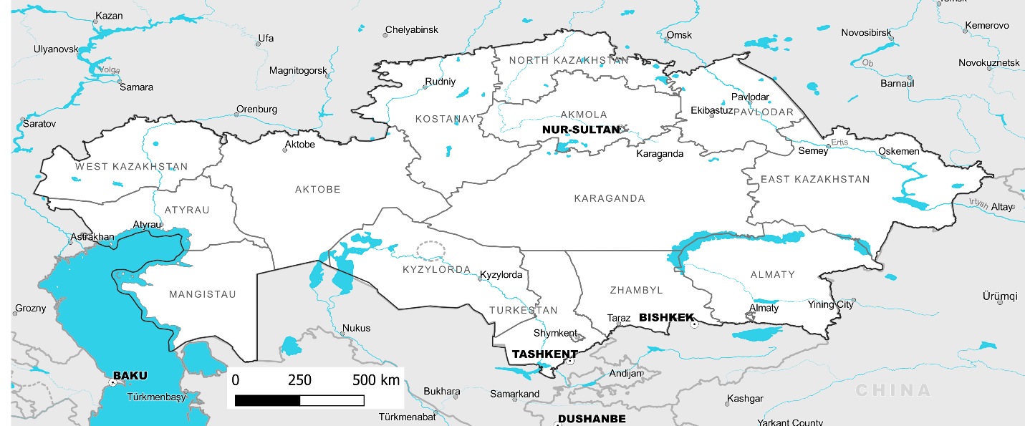

Preliminary analysis of Land Degradation and Trends ahead of Project Site Selection

MAY 2020
This annex presents the series of preliminary maps and analysis that were prepared during the design phase of the Kazakhstan Resilient Agroforestry and Rangeland Project as part of the Stakeholder Engagement Plan and in accordance with the project objectives to support the Republic of Kazakhstan in reaching its voluntary Land Degradation Neutrality (LDN) targets currently being developed by the LDN Target Setting Programme (LDN TSP), a partnership initiative implemented by the Secretariat and the Global Mechanism of the Unite Nations Convention to Combat Desertification (UNCCD).
The maps, figures and tables were shared with stakeholder groups and used to aid their decisions on key project activities from LDN and national perspectives. This included the selection of the oblasts where Component 3: Sustainable Pasture Management of the project activities would take place.
The document leads with a brief introduction on the map creation process and selection of indicators, before providing analysis of the results and discussions on the suitability of the oblasts finally chosen through the stakeholder engagement processes for work on the pastureland component of the project.
General overview of the country: climate, biomes and ecoregions
The location of the country in the Central Asia region produces a continental climate with marked thermal inversions, not only at the annual level with contrasting winters and summer temperatures but also during the day with the contrast between day and night. Nur-Sultan (formerly Astana), the capital city, is the second coldest capital of the world. Figure 1 shows images from the WorldClim database (v1, Hijsmans et al 2005) which shows the distribution of basic climatic variables.
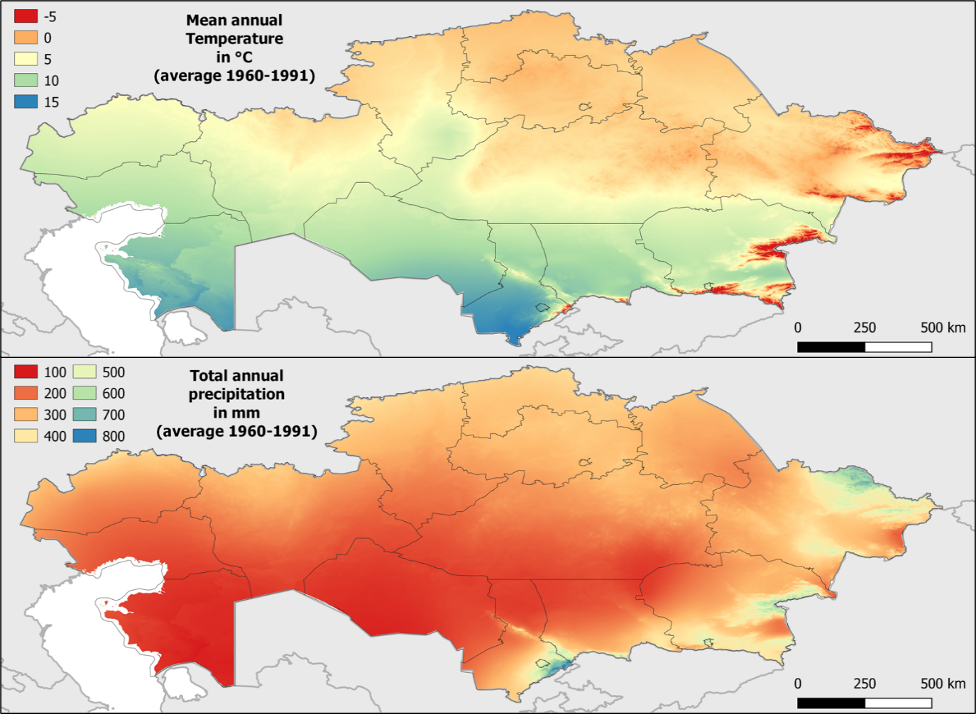
Figure 1: Mean annual Temperature and Average Precipitation for Kazakhstan
This climatic situation in combination with the type of dominant vegetation produce a series of habitats that are characterized into biomes and ecoregions. From Figure 2 from the Resolve 2017 Biomes classification (Dinerstein et al 2017), it is clear that the temperature and precipitation pattern produce mostly grasslands and shrublands with arid to semiarid characteristics for most of the country.
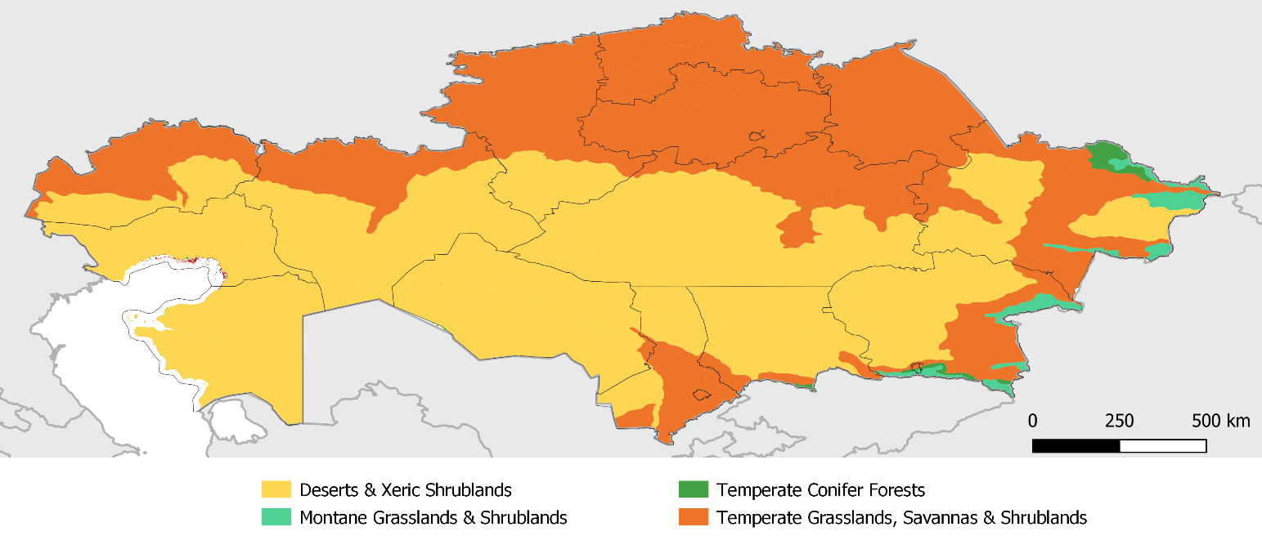
Figure 2: Biomes of Kazakhstan
The biomes are subsequently divided into ecoregions that define more specific types of bioclimatic dynamics. More desert ecoregions are located to the south of the country, with the appearance of semi-deserts and steppes while moving to the north, as can be observed in Figure 3 (RESOLVE, Dinerstein et al 2017).
Figure 3: Ecoregions of Kazakhstan
Map indicator selection for analysis
The maps below were produced through a variety of remote sensing (RS) approaches and methodologies which are briefly explained for each map and indicator set. They have been created with the intention of aiding decision-making among experts and stakeholder groups regarding project objectives and the selection of target oblasts. They have been shared with key project stakeholders for feedback and validation, as part of the Stakeholder Engagement Plan detailed in Annex K.
The indicators selected for mapping fall into three broad groups: land cover, land productivity and climate, with an additional section on Land Degradation (LD) and current climate trends. Sustainable development goal (SDG) 15.3.1 Guidelines (Sims et al. 2019) and their relation to the LDN framework (Cowie et al. 2018) played a central role in the selection of indicator types and their analysis.
As with all RS technologies, a certain caution must be applied when viewing the results as false positives are common and data should be ground-truthed and calibrated accordingly before being accepted as a basis for decision-making (Teich et al. 2019). However, where different models coincide on results, more weight can be given to their results.
Land Cover
Pastures are officially classified by whether they have been improved by seeding, fertilisation and irrigation capacity improved, or whether they have water supply capacity, either through natural or infrastructure supply. Other pastures that fall outside of these categories are referred to as ‘Natural Pastures’. The extent of these pasture types at national level and for selected oblasts is in Table 1.

Table 1: Pasture type classifications recognised by GoK and their share in the total Pastureland area.
Pasture class | Share in total  (%) | Ha.
National Scale
Improved pastures | 3.1% | 5,766,900
Water-point pastures | 56.2% | 103,795,800
Natural pastures | 40.7% | 74,868,300
Aktobe Oblast
Improved pastures | 0% | 0
Waterlogged pastures | 37.5% | 9,488,800
Natural pastures | 42.5% | 15,805,300
Pavlodar Oblast
Improved pastures | 67.9% | 5,624,700
Waterlogged pastures | 11.8% | 981,400
Natural pastures | 20.3% | 1,682,800

Understanding how these official or administrative delineations interact with land cover classes is an important element to consider when applying LDN accounting and target setting and will be approached through the project described here.
Figure 4 shows the ESA Global Thematic Land Cover Classes for the year 2018. This map series was produced annually between 1992 and 2018 using data from 5 different satellite missions at a resolution of 300m (ESA, 2017). The product shows a wide range of land cover classes that clearly shows the thresholds between the different climate zones of Kazakhstan and the effects that latitude plays in determining climate and subsequent land cover type.
The 37 ESA categories can be recategorized using the standard IPCC and UNCCD reclassification criteria (Trends.Earth) to produce a map of the main land cover categories (Figure 5). This reclassified map makes clear how changing definitions of ???? can alter mapping results. From a pastoral perspective, the map now shows the areas of perennial shrubland in the south of the country as under the Grassland class. Large areas of Desert classifications also now fall under the Grassland category and only very bare areas are in the Other land category. Deep-rooting perennial shrubs can often provide valuable, continuous fodder resources in semi-arid to arid environments and desert environs have low total biomass production but highly nutritious pastures as long as water can be supplied. This should be considered when developing management and investment options. This information is lost between the different systems.
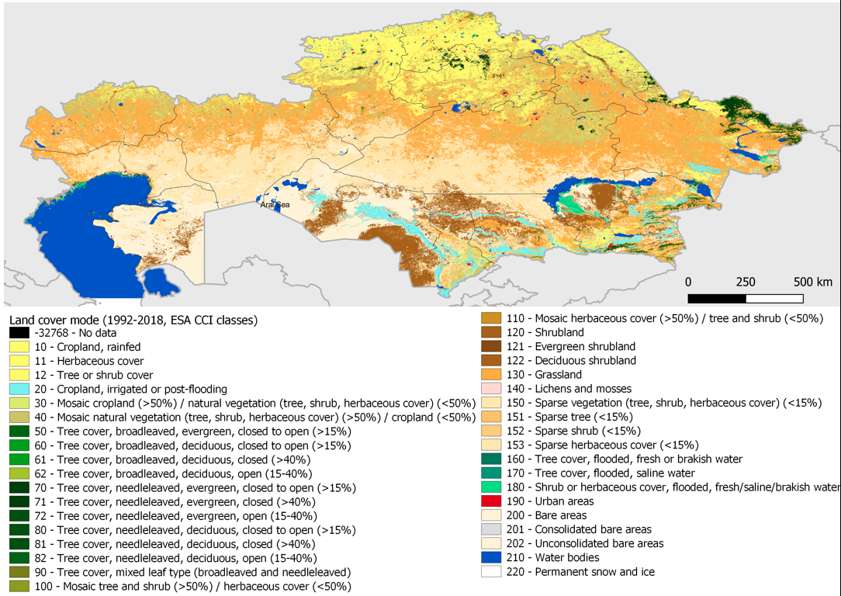
Figure 4: Land Cover as according to ESA data sources.

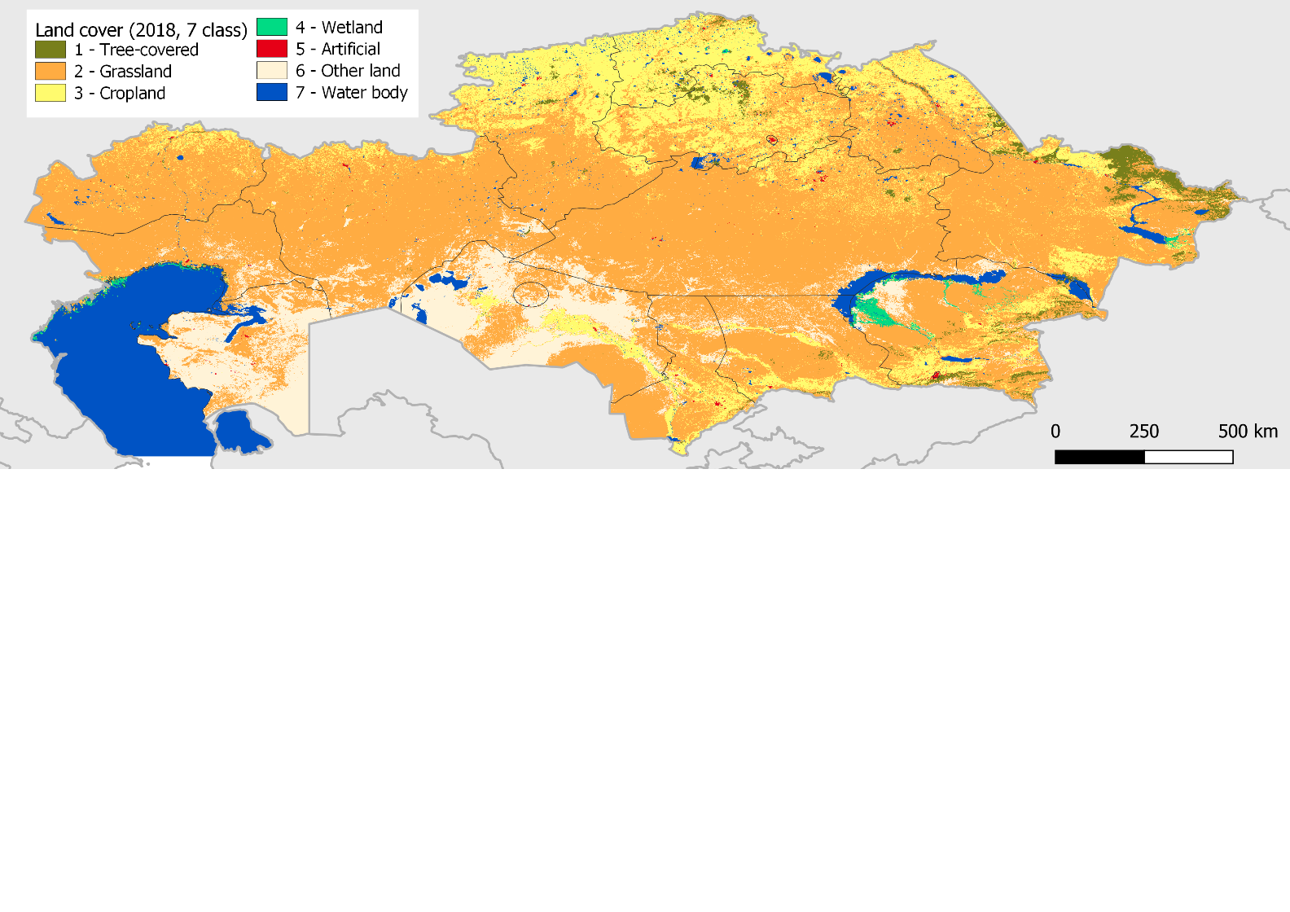
Figure 5: Land Cover classes following definitions from UNCCD.
To better understand the distribution of land classes in each oblast see Table . The oblasts of Aktobe and Pavlodar are high-lighted in yellow as these were the oblasts chosen through the Stakeholder Engagement Plan (Annex K). A clear difference is seen between these two oblasts, with Aktobe mostly covered by Grasslands and Other Lands (bare desert), while Pavlodar shows a higher presence of Cropland, especially in the north (Figure 6).

Table 2: Land Cover Classes and their distribution in the Oblasts of the Republic of Kazakhstan
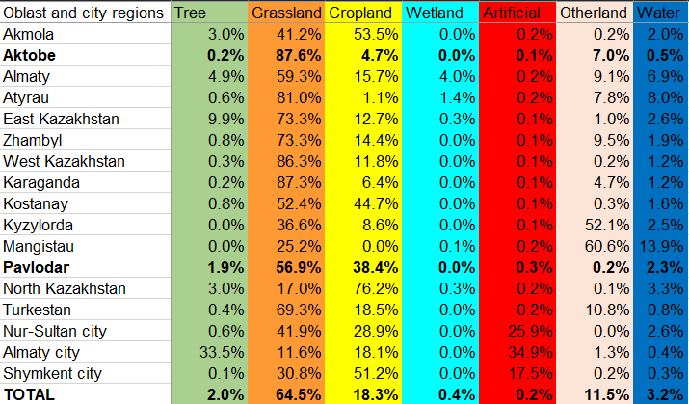
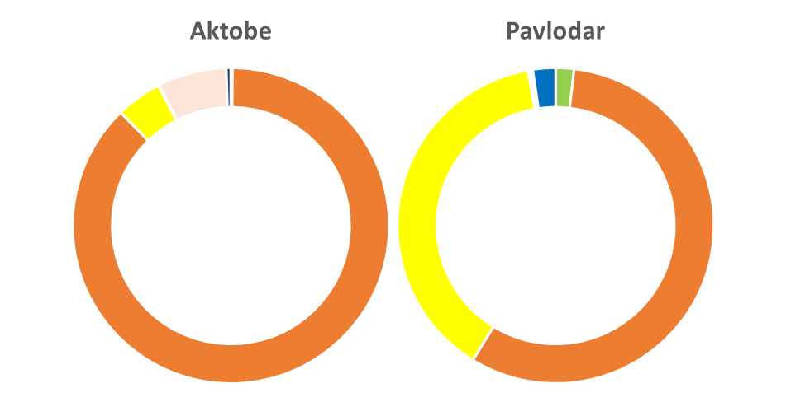
Figure 6: Land cover composition of target Oblast
Land cover change has been found to be an indicator of human disturbance and LD, as defined by the UNCCD. In recent conversations with practitioners, LDN approaches in Uruguay, Georgia and Angola have provided evidence of its importance as a lead indicator for locating human caused impact through RS activities. However, this not been the case in some other countries like Argentina, Turkey and Kyrgyzstan where land cover has remained rather stable for the last two decades and other indicators have proved more relevant to detect changes in those stable covers. In those cases, land productivity as measured through RS methods typically presents more variability as a spatial indicator.
Land Productivity
Land productivity and the effects that livestock have on short- and long-terms trends in both potential and real biomass growth is difficult to determine given the complexity of variables that can impact both the on-ground realities and the RS approach used and its temporal resolutions (Wessels et al. 2008 and Teich et al. 2019). Optimal ecological expression, such as that described by the ‘Land Potential’ which is promoted by LDN, is also difficult to measure, as it would allow for estimations of human activity or climate impacts in grassland systems. Nonetheless, it is a vital indicator and allows for long-term trends to become apparent, even under seasonal variations.
The following 6 maps in Figure 7 show different methods to calculate trends in producing land productivity models. The same original MODIS 250m 16-day resolution NDVI was used in all cases, but two different aggregation methods were computed: AM, which is the annual mean of NDVI, and ESPI index, which considers the seasonality effect by multiplying the AM with (1-coefficient of variation). Then these two treatments were modelled using 3 different trend analyses: Long Term Trend with Mann-Kendall non-parametric analysis (LTT), Step-Wise Approach Trend Index (SWATI) which considers LTT but also 3 different periods in the data, and Slope Step-Wise Approach Trend Index (SSWATI) which measures the intensity of only those periods with a significant trend.
The 6 different models that were described and calculated in accordance to the script provided by Teich et al. 20, present in Kazakhstan different situations. Some of these models are not sensitive to seasonality while others may be very sensitive to small changes in low NDVI areas. Nevertheless, many areas of agreement between the models can be observed. In an attempt to increase reliability, a consensus model was then developed for this analysis and is presented as the map in Figure 8.
The consensus map results show areas of concern around central Aktobe and the north of the Pavlodar. However, as a whole the area of Aktobe appears to show less spatial variability between its districts while Pavlodar shows a sharp divide of its territory between the north (croplands) and south (grasslands - steppe). Perennial grasslands are typically more stable and biologically speaking more productive environments than cropping systems, so changes from grassland cropland or changes in the cropland cycle could explain this pattern, also because ESPI models are specially more sensitive to this type of changes.
The difference in the productivity trend classes that cover the two oblasts have been synthesized in Figure 9. These indicate that Aktobe is subjected to a more widespread negative trend in productivity while Pavlodar is a more positive one.

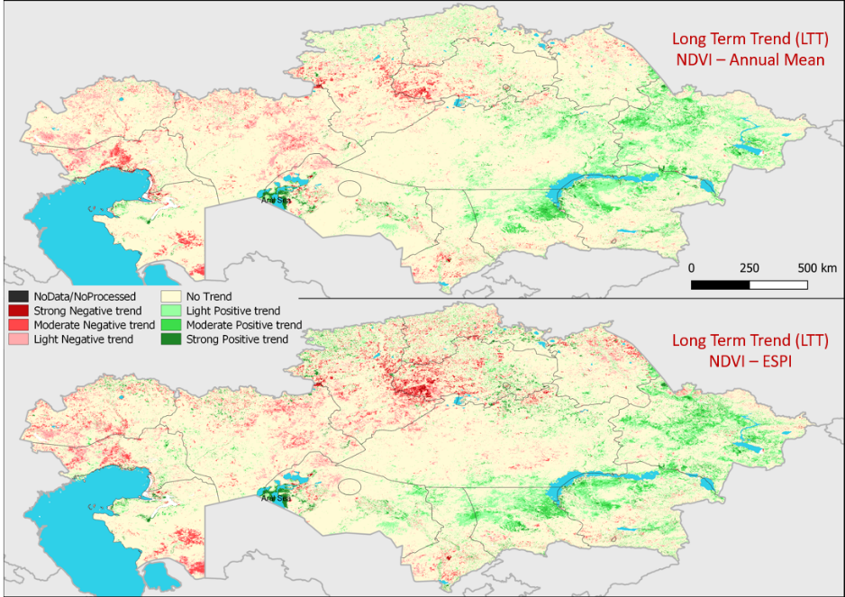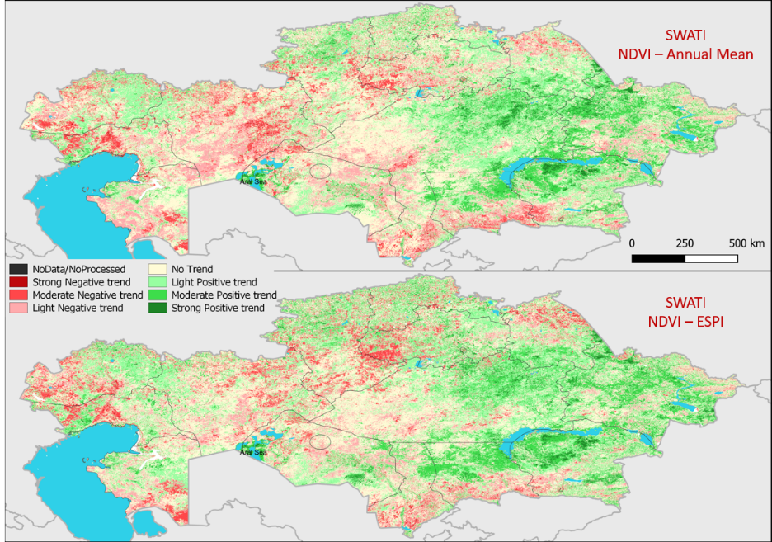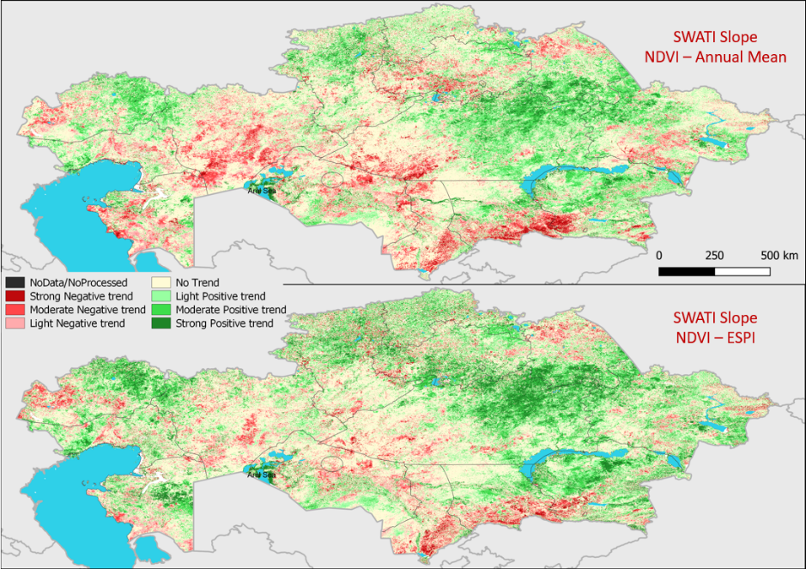
Figures 7: Land Productivity under different models and temporal resolutions.
Figure 8: Consensus map combining the findings of the 6 different maps and models of Teich et al. 2019.

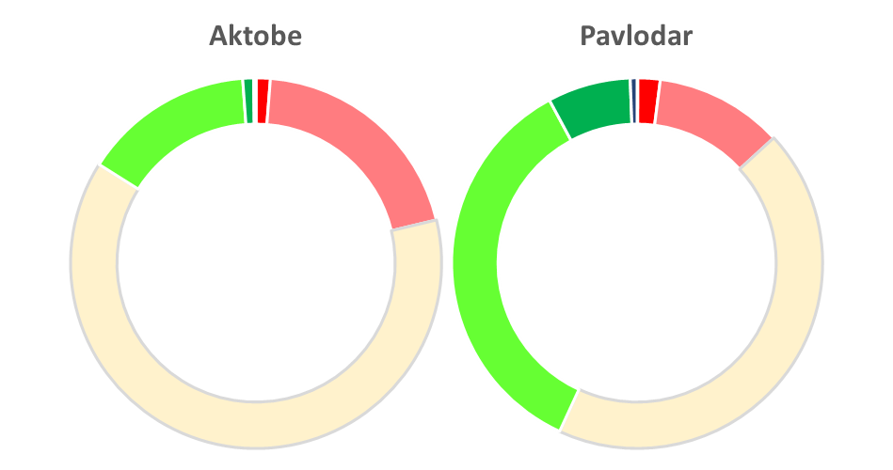
Figure 9: Percentage of cover for all the classes of the consensus map
Nevertheless, other Land Productivity Dynamic (LPD) models are available. The first one that was adopted by the UNCCD was based on a methodology presented in the World Atlas of Desertification (https://wad.jrc.ec.europa.eu/). One of the issues with that map was that it was calculated to 2013 using satellites that are no longer available. So an alternative simplified method was produce by the JRC which is applied by a FAO team in the Earth Map tool (https://beta.earthmap.org/). Using that method on MODIS images to 2019, the LPD calculus was parametrized for the range of NDVI behaviours of Kazakhstan (Figure 10). The parametrization of this methodology still needs to be defined so results should still be considered preliminary. While the legend and results differ from previous analysis it also shows a more dominant negative situation in Aktobe with respect to Pavlodar (Figure 11).
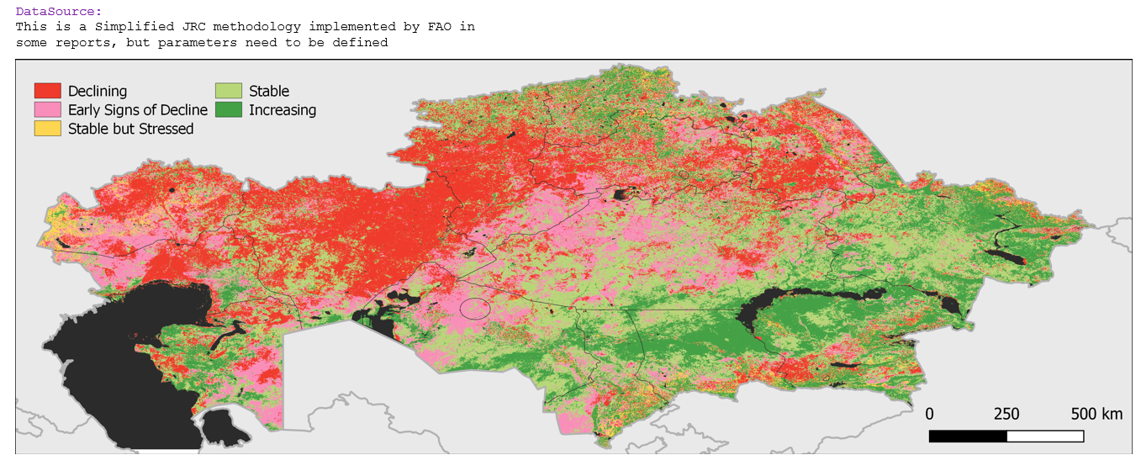
Figure 10: Land Productivity under FAO’s JRC simplified model adapted for Kazakhstan Thresholds.

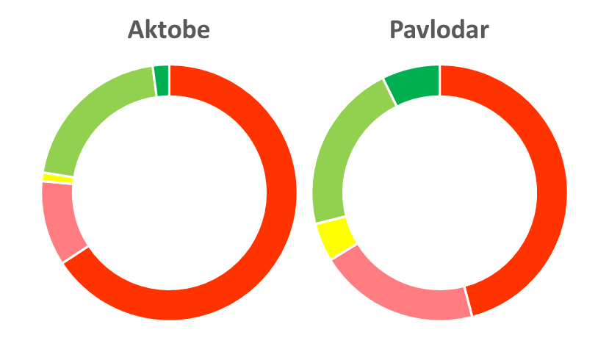
Figure 11: Land Productivity according to JRC simplified model by Oblast
The most widely recognised model using the same legend is the one produced by the Trends.Earth tool (http://trends.earth) of Conservation International. This tool is promoted by the UNCCD as a QGIS plug-in that allow users to simply compute the SDG 15.3.1 indicator with a number of options and data sources. Using the Default Trends.Earth approach on the same MODIS data to 2019 as before a very different map is produced (Figure 12). This products’ results are more in agreement with the consensus model presented in Figure 8, and it includes in the calculation a land cover change analysis and soil organic carbon (SOC) change analysis with default global data. Nevertheless, the relation between Aktobe and Pavlodar is still the same as in all other approaches (Figure 13)
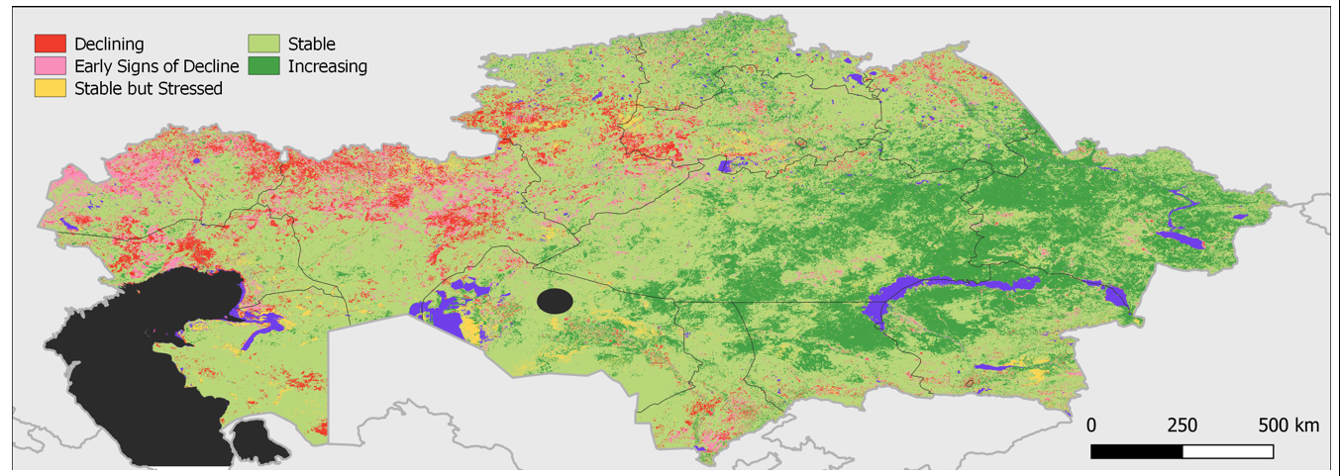
Figure 12: Land Productivity outcome following Trends.Earth software.
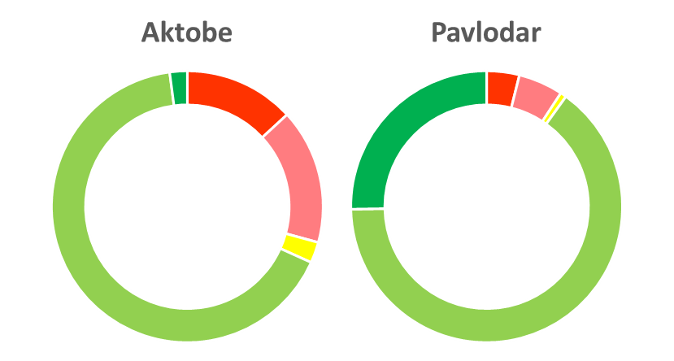
Figure 13: Land Productivity according to Trends.Earth default method by Oblast
Land Degradation Maps
The aggregation of classes from the previous maps produced by Trends.Earth are the most direct method to calculate the SDG 15.3.1 indicator: “Percentage of Degraded Land”. This map can be seen in Figure 14 and the distribution by Oblast is presented in Table 3 and Figure 15.
Figure 14: Land Degradation processes at work in Kazakhstan according to Trends.Earth modelling

Table 3: Percentage of area affected by Land Degradation by Oblast according to Trends.Earth.
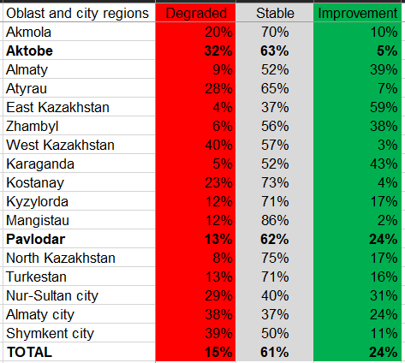
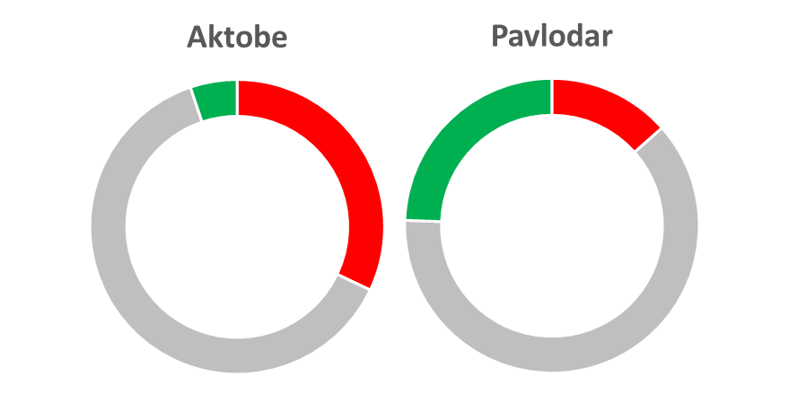
Figure 15: Land Degradation processes at work selected Oblast according to Trends.Earth modelling
Considering all previous models of LD and LPD, most areas show similar trends but disagreement on the severity or degree of the trend. Of special significance is the region of Aktobe and to a lesser degree Pavlodar; in some models the declining or negative trends in land productivity are substantial for these areas. The western oblasts of Kazakhstan could be especially identified as hot spots for LD.
Pavlodar shows LD processes in the northern zones and positive gains in the indicators to the south. However, it is important to understand the limitations discussed earlier regarding RS and the problems that come from how degradation is defined. Based on the definition, or how they interact, models can have significant differences (UNCCD 2017: Sims et al 2019). Nonetheless, all seem to agree that Aktobe and Pavlodar have hot spots of LD. Those areas that show improvement, especially under grasslands in the south of Pavlodar, should be treated with caution given the bush encroachment processes on-going in the area, until ground-truthing and further stakeholder consultations can indeed confirm these trends.
In addition to the ‘degradation map’, the incidence of fire, both in 2019 and over the last 5 years, was mapped using the now popular FIRMS dataset. The results are in Figure 16.
Figure 16. Estimation of grazing intensity for Kazakhstan (Hankerson et. al 2019).

Fire activity is interesting from various pastoral perspectives. If crop stubble is being burnt, an available fodder resource is being lost, valuable nutrients are being removed and GHG emissions are increased. If old, dry, oxidised pasture is being burnt by pastoralists to create ‘green pick’, then it means grazing opportunities and patterns are not being optimised or planned at a landscape levels.
In either case, the public reaction to the fires in Brazil in 2019 show how opinion against this practice can shape market decisions and investments. The surface area burnt over the last five years in Kazakhstan is quite significant and greatly alters the country’s abilities to meet its voluntary international GHG emissions and LDN targets. The impact of fire on the landscape when repeatedly used as a management tool has also been shown to reduce ecological resilience and productivity, and ultimately lead to reductions in soil carbon rates.
Soil Organic Carbon
As one of the 3 indicators of SDG 15.3.1 and given its importance in ecological pathways, SOC was considered as a lead indicator. However, measurement has proven complicated and most of the results are suspect. Such is the case for the results of Kazakhstan under the UNCCD guidelines, as seen in Figure 17. We know both from stakeholder consultations plus the information presented here that negative trends in land productivity and over-use of fire will lead to reductions in SOC, yet the SOC map provided shows negligible trends. The same pattern has been observed when repeated for other countries and in other project contexts, calling into question the validity of using RS for SOC measurement and monitoring.
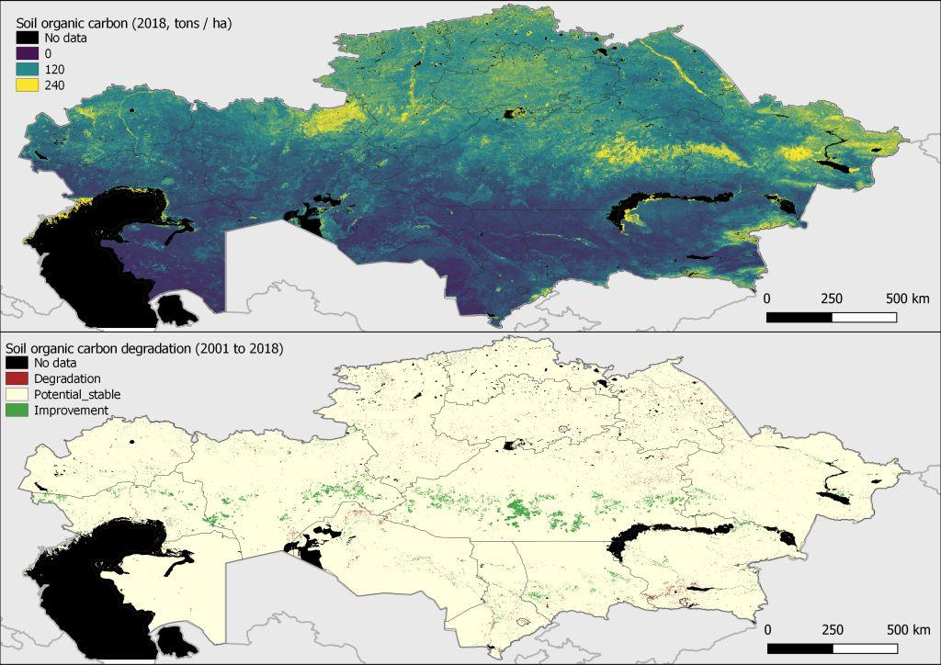
Figure 16. Estimation of grazing intensity for Kazakhstan (Hankerson et. al 2019).

Climate Trends
In addition to direct human impacts on the local vegetation, natural or human induced climatic trends or cycles are also of great significance for the Land Productivity Dynamics. Different databases exist that contains several years of climatic data, including precipitation. Some are based on interpolation of ground stations, others are RS products, and there are also combined schemes that use both approaches (Adler et al. 2003; Schneider et al. 2011; Ashouri et al. 2015; Funk et al. 2015, Adler et al. 2016). As with other models’ results, a healthy level of caution must be used when using these tools for decision-making and analysis. Climate models are possibly more suspect given the gaps in data for specific areas, the relatively short temporal range of data and the fact they have difficulties in accounting for more passive moisture inputs to the landscape. Fortunately, in the case presented in Figure 18, all the models agree at a national level pattern for the trends of the last 20 years of precipitation (1999-2019).
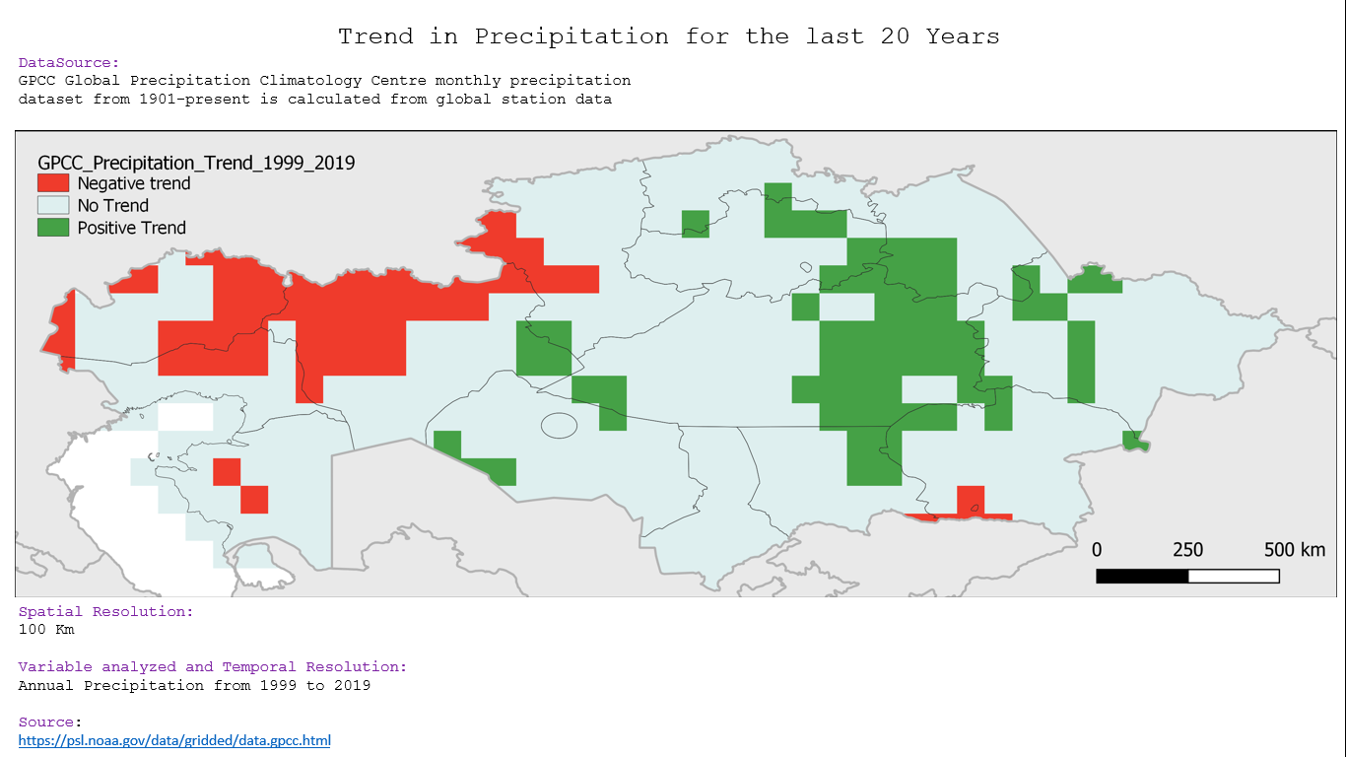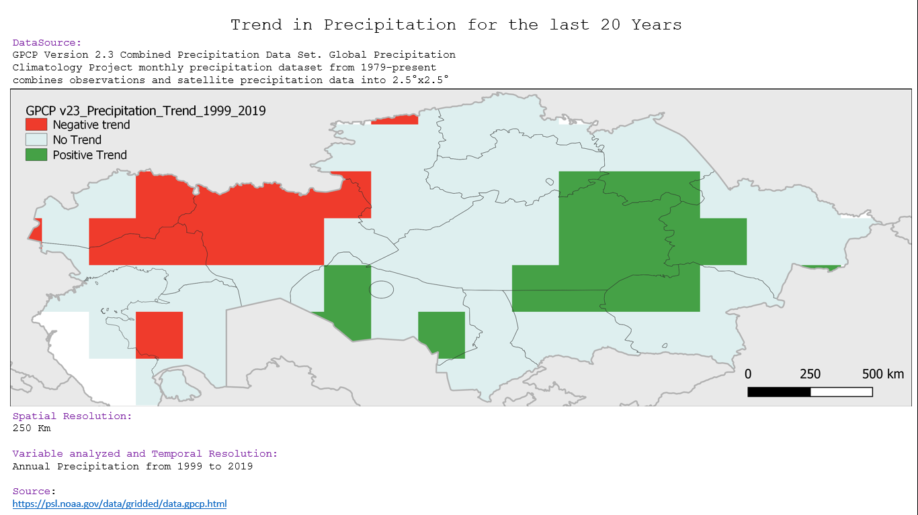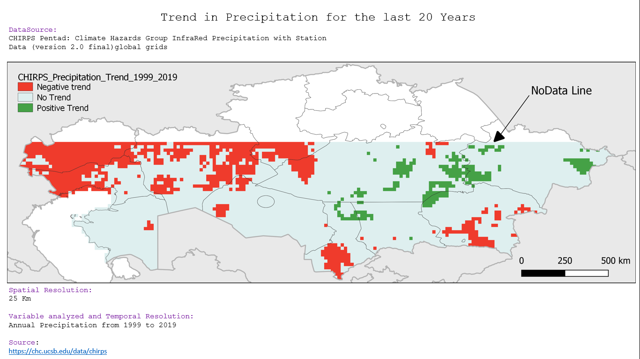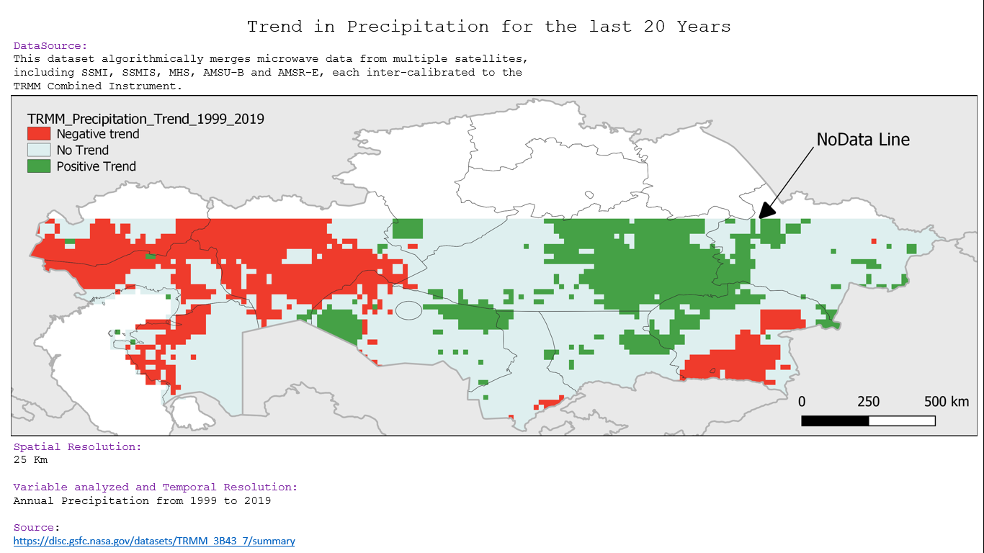
Figure 18. Precipitation trends for last 2 decades.
The different maps show a clear decline in precipitation over the last two decades for western Kazakhstan. The central areas of eastern Kazakhstan appear to have seen increases in precipitation over the same period. These results also support the increases in land productivity seen through the different approaches located around the central-eastern areas of the country. Under the more diversified land cover classes, we can see that this increase in precipitation is principally falling on a mosaic of sclerophyll plant communities comprised of woodlands, shrublands and grasslands which become sparser and more xeromorphic as one moves south. Under the broader UNCCD classifications, the area is principally classified as grassland.
Increases in land productivity in the southern steppes of Pavlodar could be associated with the increased precipitation, while in the north of Pavlodar North croplands the negative land productivity trends could be mostly due to land use/ land cover changes during the last 18 years. Conversely, Aktobe’s negative land productivity trends may be mostly related to climate, but it also stresses the need of climate resilient grazing management to compensate for the recurrent droughts.
The increase in land productivity is also being registered through other spatial modelling approaches as areas whose grasslands are being underutilized, with the majority of these areas having ‘off-take rates (utilization of fodder reserves)’ at under 10% (Hankerson et al. 2019). They point to livestock populations being concentrated around settlements, lack of water and road access and the difficulties small producers have in moving their livestock to distant pastures (especially among household producers) as possible reasons for this underutilization. Their mapping results for livestock populations per farm type and their estimates on stock densities are provided as Figures 19 and 20. Indeed, other regional studies have found that personal comfort of the producer was the key deciding factor for determining where and how livestock grazed, and stakeholder consultations have revealed both physical and legal impediments to livestock transhumance at different administrative and regional levels.
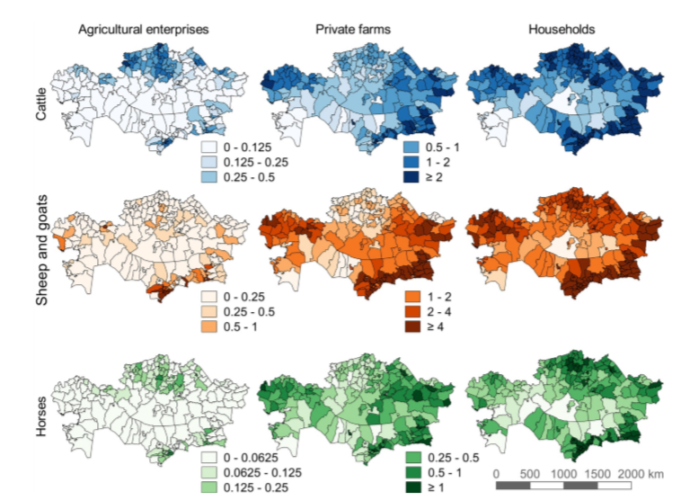
Figure 19. Distribution of livestock species by district and farm type (Hankerson et. al 2019).
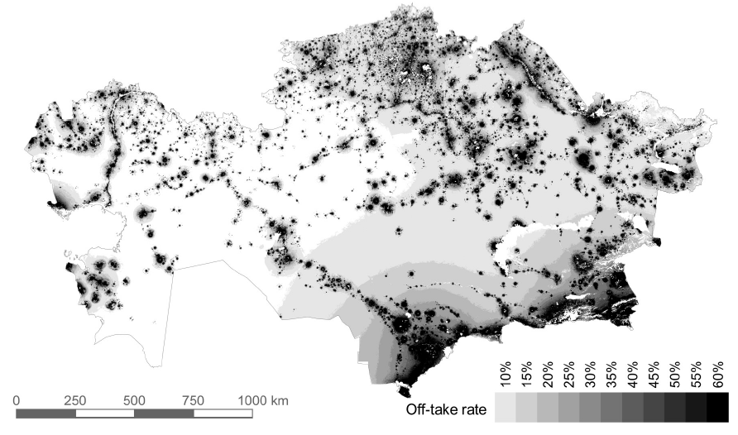
Figure 20. Estimation of grazing intensity for Kazakhstan (Hankerson et. al 2019).
Discussions
The identified drivers of ecological change in the region are complex and show how demographics, settlement patterns, management approaches, cultural norms and preferences and climate are contributing to impacts on the environment. The data presented here only provides stakeholders with a national overview of general trends, but reinforces the holistic approach being promoted by this project through its different components and collaborating partners.
Of special interest are the trends being seen in terms of changes in land productivity, LD and precipitation, as there seems to exist at least some links between the three indicator classes. Climate change is often an easy scapegoat for people when presented with these trends and maps, though landscapes have been highly modified at deep physical and biological levels, making rainfall less efficient, reducing sunlight capture and conversion into energy, simplifying nutrient flows and pathways and reducing biodiversity through outdated grazing and cropping techniques. These ecosystem functions and the services they provide will be addressed through participatory methodologies at landscape levels and through solid economic indicators put in place during project implementation.
Numerous authors have also pointed to the potential of the Kazakh livestock sector, highlighting the amount of underutilised pasture and forage opportunities (crop residues). In recognition of the role livestock production could ultimately play in the economy, the Government has put into place the National Livestock Programme 2018-2027. This programme anticipates about US$10 billion in investment over the 10-year period, with an additional US$10 billion from the private sector (including farmers’ co-financing), financial institutions, and international donors. Beef and mutton production is set to double over this period and the number of ‘family farms’ identified in the programme is set to grow from 20,000 to the Government’s target of 100,000 by 2028.
Those areas showing increased productivity could be optimised under sustainable production measures that maintain the evolutionary links between ruminants and grasslands; this in turn will maintain ecological integrity, biodiversity and increase livelihood options and benefits. At the same time, counter measures should be directed towards the western oblasts of the country to increase landscape and livelihood resilience, if the different models presented in this document are in fact accurate and the area is suffering from both climatic and human induced degradation.
As such, the results validate stakeholder selection of the Aktobe and Pavlodar oblasts as priority project oblasts, based on the following criteria:
They represent clear examples of the larger ecological and cultural systems (East/West, North/Central, semi-arid/sub-humid, ephemeral grasslands/perennial grasslands, strong cropping presence/marginal cropping presence) at work in their respective oblasts, which will provide context specific models and results which can easily be scaled to surrounding areas.
Both oblasts are heavily dependent on native grasslands for livelihoods and economic prosperity, especially important now that other sectors (energy) are at all-time lows.
Both show trends of degradation, decreases in land productivity and over-dependence on fire to remove unwanted vegetation and crop residues.
Both Oblasts have substantial numbers of HH producers and communal pastures. As the larger pastureland areas are typically leased for long periods (49 years) to more influential, wealthy producers or corporations, smaller producers are regulated to the local village pastures. Most of this grazing is not planned or directed toward concrete goals (The animals at the correct place, at the correct time, for the correct reasons, with the correct behaviour) This system of grazing leads to overgrazing of palatable species and under-grazing of less palatable or invasive woody shrubs. Leaf surface areas are also reduced to a minimum, substantially decreasing energy inputs into system. As ground cover is reduced nutrients are lost due to erosion or lost to leaching in occasional heavy downpours.
Stakeholder consultations also have shown the two Oblasts to be facing distinct land-management challenges. Aktobe has lost large areas of formerly productive cropping and grazing lands to soil salinity and the Pavlodar Oblast is struggling with invasive woody shrub encroachment on former grasslands which greatly reduce grazing areas. Shrub encroachment often is a significant factor in false positives in Land Productivity models and is most likely contributing for the gains or ‘bright spots’ in Land Productivity being seen in the south of the Oblast.

BIBLIOGRAPHY
Adler, R.F., G.J. Huffman, A. Chang, R. Ferraro, P. Xie, J. Janowiak, B. Rudolf, U. Schneider, S. Curtis, D. Bolvin, A. Gruber, J. Susskind, P. Arkin, E.J. Nelkin, 2003: The Version 2 Global Precipitation Climatology Project (GPCP) Monthly Precipitation Analysis (1979-Present). J. Hydrometeor., 4(6), 1147-1167
Adler et al., 2016. An Update (Version 2.3) of the GPCP Monthly Analysis. (in Preparation). Huffman, G.J., R.F. Adler, P. Arkin, A. Chang, R. Ferraro, A. Gruber, J. Janowiak, A. McNab, B. Rudolf, U. Schneider, 1997: The Global Precipitation Climatology Project (GPCP) Combined Precipitation Dataset. Bull. Amer. Meteor. Soc., 78(1), 5-20.
Ashouri H., K. Hsu, S. Sorooshian, D. K. Braithwaite, K. R. Knapp, L. D. Cecil, B. R. Nelson, and O. P. Prat, 2015: PERSIANN-CDR: Daily Precipitation Climate Data Record from Multi-Satellite Observations for Hydrological and Climate Studies. Bull. Amer. Meteor. Soc., dois: - https://doi.org/10.1175/BAMS-D-13-00068.1.
Cowie, A.L.; Orr, B.J.; Castillo Sanchez, V.M.; Chasek, P.; Crossman, N.D.; Erlewein, A.; Louwagie, G.; Maron, M.; Metternicht, G.I.; Minelli, S., et al. Land in balance: The scientific conceptual framework for Land Degradation Neutrality. Environmental Science & Policy 2018, 79, 25-35, doi:https://doi.org/10.1016/j.envsci.2017.10.011
Eric Dinerstein, David Olson, Anup Joshi, Carly Vynne, Neil D. Burgess, Eric Wikramanayake, et al. 2017. An Ecoregion-Based Approach to Protecting Half the Terrestrial Realm, BioScience, Volume 67, Issue 6, June 2017, Pages 534–545, https://doi.org/10.1093/biosci/bix014
ESA. Land Cover CCI Product User Guide Version 2. Tech. Rep. (2017). Available at: maps.elie.ucl.ac.be/CCI/viewer/download/ESACCI-LC-Ph2-PUGv2_2.0.pdf. URL of the data: https://www.esa-landcover-cci.org/?q=node/164
Funk, Chris, Pete Peterson, Martin Landsfeld, Diego Pedreros, James Verdin, Shraddhanand Shukla, Gregory Husak, James Rowland, Laura Harrison, Andrew Hoell & Joel Michaelsen.2015. "The climate hazards infrared precipitation with stations—a new environmental record for monitoring extremes". Scientific Data 2, 150066. doi:10.1038/sdata.2015.66 2015.
Hankerson BR, Schierhorn F, Prishchepov AV, Dong C, Eisfelder C, Müller D (2019), Modeling the spatial distribution of grazing intensity in Kazakhstan. PLoS ONE 14(1): e0210051.https://doi.org/10.1371/journal. pone.0210051
Hijmans, R.J., S.E. Cameron, J.L. Parra, P.G. Jones and A. Jarvis, 2005. Very High Resolution Interpolated Climate Surfaces for Global Land Areas. International Journal of Climatology 25: 1965-1978.
Schneider, Udo; Becker, Andreas; Finger, Peter; Meyer-Christoffer, Anja; Rudolf, Bruno; Ziese, Markus (2011): GPCC Full Data Reanalysis Version 6.0 at 0.5°: Monthly Land-Surface Precipitation from Rain-Gauges built on GTS-based and Historic Data. DOI: 10.5676/DWD_GPCC/FD_M_V7_050
Sims, N.C.; England, J.R.; Newnham, G.J.; Alexander, S.; Green, C.; Minelli, S.; Held, A. Developing good practice guidance for estimating land degradation in the context of the United Nations Sustainable Development Goals. Environmental Science & Policy 2019, 92, 349-355, doi:https://doi.org/10.1016/j.envsci.2018.10.014.
Teich, I.; Gonzalez Roglich, M.; Corso, M.L.; García, C.L. 2019. Combining Earth Observations, Cloud Computing, and Expert Knowledge to Inform National Level Degradation Assessments in Support of the 2030 Development Agenda. Remote Sensing. 2019, 11, 2918. https://doi.org/10.3390/rs11242918
UNCCD, CSIRO (2017). Good Practice Guidance, SDG Indicator 15.3.1: Proportion of land that is degraded over total land area. Technical Report

Annex F: GEF TF / LDCF/ SCCF Core Indicator Worksheet
Use this Worksheet to compute those indicator values as required in Part I, Table F to the extent applicable to your proposed project. Progress in programming against these targets for the program will be aggregated and reported at anytime during the replenishment period. LDCF and SCCF should complete, instead, the below CCA core indicator and built them into the results framework.

Core Indicator 1 | Terrestrial protected areas created or under improved management for conservation and sustainable use |  |  |  |  |  |  |  |  |  |  |  |  |  |  | (Hectares)
 |  |  |  |  |  |  | Hectares (1.1+1.2)
 |  |  |  |  |  |  | Expected |  |  |  |  |  |  | Achieved
 |  |  |  |  |  |  | PIF stage |  |  |  | Endorsement |  |  | MTR |  | TE
Indicator 1.1 | Terrestrial protected areas newly created
Name of Protected Area | WDPA ID | IUCN category |  |  |  |  |  | Hectares
Name of Protected Area | WDPA ID |  |  |  |  |  |  | Expected |  |  |  |  |  |  | Achieved
Name of Protected Area | WDPA ID |  |  |  |  |  |  | PIF stage |  |  | Endorsement |  |  |  | MTR | TE
 |  | Sum
Indicator 1.2 | Terrestrial protected areas under improved management effectiveness
Name of Protected Area | WDPA ID | IUCN category |  | Hectares |  |  |  | METT Score (Scale 1-3)
 |  |  |  |  |  |  |  | Expected |  |  |  |  |  |  | Achieved
 |  |  |  |  |  |  |  | PIF stage |  |  | Endorsement |  |  |  | MTR | TE
 |  | Sum
Core Indicator 2 | Marine protected areas created or under improved management for conservation and sustainable use |  |  |  |  |  |  |  |  |  |  |  |  |  |  | (Hectares)
 |  |  |  |  |  | Hectares (2.1+2.2)
 |  |  |  |  |  | Expected |  |  |  |  |  |  | Achieved
 |  |  |  |  |  | PIF stage |  |  | Endorsement |  |  |  | MTR |  |  | TE
Indicator 2.1 | Marine protected areas newly created
Name of Protected Area | WDPA ID | IUCN category |  |  |  |  |  | Hectares
Name of Protected Area | WDPA ID |  |  |  |  |  |  | Expected |  |  |  |  |  |  | Achieved
Name of Protected Area | WDPA ID |  |  |  |  |  |  | PIF stage |  |  | Endorsement |  |  |  | MTR | TE
 |  | Sum
Indicator 2.2 | Marine protected areas under improved management effectiveness
Name of Protected Area | WDPA ID | IUCN category |  |  | Hectares |  |  | METT Score (Scale 1-3)
 |  |  |  |  |  |  |  | Expected |  |  |  |  |  |  | Achieved
 |  |  |  |  |  |  |  | PIF stage |  |  | Endorsement |  |  |  | MTR | TE
 |  | Sum
Core Indicator 3 | Area of land restored |  |  |  |  |  |  |  |  |  |  |  |  |  |  | (Hectares)
 |  |  |  |  |  |  | Hectares (3.1+3.2+3.3+3.4)
 |  |  |  |  |  |  | Expected |  |  |  |  |  | Achieved
 |  |  |  |  |  |  | PIF stage |  |  |  | Endorsement |  | MTR |  |  | TE
 |  |  |  |  |  |  | 4,000 |  |  |  | 4,000
Indicator 3.1 | Area of degraded agricultural land restored
 |  |  |  |  |  |  |  | Hectares
 |  |  |  |  |  |  |  | Expected |  |  |  |  |  |  | Achieved
 |  |  |  |  |  |  |  | PIF stage |  |  | Endorsement |  |  |  | MTR | TE
Indicator 3.2 | Area of forest and forest land restored
 |  |  |  |  |  |  |  | Hectares
 |  |  |  |  |  |  |  | Expected |  |  |  |  |  |  | Achieved
 |  |  |  |  |  |  |  | PIF stage |  |  | Endorsement |  |  |  | MTR | TE
Indicator 3.3 | Area of natural grass and shrublands restored
 |  |  |  |  |  |  |  | Hectares
 |  |  |  |  |  |  |  | Expected |  |  |  |  |  |  | Achieved
 |  |  |  |  |  |  |  | PIF stage |  |  | Endorsement |  |  |  | MTR | TE
 |  |  |  |  |  |  |  | 4,000 |  |  | 4,000
Indicator 3.4 | Area of wetlands (including estuaries, mangroves) restored
 |  |  |  |  |  |  |  | Hectares
 |  |  |  |  |  |  |  | Expected |  |  |  |  |  |  | Achieved
 |  |  |  |  |  |  |  | PIF stage |  |  | Endorsement |  |  |  | MTR | TE
Core Indicator 4 | Area of landscapes under improved practices (hectares; excluding protected areas) |  |  |  |  |  |  |  |  |  |  |  |  |  |  | (Hectares)
 |  |  |  |  |  |  | Hectares (4.1+4.2+4.3+4.4)
 |  |  |  |  |  |  | Expected |  |  |  |  |  | Expected
 |  |  |  |  |  |  | PIF stage |  |  |  | Endorsement |  | MTR |  |  | TE
 |  |  |  |  |  |  | 30,000 |  |  |  | 816,000
Indicator 4.1 | Area of landscapes under improved management to benefit biodiversity
 |  |  |  |  |  |  |  | Hectares
 |  |  |  |  |  |  |  | Expected |  |  |  |  |  |  | Achieved
 |  |  |  |  |  |  |  | PIF stage |  |  | Endorsement |  |  |  | MTR | TE
Indicator 4.2 | Area of landscapes that meet national or international third-party certification that incorporates biodiversity considerations
Third party certification: |  |  |  |  |  |  |  | Hectares
 |  |  |  |  |  |  |  | Expected |  |  |  |  |  |  | Achieved
 |  |  |  |  |  |  |  | PIF stage |  |  | Endorsement |  |  |  | MTR | TE
Indicator 4.3 | Area of landscapes under sustainable land management in production systems
 |  |  |  |  |  |  |  | Hectares
 |  |  |  |  |  |  |  | Expected |  |  |  |  |  |  | Achieved
 |  |  |  |  |  |  |  | PIF stage |  |  | Endorsement |  |  |  | MTR | TE
 |  |  |  |  |  |  |  | 30,000 |  |  | 816,000
Indicator 4.4 | Area of High Conservation Value Forest (HCVF) loss avoided
 |  |  |  |  |  |  |  | Hectares
 |  |  |  |  |  |  |  | Expected |  |  |  |  |  |  | Achieved
 |  |  |  |  |  |  |  | PIF stage |  |  | Endorsement |  |  |  | MTR | TE
Core Indicator 5 | Area of marine habitat under improved practices to benefit biodiversity |  |  |  |  |  |  |  |  |  |  |  |  |  |  | (Hectares)
Indicator 5.1 | Number of fisheries that meet national or international third-party certification that incorporates biodiversity considerations
Third party certification: |  |  |  |  |  |  |  | Number
 |  |  |  |  |  |  |  | Expected |  |  |  |  |  |  | Achieved
 |  |  |  |  |  |  |  | PIF stage |  |  | Endorsement |  |  |  | MTR | TE
Indicator 5.2 | Number of large marine ecosystems (LMEs) with reduced pollution and hypoxial
 |  |  |  |  |  |  |  | Number
 |  |  |  |  |  |  |  | Expected |  |  |  |  |  |  | Achieved
 |  |  |  |  |  |  |  | PIF stage |  |  | Endorsement |  |  |  | MTR | TE
Core Indicator 6 | Greenhouse gas emission mitigated |  |  |  |  |  |  |  |  |  |  |  |  |  |  | (Tons)
 |  |  |  |  |  |  |  | Tons (6.1+6.2)
 |  |  |  |  |  |  |  | Entered |  |  |  | Entered
 |  |  |  |  |  |  |  | PIF stage |  | Endorsement |  | MTR |  |  |  | TE
 | Expected CO2e (direct) |  |  |  |  |  |  | 1,000,000 (WB+FAO) |  | 1,271,505 (only FAO Component)
 | Expected CO2e (indirect)
Indicator 6.1 | Carbon sequestered or emissions avoided in the AFOLU sector
 |  |  |  |  |  |  |  | Tons
 |  |  |  |  |  |  |  | Entered |  |  |  |  |  |  | Entered
 |  |  |  |  |  |  |  | PIF stage |  |  | Endorsement |  |  |  | MTR | TE
 | Expected CO2e (direct) |  |  |  |  |  |  | 1,000,000 (WB+FAO) |  |  | 1,271,505 (only FAO Component)
 | Expected CO2e (indirect)
 | Anticipated Year
Indicator 6.2 | Emissions avoided
 |  |  |  |  |  |  |  | Hectares
 |  |  |  |  |  |  |  | Expected |  |  |  |  |  |  | Achieved
 |  |  |  |  |  |  |  | PIF stage |  |  | Endorsement |  |  |  | MTR | TE
 | Expected CO2e (direct)
 | Expected CO2e (indirect)
 | Anticipated Year
Indicator 6.3 | Energy saved
 |  |  |  |  |  |  |  | MJ
 |  |  |  |  |  |  |  | Expected |  |  |  |  |  |  | Achieved
 |  |  |  |  |  |  |  | PIF stage |  |  | Endorsement |  |  |  | MTR | TE
Indicator 6.4 | Increase in installed renewable energy capacity per technology
 |  | Technology |  |  |  |  |  | Capacity (MW)
 |  |  |  |  |  |  |  | Expected |  |  |  |  |  |  | Achieved
 |  |  |  |  |  |  |  | PIF stage |  |  | Endorsement |  |  |  | MTR | TE
Core Indicator 7 | Number of shared water ecosystems (fresh or marine) under new or improved cooperative management |  |  |  |  |  |  |  |  |  |  |  |  |  |  | (Number)
Indicator 7.1 | Level of Transboundary Diagnostic Analysis and Strategic Action Program (TDA/SAP) formulation and implementation
 |  | Shared water ecosystem |  |  |  |  |  | Rating (scale 1-4)
 |  |  |  |  |  |  |  | PIF stage |  |  | Endorsement |  |  |  | MTR | TE
Indicator 7.2 | Level of Regional Legal Agreements and Regional Management Institutions to support its implementation
 |  | Shared water ecosystem |  |  |  |  |  | Rating (scale 1-4)
 |  |  |  |  |  |  |  | PIF stage |  |  | Endorsement |  |  |  | MTR | TE
Indicator 7.3 | Level of National/Local reforms and active participation of Inter-Ministerial Committees
 |  | Shared water ecosystem |  |  |  |  |  | Rating (scale 1-4)
 |  |  |  |  |  |  |  | PIF stage |  |  | Endorsement |  |  |  | MTR | TE
Indicator 7.4 | Level of engagement in IWLEARN through participation and delivery of key products
 |  | Shared water ecosystem |  |  |  |  |  | Rating (scale 1-4)
 |  |  |  |  |  |  |  | Rating |  |  |  |  |  |  | Rating
 |  |  |  |  |  |  |  | PIF stage |  |  | Endorsement |  |  |  | MTR | TE
Core Indicator 8 | Globally over-exploited fisheries Moved to more sustainable levels |  |  |  |  |  |  |  |  |  |  |  |  |  |  | (Tons)
 |  |  |  |  |  |  |  | Metric Tons
 |  |  |  |  |  |  |  | PIF stage |  |  | Endorsement |  |  |  | MTR | TE
Core Indicator 9 | Reduction, disposal/destruction, phase out, elimination and avoidance of chemicals of global concern and their waste in the environment and in processes, materials and products |  |  |  |  |  |  |  |  |  |  |  |  |  |  | (Tons)
 |  |  |  |  |  |  | Metric Tons (9.1+9.2+9.3)
 |  |  |  |  |  |  | Expected |  |  |  |  |  |  | Achieved
 |  |  |  |  |  |  | PIF stage |  |  |  | PIF stage |  |  | MTR |  | TE
Indicator 9.1 | Solid and liquid Persistent Organic Pollutants (POPs) and POPs containing materials and products removed or disposed
POPs type |  |  |  |  |  |  |  | Metric Tons
 |  |  |  |  |  |  |  | Expected |  |  |  |  |  |  | Achieved
 |  |  |  |  |  |  |  | PIF stage |  |  | Endorsement |  |  |  | MTR | TE
Indicator 9.2 | Quantity of mercury reduced
 |  |  |  |  |  |  |  | Metric Tons
 |  |  |  |  |  |  |  | Expected |  |  |  |  |  |  | Achieved
 |  |  |  |  |  |  |  | PIF stage |  |  | Endorsement |  |  |  | MTR | TE
Indicator 9.3 | Number of countries with legislation and policy implemented to control chemicals and waste
 |  |  |  |  |  |  |  | Number of Countries
 |  |  |  |  |  |  |  | Expected |  |  |  |  |  |  | Achieved
 |  |  |  |  |  |  |  | PIF stage |  |  | Endorsement |  |  |  | MTR | TE
Indicator 9.4 | Number of low-chemical/non-chemical systems implemented particularly in food production, manufacturing and cities
 |  | Technology |  |  |  |  |  | Number
 |  |  |  |  |  |  |  | Expected |  |  |  |  |  |  | Achieved
 |  |  |  |  |  |  |  | PIF stage |  |  | Endorsement |  |  |  | MTR | TE
Core Indicator 10 | Reduction, avoidance of emissions of POPs to air from point and non-point sources |  |  |  |  |  |  |  |  |  |  |  |  |  |  | (Grams)
Indicator 10.1 | Number of countries with legislation and policy implemented to control emissions of POPs to air
 |  |  |  |  |  |  |  | Number of Countries
 |  |  |  |  |  |  |  | Expected |  |  |  |  |  |  | Achieved
 |  |  |  |  |  |  |  | PIF stage |  |  | Endorsement |  |  |  | MTR | TE
Indicator 10.2 | Number of emission control technologies/practices implemented
 |  |  |  |  |  |  |  | Number
 |  |  |  |  |  |  |  | Expected |  |  |  |  |  |  | Achieved
 |  |  |  |  |  |  |  | PIF stage |  |  | Endorsement |  |  |  | MTR | TE
Indicator 10.3 | Number of countries with legislation and policy implemented to control chemicals and waste
 |  |  |  |  |  |  |  | Number of Countries
 |  |  |  |  |  |  |  | Expected |  |  |  |  |  |  | Achieved
 |  |  |  |  |  |  |  | PIF stage |  |  | Endorsement |  |  |  | MTR | TE
Core Indicator 11 | Number of direct beneficiaries disaggregated by gender as co-benefit of GEF investment |  |  |  |  |  |  |  |  |  |  |  |  |  |  | (Number)
 |  |  |  |  |  |  |  |  |  |  |  |  |  |  | Number Achieved
 |  |  |  |  |  |  |  |  |  |  |  |  |  |  | MTR | TE
 |  |  |  |  |  |  |  |  |  |  | Female
 |  |  |  |  |  |  |  |  |  |  | Male
 |  |  |  |  |  |  |  |  |  |  | Total

Annex G: GEF Project Taxonomy Worksheet
Use this Worksheet to list down the taxonomic information required under Part I, item G by ticking the most relevant keywords/ topics/themes that best describe this project.



Annex H: Work Plan (indicative)

Output | Main Activities | Responsible | Year 1 |  |  |  |  |  |  | Year 2 |  |  |  |  |  |  | Year 3 |  |  |  |  |  | Year 4
Output | Main Activities | Responsible | Q1 |  | Q2 |  | Q3 |  | Q4 | Q1 | Q2 |  | Q3 |  | Q4 |  | Q1 | Q2 | Q3 |  | Q4 |  | Q1 | Q2 | Q3 | Q4
Component 1: Land use policy and planning
Output 1.1.1: | Led by World Bank
Output | Main Activities | Responsible | Year 1 |  |  |  |  |  |  | Year 2 |  |  |  |  |  |  | Year 3 |  |  |  |  |  | Year 4
Output | Main Activities | Responsible | Q1 |  | Q2 |  | Q3 |  | Q4 | Q1 | Q2 |  | Q3 |  | Q4 |  | Q1 | Q2 | Q3 |  | Q4 |  | Q1 | Q2 | Q3 | Q4
Component 2: Dryland agroforestry and landscape restoration
Output 2.1.1: | Led by World Bank
Output | Main Activities | Responsible | Year 1 |  |  |  |  |  |  | Year 2 |  |  |  |  |  |  | Year 3 |  |  |  |  |  | Year 4
Output | Main Activities | Responsible | Q1 |  | Q2 |  | Q3 |  | Q4 | Q1 | Q2 |  | Q3 |  | Q4 |  | Q1 | Q2 |  | Q3 |  | Q4 | Q1 | Q2 | Q3 | Q4
Component 3: Sustainable Pasture Management
Output 3.1.1: Training on SPM practices. | Activity 1: Analysis of Kazakhstan context, project objectives and beneficiary livelihoods for the development of contextualized training curriculum and approach. |  | X | X |  |  |  |  |  | X |  |  |  | X |  |  | X |  |  | X |  |  |  |  |  | X
Output 3.1.1: Training on SPM practices. | Activity 2: Selection and training of facilitators by International Master APFS Trainer (National refresher end year 2 on FFS methodology) |  |  | X |  | X |  | X
Output 3.1.1: Training on SPM practices. | Activity 3: Technical workshops and field-based practicals on SPM and integrated landscape planning in Aktobe and Pavlodar Oblast. |  |  |  |  | X |  | X |  |  |  |  |  |  |  |  | X | X |  | X
Output 3.2.1: Demonstration of pasture/SLM rehabilitation and technologies. | Activity 1: Stakeholder endorsed selection of sustainable pastureland demonstration / restoration landscapes. |  | X | X |  | X |  | X
 | Activity 2: Participatory LD and pastureland assessments realized and used to establish baselines and inform land management approaches. |  | X | X |  | X |  | X
 | Activity 3: Restoration of 4,000 ha of pastureland within Aktobe and Pavlodar oblasts through participatory methodologies and practices (By Operational Partner). |  |  |  |  | X |  | X |  | X |  | X |  | X |  | X | X | X |  | X |  | X | X | X
 | Activity 4: Technical and financial support to introduce SLM practices and landscape management approaches on an area of over 816,000 ha in Pavlodar and Aktobe oblasts. |  |  |  |  | X |  | X |  | X |  | X |  | X |  | X | X | X |  | X |  | X | X | X
 | Activity 5: Demonstration landscapes open field days and demonstration side exchange visits (rayon level). |  |  |  |  |  |  |  |  |  |  |  |  |  |  |  | X | X |  | X |  | X
 | Activity 6: Support of information sharing and collaboration between demonstrations sites, SLM/climate-smart agri-business models and VCs. |  |  |  |  | X |  | X |  | X |  | X |  | X |  | X | X | X |  | X |  | X
Output 3.2.2: Demonstration of climate smart agricultural management practices. | Activity 1: Pasture-based business models with SLM/climate-smart approaches are selected for consideration with project stakeholders and beneficiaries. |  |  |  |  |  |  |  |  | X |  | X |  | X |  | X
 | Activity 2: Models are chosen by collaborating stakeholder entities for development under supervision of project technicians and coordinators and validated by different financial and GoK agencies. |  |  |  |  |  |  |  |  |  |  |  |  | X |  | X
 | Activity 3: Models are developed, documented and analysed through environmental, social and economic indicators. |  |  |  |  |  |  |  |  |  |  |  |  | X |  | X | X | X
 | Activity 4: Development support and funding for two gender-sensitive VC based models developed. |  |  |  |  |  |  |  |  |  |  |  |  | X |  | X | X | X
 | Activities 5: Systems are adapted based on lessons learnt and final models are presented to national and international institutions for scaling and investment. |  |  |  |  |  |  |  |  |  |  |  |  |  |  |  |  | X |  | X |  | X
Output.3.3.1: Economic assessment of investments in carbon sequestering projects in the agriculture sector. | Activity 1: Development of a policy brief on current legal framework regarding carbon trading within Kazakhstan and recommendations for increased involvement and access of agriculture sector to international carbon markets. |  |  |  |  |  |  |  |  | X |  | X |  | X |  | X
 | Activity 2: Development of monitoring and reporting system to establish a basis for carbon measurement at landscape level. |  |  |  |  | X |  | X |  | X |  | X |  | X |  | X
 | Activity 3: Use of developed landscape SOC methodology to conduct baseline assessments and monitoring of SOC levels in project demonstration sites to calculate carbon flows and potential economic impacts for scaling. |  |  |  |  | X |  | X |  |  |  |  |  |  |  | X |  |  |  |  |  | X
 | Activity 4: Development of national SOC monitoring and reporting system so as to inform LDN processes and targets. |  |  |  |  | X |  | X |  | X |  | X |  | X |  | X | X | X |  | X |  | X
Output.3.3.2: Training on the international carbon trading system. | Activity 1: Training on metrics and methods for land-based carbon measurement and monitoring and its role in the LDN Framework. |  |  |  |  |  |  |  |  |  |  |  |  | X |  | X | X | X
 | Activity 2: Training on international carbon markets and standards. |  |  |  |  |  |  |  |  |  |  |  |  | X |  | X | X | X
Output | Main Activities | Responsible | Year 1 |  |  |  |  |  |  | Year 2 |  |  |  |  |  |  | Year 3 |  |  |  |  |  | Year 4
Output | Main Activities | Responsible | Q1 |  | Q2 |  | Q3 |  | Q4 | Q1 | Q2 |  | Q3 |  | Q4 |  | Q1 | Q2 | Q3 |  | Q4 |  | Q1 | Q2 | Q3 | Q4
Component 4: Monitoring and Evaluation
Output 4.1.1: | Led by World Bank
Notes: APFS = agro-pastoral field schools; FFS = farmer field schools; GoK = Government of Kazakhstan; LD = land degradation; LDN = land degradation neutrality; SOC = soil organic carbon; SPM = sustainable pasture management; VC = value chain;

Annex I: Financial Management

Financial management in relation to the GEF resources directly managed by FAO will be carried out in accordance with FAO’s rules and procedures as outlined below. The OP is accountable to FAO for achieving the agreed project results and for the effective use of resources made available by FAO. Financial management and reporting for the funds transferred to the OP will be done by the OP in accordance with terms, conditions, formats and requirements of FAO and the provisions of the signed Operational Partners Agreement (OPA). The administration by the OP of the funds received from FAO shall be carried out under its own financial regulations, rules and procedures, which shall provide adequate controls to ensure that the funds received, are properly administered and expended. The Operational Partner shall maintain the account in accordance with generally accepted accounting standards.
Financial Records. FAO shall maintain a separate account in United States dollars for the project’s GEF resources showing all income and expenditures. FAO shall administer the project in accordance with its regulations, rules and directives. The OP shall maintain books and records that are accurate, complete and up-to-date. The OP’s books and records will clearly identify all Fund Transfers received by the OP as well as disbursements made by the OP under the OPA, including the amount of any unspent funds and interest accrued.
Financial Reports. The BH shall prepare quarterly project expenditure accounts and final accounts for the project, showing amount budgeted for the year, amount expended since the beginning of the year, and separately, the un-liquidated obligations as follows: i) Details of project expenditures on outcome-by-outcome basis, reported in line with Project Budget as at 30 June and 31 December each year; ii) Final accounts on completion of the Project on a component-by-component and outcome-by-outcome basis, reported in line with the Project Budget; iii) A final statement of account in line with FAO Oracle Project budget codes, reflecting actual final expenditures under the Project, when all obligations have been liquidated.
The OP will prepare the financial reports in accordance with terms, conditions, formats and requirements of FAO and the provisions of the signed OPA. The BH will review and approve request for funds and financial reports of the OP. The subsequent instalments can be released only based on the BH confirmation that all expenditures are eligible and all OPA requirements are fulfilled to the satisfaction of FAO. The BH will withhold any payment due to the OP in case of non-compliance with the reporting obligations detailed in the OPA.
Financial reports for submission to the donor (GEF) will include both FAO- and OP-managed resources, will be prepared in accordance with the provisions in the GEF Financial Procedures Agreement and submitted by the FAO Finance Division.
Responsibility for Cost Overruns. As regards resources directly managed by FAO, the BH shall utilize the GEF project funds in strict compliance with the Project Budget (Appendix A2) and the approved AWP/Bs. The BH can make variations provided that the total allocated for each budgeted project component is not exceeded and the reallocation of funds does not impact the achievement of any project output as per the project Results Framework (Appendix A1). At least once a year, the BH will submit a budget revision for approval of the LTO and the FAO/GEF Coordination Unit. Cost overruns shall be the sole responsibility of the BH.
As regards resources managed by the OP, the OP shall utilize the funds received from FAO in strict compliance with provisions of the signed OPA and its Annexes, including approved work plan and budget. The OP can make variations not exceeding 10 percent on any budget heading. Any variations above 10 percent on any budget heading that may be necessary will be subject to prior consultations with and approval by FAO.
Under no circumstances can expenditures exceed the approved total project budget or be approved beyond the NTE date of the OPA and/or the project. Any over-expenditure is the responsibility of the BH.
Audit. The project shall be subject to the internal and external auditing procedures provided for in FAO financial regulations, rules and directives and in keeping with the Financial Procedures Agreement between the GEF Trustee and FAO.
The audit regime at FAO consists of an external audit provided by the Auditor-General (or persons exercising an equivalent function) of a member nation appointed by the Governing Bodies of the Organization and reporting directly to them, and an internal audit function headed by the FAO Inspector-General who reports directly to the Director-General. This function operates as an integral part of the Organization under policies established by senior management, and furthermore has a reporting line to the governing bodies. Both functions are required under the Basic Texts of FAO which establish a framework for the terms of reference of each. Internal audits of imprest accounts, records, bank reconciliation and asset verification take place at FAO field and liaison offices on a cyclical basis. Specific provision for auditing the OP managed funds are included in the signed Operational Partners Agreement (OPA). During implementation, assurance activities are organized by FAO to determine whether the progress has been made and whether funds transferred to Operational Partners were used for their intended purpose, in accordance with the work plan and relevant rules and regulations. This may include, but is not limited to, monitoring missions, spot checks, quarterly progress and annual implementation reviews, and audits on the resources received from FAO.
Procurement. Careful procurement planning is necessary for securing goods, services and works in a timely manner, on a “Best Value for Money” basis. It requires analysis of needs and constraints, including forecast of the reasonable timeframe required to execute the procurement process.
Procurement will follow OP rules and regulations for the procurement of supplies, equipment and services. The OP will draw up a procurement plan as part of the supporting documentation to each request for funds submitted to FAO. The plan will include a description of the goods, works, or services to be procured, estimated budget and source of funding, schedule of procurement activities and proposed method of procurement. In situations where exact information is not yet available, the procurement plan should at least contain reasonable projections that will be corrected as information becomes available.
The procurement plan shall be updated every quarter and submitted to FAO BH and LTO for clearance.

Annex J: Terms of Reference for Key Project Staff

Title: National Project Manager
Timing/Duration: 4 years
Main tasks:
Planning, operations and resource management of the national project:
- Plan and design all project activities in the country, including preparation of the national-level Annual Work Plan (AWP);
- Coordinate the establishment of the reporting and monitoring and evaluation system at the national level in accordance with FAO/GEF requirements, introduce and maintain the system of reporting and adaptive management where appropriate;
- Implement and/or supervise the outcome monitoring system, designed by the programme, for capacity building and awareness activities for organizations, groups and individuals at national and local level;
- Ensure implementation of project activities in accordance with work plan and facilitate the two-ways flow of information and knowledge between the field and national/regional project components/activities;
- Provide leadership and contribute to the capacity building and development of national specialists and project staff for successful project implementation, including gender mainstreaming;
- Perform similar duties to ensure the country’s relevant participation in CACILM2 processes, coordinate project activities with FAO’s current work in the country, assist development of synergies and cooperation among various stakeholders and partners;
- Provide other implementation support such as gender mainstreaming to ensure the successful implementation of the project activities and delivery of results.
Technical support of project implementation:
- Adapt and introduce knowledge management and practice sharing mechanisms, including provision of necessary training and other capacity building;
- Coordinate the implementation of field activities as per approved annual workplan, including multilateral land use planning, introduction of innovative drought mitigation technologies, conservation agriculture approaches, agro-sylvo-pastoral and agroforestry practices, water-saving irrigation and drought-resistant varieties, strengthening of value chains and other;
- Supervise and coordinate the organization of various capacity building and awareness events, including training events both at local and national level, including symposia, fairs, workshops and other;
- Introduce mechanism for coordination of SLM efforts among various partners and stakeholders;
- Promote mainstreaming of SLM approaches and climate change issues (drought- and salinity-related) into existing policy mechanisms in the country;
- Provide required coordination for project outreach and communication plan.
Partnership development:
  - Coordinate national and regional project interventions in Kazakhstan with ongoing activities of national projects and programs of other donors and stakeholders at the national level;
  - Liaise regularly with national and provincial government on field activities;
  - Maintain an effective project coordination between national focal points for UNCCD, UNFCCC and GEF OFP and project partners;
  - Form a national expert group on SLM practices

Key competences/ qualifications:
Technical competencies:
- University degree in Environmental Science or Engineering, Rural Development; agricultural science or engineering, or any other related fields with extensive experience in project management and implementation of sustainable land management (SLM) practices;
- At least 5 years of demonstrated experience in project management, at the local level or/and international level; with extensive knowledge of application of SLM practices;
- Ability to use computer programs such excel, SPSS, or other software to manage and analyze (large) data sets;
- Excellent communication skills with district and national government, national experts and local communities;
- Advanced level of English and Russian languages is required, and a good command of local language will be an advantage;
- Knowledge and experience on UN system is an asset;
- Experience in programme/project matters with international organizations (GEF, UNCCD, UNFCCC etc.) would be desirable.
Project Management competencies:
- Solid management skills in development projects, particularly on area of SNRM at national or international level;
- Proven leadership skills demonstrated ability to open up to new approaches and new practices;
- Systematic and efficient approach to work assignments, good judgment and analytical ability;
- Experience in supervision of project technical experts and group of consultants;
- Ability to deliver project outputs and budgets on timely manner with high standard quality;
- Proven coordination and management skills to implement the capacity building programs and activities, including development and organization of training events at the national and local level;
- Experience in the monitoring of programme outcomes and the design and implementation of base and end-line surveys.

Title: Project Assistant
Timing/Duration: 4 years
Main tasks:
- Arrange appointments for the supervisor, receive visitors, place and screen incoming communications (telephone calls, letters, EMs) and respond to routine requests for information;
- Provide office, administrative and logistics support to meetings, committees, conferences, etc.;
- Review, record, distribute and process incoming mail and correspondence; follow-up on pending actions;
- Respond or draft responses to standard/ routine correspondence and other communications; use word processing package to produce a wide variety of large, complex documents and reports;
- Proofread documents and format texts for accuracy, grammar, punctuation and style, as well as for adherence to established standards;
- Initiate and follow up on administrative tasks in computerized financial / travel / procurement / human resources systems;
- Make travel and hotel arrangements and prepare travel authorizations/claims for staff as required;
- Provide assistance in the administrative processing of travels, recruitments, contracts and procurements;
- Research, compile and organize information and reference materials from various sources for reports; create spreadsheets and presentations; manage and update databases for mailing lists and other information; and maintain electronic and paper files;
- Perform other duties as required.

Key competences/qualifications:
- Secondary School Education
- Minimum of three years of relevant experience in office support work. Work experience from UN agencies is considered a strong asset;
- Excellent knowledge of English and Russian languages;
- Ability to use office soft/hardware as a tool to work productively and effectively; Good knowledge of the MS Word, Excel, Outlook applications, Internet and office technology equipment

Title: Livestock Value Chains development expert
Timing/Duration: 2 months
Main tasks:
- Conduct a brief market and VC analysis of amaranth and quinoa at the regional and international levels;
- Assess a market capacity of amaranth and quinoa in Kazakhstan;
- Conduct a brief gender-sensitive overview of the existing VC of sudan grass in project areas;
- Conduct a gender-sensitive VC gap analysis of the sudan grass in project areas;
- Identify activities/interventions required to strengthen the production and VC of Sudan grass;
- Develop business models for crops cultivation toward development/strengthening of VCs of amaranth, quinoa and sudan grass using INRM/SLM/CSA practices;
- Develop a plan and list of activities for capacity building based on the business models, by taking into the consideration of gender disparities, stereotypes, and other constraints experienced in the field;
- Perform other duties as required.

Key competences/qualifications:
- University degree in economics, agriculture, social sciences or related fields;
- At least five years of relevant professional work experience in development of VC;
- Proven ability to conduct comprehensive agriculture economic and policy analyses and institutional capacity assessment;
- Demonstrated ability to work in partnerships with state agencies, manage and coordinate the work process;
- Good written and oral communication skills in Russian and English;
- Knowledge of Kazakh is an asset.

Title: National GIS expert
Timing/Duration: 16 months
Main tasks:
- Directly perform work on digitizing land use maps for the country;
- Provide assistance to the FAO National Consultant and carry out its instructions and recommendations for the creating and managing a database, installation and operation of software for digitizing land use maps;
- Ensure uninterrupted operation of equipment for the digitalization of maps;
- Prepare monthly reports on completed work.

Key competences/qualifications:
- Academic qualifications in IT technology, land management, cartography, or related disciplines relevant to a specific project;
- Experience in land management, digitization of land use maps and agriculture;
- Experience of participation in international projects in the field of land management and agricultural development, preferably;
- Knowledge of Russian, Kazakh and English is preferred.

Title: Pastureland Management and Monitoring expert
Timing/Duration: 3 months

Main tasks:
- Development of two INRM plans for selected agricultural landscapes in the country;
- Creation of working group on INRM, based tools of FAO;
- Selection of water saving technologies, in accordance with methods and tools of FAO, etc.;
- Selection of project sites in agriculture landscapes (rainfed, irrigated, pastoral etc.), based on multiple criteria suggested by FAO;
- Identification of training needs to enhance the national capacity on INRM planning;
- Participation in selection of water saving technologies, in accordance with methods and tools of FAO, etc.;
- Development of guidelines for integrated salinity management planning (ISMP) at watershed level in project sites;
- Participation in developing capacity building program (including training modules) on knowledge sharing and extension services for local land- and water users;
- Participation in developing FFS training course and modules for capacity building on knowledge sharing and extension services for land/water user groups, based on FAO approaches and tools;
- Review of national experiences and assessment of SLM practices and approaches adapted in Uzbekistan under support of the FAO, ICBA, ICARDA, etc;
- Conducting the consultative expert meetings with local partners on planning of SLM technologies and approaches in project areas and development of scaling-up plan for actions;
- Participation in analysis of the existing practices and institutional capacities for improvement varieties of seeds and development of specific plan for scaling-up;
- Other related activities on SLM;
- Perform other related duties as required.

Key competences/qualifications:
- University degree in soil management, land management, agronomy, agricultural economics, other related to agriculture fields;
- At least 10 years of demonstrated experience in sustainable land management at the local level and/international level;
- Proven experience in land use planning at local and international level;
- Proved communication skills, with district/oblast government, national experts and local communities;
- Proved leadership skills, demonstrated ability to open up to new approaches and new practices;
- Working level of English, Russian and Kazakh is required
- Systematic and efficient approach to work assignments, good judgment and analytical ability;
- Knowledge on UN system is an asset.
- Experience in programme/project matters with international organizations would be desirable.

Title: Communications Specialist
Timing/Duration: 30 days
Main tasks:
- Determine key audiences, principal messages and optimal media tools/means for conveying information to target audiences;
- In close collaboration with OCC, draft a communication strategy, including short- and long-term action plan for effective communication with project countries;
- Organize public events attracting media interest in a cost-effective manner with timely issuance of the press releases and outreach;
- Design, develop and support the use of communication tools as the project evolves, conveying the project findings and outputs via corporate digital channels: website, YouTube, Facebook, Twitter, etc. and posters, leaflets, brochures, TV iand radio interviews.
- Review existing, on-going networks, initiatives and their capabilities, and identify potential partners at national and regional levels;
- Develop draft project briefing/publicity materials including the country profile, program/project factsheets, one-page “success stories”, and summaries of project activity results in consultation with the relevant and support technical offices, and share them up for use on FAO websites;
- In close collaboration with OCCI, develop appropriate and high-quality media materials for communication and outreach, including videos, articles and social media products;
- Organize outreach and communication materials to ensure there are enough knowledge distribution and awareness raising products on hand for workshops, trainings and to be responsive to requests for information from project staff, FAO, press and Regional offices;
- Provide professional recordings of audio and video materials on project activities for regional media programs;
- In close collaboration with OCCI, collect and organize content for the project website and social media in coordination with FAO staff and implementing partners, making regular updates and offering recommendations for useful technical and/or informational modifications;
- In close collaboration with OCCI, ensure ongoing updates of the project website;
- Write and distribute press releases, background briefings for media, speeches, and talking points as required;
- Develop and maintain up to date database / mailing list of media contacts in the coverage area particularly those interested in issues of climate change, ecology and agriculture development, and share those updates with the Sub-regional Office and Regional Office communications teams;
- Monitor Central Asian and other Russian and English language media for coverage of FAO and share it with the Regional Office;
- Assist the project staff in production of both print and digital communication material, ensuring they are of high quality and follow FAO corporate communication policies, paying special attention to logo and copyright issues;
- Work with the media in all countries-participants of the project to improve the FAO/GEF visibility and image, and to assist in enhancing their visibility in all public events;
- Train the project staff in communication techniques.

Key competences/qualifications:
- Higher degree in journalism, media/communications, social sciences, international relations, development studies and other relevant fields
- At least 5 years of experience in communications and media relations at national, regional or international platforms in Central Asia
- Previous proactive work experience in communications and outreach in Central Asian countries
- Demonstrated ability to (i) train (ii) develop communication tools – written, verbal, electronic, multimedia etc.
- Report writing, project visibility, outreach and presentation delivery skills
- Systematic and efficient approach to work assignments, good judgment and analytical ability
- Excellent verbal and written English and Russian language skills, good knowledge of other UN languages is an advantage
- Knowledge and experience with the UN system is a considerable asset
- Experience in programme/project matters with international organizations and national governments would be desirable.

Title: Monitoring & Evaluation Expert (including MTR)
Timing/Duration: 30 days
Main tasks:
- Develop M&E system for the Project and for the government counterpart/stakeholders, including baseline data collection;
- Support project team to develop and strengthen monitoring, inspection and evaluation procedures;
- Assist the project manager to monitor all project activities and progress towards achieving the project output;
- Monitor and evaluate overall progress and the sustainability of the project results;
- Provide feedback to the Project Manager on project strategies and activities on M&E;
- Suggest strategies to the Project Management for improving the efficiency and effectiveness of the project by identifying bottlenecks in completing project activities and developing plans to minimize or eliminate such bottlenecks;
- Report monthly, quarterly, half-yearly and annual progress on all project activities to the National Project Manager;
- Conduct capacity assessment on existing monitoring and evaluation system;
- Provide inputs, information and statistics for quarterly, annual and other reports to raft the Project Implementation Reporting;
- Participate in annual project reviews and planning workshops and assist the Project Manager in preparing relevant reports;
- Support International M&E Expert with required data collection to effectively assess progress and impact of the project;
- Assist the project staff in applying M&E tools during the project implementation;
- When necessary, organizing and conducting training sessions on M&E for project and government staff;
- Assist the Project Manager in preparing relevant M&E reports and perform other related duties as required.

Key competences/qualifications:
- University Degree preferably in Statistical Mathematics, Management, Administration, Economics or related fields;
- At least 5 years of experience in designing and implementation of M&E/MIS in development projects implemented by national/international NGOs/UN organizations/ Government. Experience from UN projects would be desirable;
- Working level of Russian or Kazakh languages is required, and a good command of English language will be an advantage;
- Solid experience in designing M&E tools and strategies for data collection, analysis and production of reports;
- Proven ICT skills, especially in the development of MIS software using database software;
- Expertise in analyzing data using statistical software;
- Systematic and efficient approach to work assignments, good judgment and analytical ability;
- Knowledge on UN system is an asset.

Title: National Gender Expert
Timing/Duration: 40 days
Main tasks:
- Operationalize the project’s Gender and social inclusion mainstreaming strategy at the country level, in close coordination with the national project teams. For this, develop an implementation plan with clear time bounds and indicators, and colleagues to coordinate with, and mainstream gender in all workplans;
- Conduct capacity development activities in gender mainstreaming and social inclusion to the national project teams;
- Ensure that the national project teams are also familiar with the VGGT, CEDAW and SDG target 5.a.;
- Conduct stakeholder analysis for the project, to ensure involvement of various social groups, including those working on gender, social inclusion and social protection issues in all countries of the region;
- Conduct a gender, social inclusion and social protection assessments in each country, with focus on the communities affected by drought and salinity, and for gender-responsive, socially inclusive and pro-poor integrated natural resource management (INRM) in collaboration with relevant research institutions. As part of this assessment, include the identification of bottlenecks for the achievement of SDG target 5.a.;
- Revise the national targets and monitoring framework in the project countries, and propose changes as needed;
- Develop capacities of stakeholders on gender, social inclusion and social protection issues on INRM through 1) the dissemination of knowledge through existing internet portals and project’s regional Knowledge Management platform; 2) trainings and awareness raising events and sessions, and 3) the development of communication and knowledge materials in collaboration with the project’s Communications Specialist;
- Support the development of INRM monitoring systems that are gender-responsive, socially inclusive, pro-poor, and consider the impact of social protection schemes for the resilience of draught and salinity affected populations;
- Reviewing relevant national policies, legal and institutional frameworks, so: 1) national objectives and commitments towards gender equality, poverty reduction and social inclusion are taken into consideration within INRM; 2) Social protection systems gaps to contribute to the resilience of draught and salinity-affected populations are identified and 3) inter-institutional cooperation gaps are mapped. Mainstreaming these topics into national policies, strategies and guidelines;
- Support the project’s field demonstration activities in a gender-responsive and socially inclusive form;
- Framing the assessments and interventions by FAO gender-sensitive frameworks, and selecting approaches that contribute to both women and of men;
- Ensuring that all training, events and other capacity development activities reach and benefit both women and men;
- Develop public and private rural advisory service (RAS) capacities to work with different social groups, so they are gender- responsive, socially inclusive and reach the vulnerable and the poor;
- Support the periodic reporting of the project to ensure visibility and good communication;
- Provide technical support in gender mainstreaming to national and international project team members as needed;
- Contribute to preparing regular materials on lessons learnt and best practices, and develop case studies documenting the project experiences on gender mainstreaming and social inclusion.

Key competences/qualifications:
- Higher degree related to social development or gender;
- At least 3 years of experience working on gender and livelihoods in Central Asia;
- Demonstrated experience successfully working with international / regional partners on natural resource management issues;
- Demonstrated ability to interact effectively with a range of stakeholders – national government, local government and local land users;
- English and Russian language communications skills are essential.
- Systematic and efficient approach to work assignments, good judgment and analytical ability;
- Knowledge on UN system is an asset.

Title: Agro-Pastoral Farmer Field School (APFS) Intl. Master Trainer
Timing/Duration: 30 days
Main tasks:
- Preparation of FFS master plan for all project sites/areas and thematic courses, including selection of FFS master trainer for each course, and field trainers in selected areas (including women farmers);
- Planning and implementation of the quality trainings with all component under FFS approach to the farmers;
- Participation in developing capacity building program (including training modules) on knowledge sharing and extension services for local land- and water users;
- Developing FFS training course and modules for capacity building and extension services for land/water user groups, based on FAO approaches and tools;
- Ensuring close liaison with Community Mobilizers’ in formation of groups;
- Establishing strong liaison with the all Trainers/ Facilitators and provide technical guidance in implementing and monitoring FFS trainings;
- Monitoring and evaluating performance of the Trainers/ Facilitators and undertake necessary measures for their improvement;
- Assisting in preparing Annual/Quarterly Work Plan – particularly for FFS training and implementation of the project;
- Providing guidance/support to the Trainers in planning and conducting basic training/refresher training;
- Other related activities on FFS;
- Perform other related duties as required.

Key competences/qualifications:
- University degree in agriculture, socioeconomics, social sciences, rural development, education, and other related fields;
- At least 10 years’ experience in training and extension activities with good track record. Candidate should have experience on curriculum development related to FFS, planning, programming, implementation and monitoring of FFS. Must be capable of providing overall technical guidance in FFS approach and capacity development of the trainers / Co trainers and the farmers;
- Good skill in developing training modules and facilitating as imparting trainings;
- Experienced in guiding Trainers to facilitate trainings to the Farmers;
- Excellent Communication Skills;
- Report writing and proposal writing and presentation delivery skills;
- Proficient in MS Office;
- Working level of Russian and Uzbek is required, and a good command of English language will be an advantage;
- Systematic and efficient approach to work assignments, good judgment and analytical ability;
- Knowledge on UN system is an asset;
- Experience in programme/project matters with international organizations would be desirable.

Annex K: Environmental and Social Risk Certification
Please copy here the Environmental and Social Risk Certification under generated by FPMIS under the responsibility of the Lead Technical Officer.

Annex L: Stakeholder Engagement Matrix and Grievance Redress Mechanism
Stakeholder Engagement Matrix
Introduction
'Stakeholders' are individuals, communities, institutions, organisations or groups that are directly or indirectly affected by project interventions. Stakeholders also are represented by the government of the recipient country; project executing agencies; groups contracted to carry out project activities and/or consulted at various stages of the project; and project beneficiaries. Stakeholder Engagement is crucial to achieving sound project results and hence the roles and responsibilities of all engaged stakeholders should be clearly identified and communicated in order to assure sustainable implementation of project activities. FAO follows inter coordinated communication with relevant stakeholders while formulating objectives and implementation activities of programmes and projects. The land degradation neutrality (LDN) project will build its communication with stakeholders through maintaining regular dialogue with relevant government ministries, extension agencies, and selected local community groups and non-government organizations (NGOs), as well as the international community. Initial consultations were able to be held with government officials working in conjunction with CACILM-2 staff, the more detailed planned household and farmer level analysis was not possible due to the emergence and spread of Covid-19. However, the district/regional level data was provided by the CACILM-2 surveys for pasture users. The initial analysis of households relies on national and regional statistical data.
Stakeholder Methodology
Consultation: Consultation is a continuous process that includes activities as information exchange among the government, the Implementing Agency, the project executing agencies, and other stakeholders. Although the decision-making authority rests with the government, the Implementing Agencies, and the project executing agencies, periodic consultations throughout the project cycle help managers make informed choices about project activities. More importantly, it provides opportunities for communities and local groups to contribute to project design, implementation, and evaluation.
Public Involvement: Public involvement consists of three related, and often overlapping, processes: information dissemination, consultation, and stakeholder participation. Public involvement in project implementation activities can be realized using a number of techniques designed to encourage responsive public participation, including but not limited to: public meetings; advisory panels; interviews and questionnaires; and participatory appraisal techniques.
Stakeholder participation: This is a process, where stakeholders are engaged in the identification of project concepts and objectives, selection of sites, design and implementation of activities, and monitoring and evaluation of project outcomes. Developing strategies for incorporating stakeholder participation throughout the project cycle is particularly necessary in projects, which have impacts on the incomes and livelihoods of local groups, especially disadvantaged populations in and around project sites (e.g., indigenous peoples, women, and poor households).

- Stakeholder Consultation in project formulation
Stakeholder Name | Stakeholder Type | Stakeholder profile | Consultation Methodology | Consultation  Findings | Date | Comments
THE LAND RESOURCES MANAGEMENT COMMITTEE OF THE MINISTRY OF AGRICULTURE OF THE REPUBLIC OF KAZAKHSTAN | Direct beneficiary | National Government Institution body | Consultation, public involvement, stakeholder participation | The Vice-Minister of Agriculture is interested in land management, including pasturelands. He expressed an interest in analyzing international experience in managing lands.  The Head of the Committee asked to consider the commune pastures as target sites of the GEF-7 project.  Will play a main role in rayon selection in target oblasts.  Will support project implementation.  Will play a main role in replicating the pilot sites to other places. Will benefit from capacity building activities. | 6 February 2020 | Meeting Participants:  Mr Rustem Kurmanov, Vice-Minister of Agriculture of the Republic of Kazakhstan;  Ms Gulzhakhan Bimendina, Head of the Land Resources Management Committee of the Ministry of Agriculture of the Republic of Kazakhstan;  The Committee experts;  Ms Zhanyl Bozayeva, National CACILM-2 Project Manager;  Mr Khafiz Akbergenov, FAO DPIC Economist/Project Coordinator.
THE DEPARTMENT OF CLIMATE POLICY AND GREEN TECHNOLOGIES OF THE MINISTRY OF ECOLOGY, GEOLOGY AND NATURAL RESOURCES OF THE REPUBLIC OF KAZAKHSTAN | Direct beneficiary | National Government Institution body | Consultation | The director of the Department informed that the Department is coordinating the work on GEF projects in the country with the GEF Agencies.  Will play an important role in Outcome 3.3 of the Project: Participation of the GoK in the international carbon trading system. | 2 June 2020 | Meeting Participants:  Mr Olzhas Agabekov, Director of the Department of Climate Policy and Green Technologies of the Ministry of Ecology, Geology and Natural Resources of Kazakhstan;  Ms Saule Sabiyeva. Head of the Office of Green Technologies and Projects of the Department of Climate Policy and Green Technologies;  Mr Khafiz Akbergenov, FAO DPIC Economist/Project Coordinator.
WORKING GROUP MEETING OF THE COMMITTEE ON AGRARIAN ISSUES OF THE PARLIAMENT OF THE REPUBLIC OF KAZAKHSTAN | Direct beneficiary | National Government Institution body | Consultation, public involvement, stakeholder participation | The main aim of the working group is to analyze barriers that the government faces in implementing the Law on Pastures, especially with regard to the development of pasture management plans in all regions of Kazakhstan. After a series of consultations, in particular with the representatives of the relevant ministries, the working group identified that local Government bodies face difficulties in developing and registering the plans (a core element of the Law on Pastures) due to procedural and other reasons. The working group members agreed to elaborate recommendations on improving the Law. | 12 February 2020  19 February 2020 | Meeting Participants:  Mr Nurzhan Ashimbetov, Member of the Committee on Agrarian issues of the Parliament of the Republic of Kazakhstan;  Ms Zhanyl Bozayeva, National CACILM-2 Project Manager;  Mr Khafiz Akbergenov, FAO DPIC Economist/Project Coordinator.  Ms Zhanna Akisheva,  Policy and Institutional Analysis Specialist, CACILM-2 project
NATIONAL AGRARIAN SCIENTIFIC AND EDUCATIONAL  CENTER (NASEC) | Direct beneficiary | National Government Institution body | Consultation, public involvement, stakeholder participation | The NASEC is the scientific and education center of the Ministry of Agriculture that coordinates 3 agricultural universities, 3 research and production centers, 13 research institutes, 18 agricultural pilot stations and 3 service companies that provide scientific support to agricultural producers in all regions of Kazakhstan. The NASEC is closely involved in the development and implementation of the state’s main strategic documents and programmes.  CACILM-2 project has already been working closely with the subsidiary research institutes of the NASEC, including with the Kazakh Research Institute of Livestock and Fodder Production which is mostly engaged with providing scıentific backup in the development of livestock, fodder production and pasture management. The CACILM-2 project works with the Institute on upscaling restoration approaches in degraded pasturelands and sustainable management of pastures on the project sites.  NASEC is looking forward to cooperation via its dissemination centers (extension centers) in the oblasts. | 30 May – 4 July 2020 | CACILM-2 Project Mission.  Meeting Participants:  Mr. Toleutai Rakhimbekov,  Chairman of the National Agrarian Scientific and Educational  Center (NASEC)  CACILM-2 Mission members.
INFORMATION AND  ACCOUNTING CENTER (IAC) | Indirect beneficiary | Non-Gonvernmental Organization | Consultation | Mr Serik Ibrayev mentioned the possibility of cooperation with the Information and Accounting Center. The Center can provide their services using a digital platform on sustainable land management, including pastures. | 30 May – 4 July 2020 | CACILM-2 Project Mission.  Meeting Participants:  Mr Zhanasyl Ospanov, Chairman of the Information and  Accounting Center (IAC) - Qoldau.kz  Mr Serik Ibrayev, Deputy Chairman of the Farmers’ Union of  Kazakhstan/Advisor to the Chairman of the IAC.  CACILM-2 Mission members.
THE ASSOCIATION OF ECOLOGICAL ORGANIZATIONS OF KAZAKHSTAN | Direct beneficiary | Executing Partner | Consultation, public involvement, | Provided direct contributions to the design of the project components. | Recurrent meetings | Meetings Participants:  Ms Aigul Solovyova, Chairman of the Board of the Association of Ecological Organizations of Kazakhstan;  Mr Yeldos Abakanov, Deputy-Chairman of the Board of the Association of Ecological Organizations of Kazakhstan;  FAO Kazakhstan staff;  Mr Khafiz Akbergenov, FAO DPIC Economist/Project Coordinator.  Ms Zhanyl Bozayeva, National CACILM-2 Project Manager;
THE NON-PROFIT JSC “STATE CORPORATION” ‘GOVERNMENT FOR CITIZENS’ | Direct beneficiary | National Government Institution body | Consultation | The State Corporation “Government for Citizens” is an entity responsible for conducting soil and geobotanical surveys of land resources on behalf of the Committee for Land Resources Management of MoA of Kazakhstan within the State Programme on the Development of Agro-Industrial Complex of Kazakhstan for 2017-2021.  Most of the degraded pasturelands are located near villages due to non-use of distant pastures and the pasture rotations in place. Traditionally used livestock routes and other pasture infrastructure is outdated. Consequently, commune pastures are managed inefficiently that has lead to pasture degradation.  To manage commune pasturelands, they should be fenced. Also, pastures could be improved through the cultivation of zhitnyak in both regions and legume grasses in Pavlodar oblast, in particular.  In Pavlodar Oblast, most of the commune pasturelands could be categorized as overgrazed. Pasture infrastructure (livestock routes, wells, watering points etc) is a barrier for pasture management. Villagers are reluctant to graze animals in distant pastures due to lack of infrastructure. Land inspections of the region, the conduct of awareness and knowledge activities among the local population on pasture management, are ineffective without the provision of pasture infrastructure.  Similar challenges in managing pastures exist in Aktobe Oblast. Commune pastures near villages are used by smallholders and peasant farms. This is because most of the water sources are located near the settlements, while there is an insufficient quantity of water sources near distant pastures. The area of waterlogged pastures has been decreasing in the Aktobe Oblast, though water sources are sufficient in the region. No activities related to the improvement of pastures and haylands are being conducted in the region, so the yield of grasslands is low. | Recurrent meetings with the head office of the State Corporation; сonsultatıions over phone and email on 15 June 2020 with the branch offices | Participants:  Ms. Sakyp Tairova, Specialist of the Research and Monitoring Department of the State Corporation of the head office in Nur-Sultan;  Mr. Zhanat Bekenov,  Head of the Office of Survey Management, Land Monitoring and Laboratory Research of the Branch of Pavlodar Oblast;  Mr. Azamat Kuatov,  Head of the Office of Survey Management, Land Monitoring and Laboratory Research of the Branch of Aktobe Oblast;  Ms Zhanyl Bozayeva, National CACILM-2 Project Manager.
LOCAL GOVERNMENT REPRESENTATIVES – RAYON AKIMATS | Direct beneficiary | Local Government Institution/body | Survey | The high demand in capacity building of local akimats in management of rational use of pastures. As per their opinion, the rational pasture management envisages rehabilitation of relevant infrastructure, including water wells, livestock routes, etc; application of pasture rotation; planting of perennial plants; effective use of remote pastures. | September 2020 | CACILM-2 Stakeholder Survey
PEASANT FARMS / AGRICULTURAL ENTITIES | Direct beneficiary | Local community | Survey | Not enough water resources on pastures. Ineffective planning of infrastructure in rural areas. Lack of coordination between the local government representations and land users. | September 2020 | CACILM-2 Stakeholder Survey
FARMERS (USERS OF COMMUNE PASTURES) | Direct beneficiary | Local community | Survey | Smallholder farmers have issues with access to finance, they do not have enough turnover funds. Lack of local self-governance. | September 2020 | CACILM-2 Stakeholder Survey

Stakeholder Consultation in project Implementation
Stakeholder Name | Stakeholder Type | Stakeholder profile | Consultation Methodology | Expected timing | Comments
Local Government representatives – Rayon Akimats | Direct beneficiary | Local Government Institution/body | Consultation, public involvement, stakeholder participation | 2020-2021 | They will be selected at the beginning of Project implementation.
Peasant farms / Agricultural entities | Direct beneficiary | Local community | Consultation, public involvement, stakeholder participation | 2020-2021 | Information will be provided about the project, next steps and the role of the Executing Partner will be introduced
Farmers | Direct beneficiary | Local community | Consultation, public involvement, stakeholder participation | 2020-2021 | Information will be provided about project, next steps and role of the Executing Partner will be introduced
(+) Add stakeholders as necessary

Grievance Redress Mechanism

Focal Point Information
Contact Details
Explain how the grievance mechanism will be/ has been communicated to stakeholders

Disclosure (only for Moderate or High Risk)
Disclosure Means
Disclosure information/document shared
Disclosure dates | From: Click here to enter a date. | To: Click here to enter a date.
Location
Language(s)
Other Info
(+) Add disclosure as necessary

FAO is committed to ensuring that its programs are implemented in accordance with the Organization’s environmental and social obligations. In order to better achieve these goals, and to ensure that beneficiaries of FAO programs have access to an effective and timely mechanism to address their concerns about non-compliance with these obligations, the Organization, in order to supplement measures for receiving, reviewing and acting as appropriate on these concerns at the program management level, has entrusted the Office of the Inspector-General with the mandate to independently review the complaints that cannot be resolved at that level.
FAO will facilitate the resolution of concerns of beneficiaries of FAO programs regarding alleged or potential violations of FAO’s social and environmental commitments. For this purpose, concerns may be communicated in accordance with the eligibility criteria of the Guidelines for Compliance Reviews Following Complaints Related to the Organization’s Environmental and Social Standards, which applies to all FAO programs and projects.
Concerns must be addressed at the closest appropriate level, i.e. at the project management/technical level, and if necessary at the Regional Office level. If a concern or grievance cannot be resolved through consultations and measures at the project management level, a complaint requesting a Compliance Review may be filed with the Office of the Inspector-General (OIG) in accordance with the Guidelines. Program and project managers will have the responsibility to address concerns brought to the attention of the focal point.
The principles to be followed during the complaint resolution process include impartiality, respect for human rights, including those pertaining to indigenous peoples, compliance of national norms, coherence with the norms, equality, transparency, honesty, and mutual respect.

Project-level grievance mechanism
The project will establish a grievance mechanism at field level to file complaints during project inception phase. Contact information and information on the process to file a complaint will be disclosed in all meetings, workshops and other related events throughout the life of the project. In addition, it is expected that all awareness raising material to be distributed will include the necessary information regarding the contacts and the process for filing grievances.
The project will also be responsible for documenting and reporting as part of the safeguards performance monitoring on any grievances received and how they were addressed.
The mechanism includes the following stages:
    - In the instance in which the claimant has the means to directly file the claim, he/she has the right to do so, presenting it directly to the Project Coordination Unit (PCU). The process of filing a complaint will duly consider anonymity as well as any existing traditional or indigenous dispute resolution mechanisms and it will not interfere with the community’s self-governance system.
    - The complainant files a complaint through one of the channels of the grievance mechanism. This will be sent to the Project Coordinator (PC) to assess whether the complaint is eligible. The confidentiality of the complaint must be preserved during the process.
    - The PGC will be responsible for recording the grievance and how it has been addressed if a resolution was agreed.
    - If the situation is too complex, or the complainer does not accept the resolution, the complaint must be sent to a higher level, until a solution or acceptance is reached.
    - For every complaint received, a written proof will be sent within ten (10) working days; afterwards, a resolution proposal will be made within thirty (30) working days.
    - In compliance with the resolution, the person in charge of dealing with the complaint, may interact with the complainant, or may call for interviews and meetings, to better understand the reasons.
    - All complaint received, its response and resolutions, must be duly registered.

Internal process
1. Project Coordination Unit (PCU). The complaint could come in writing or orally to the PCU directly. At this level, received complaints will be registered, investigated and solved by the PCU.
2. If the complaint has not been solved and could not be solve in level 1, then the Project Coordinator (PC) elevates it to the FAO Representative of….
3. Project Steering Committee (PSC). The assistance of the PSC is requested if a resolution was not agreed in levels 1 and 2.
4. FAO Regional Office for ___. FAO Representative will request if necessary the advice of the Regional Office to resolve a grievance, or will transfer the resolution of the grievance entirely to the regional office, if the problem is highly complex.
5. The FAO Regional Representative will request only on very specific situations or complex problems the assistance on the FAO Inspector General who pursuits its own procedures to solve the problem.

Resolution
Upon acceptance a solution by the complainer, a document with the agreement should be signed with the agreement.
Project Coordination Unit (PCU) | Must respond within 5 working days.
FAO Representation in ___ | Anyone in the FAO Representation may receive a complaint and must request proof of receipt. If the case is accepted, the FAO Representative must respond within 5 working days in consultation with FAO's Representation and Project Team.  FAO Representative: ___  e-mail:___  Tel:___
Project Steering Committee (PSC) | If the case cannot be dealt by the FAO Representative, he/she must send the information to all PSC members and call for a meeting to find a solution. The response must be sent within 5 working days after the meeting of the PSC.
FAO Regional Office for___ | Must respond within 5 working days in consultation with FAO's Representation.  FAO Regional Representative: ___  e-mail:___  Tel:___
Office of the Inspector General (OIG) | To report possible fraud and bad behaviour by fax, confidential:  (+39) 06 570 55550  By e-mail: Investigations-hotline@fao.org  By confidential hotline: (+ 39) 06 570 52333

Guidance on how to proceed if Indigenous Peoples are present in the project intervention area:

FAO Standard template for Indigenous Peoples Plan is provided below:
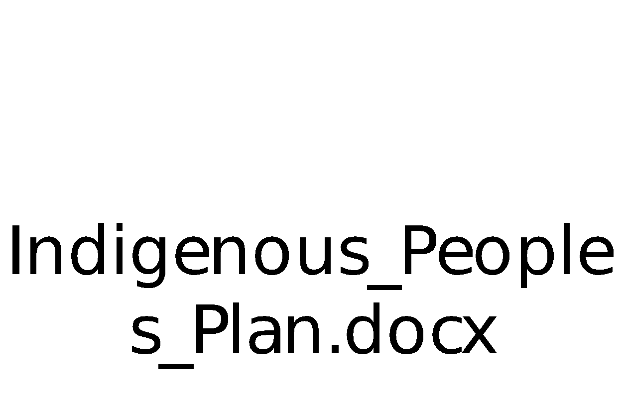

Annex M: Pasture calculations for regeneration

Table 1. Cost of radical pasture improvement (pasture cropping + fencing)
Pasture area, ha | 200
US$ to KZT exchange rate, US$ 1 = KZT | 420
Investment costs
Item | Unit | Value | Unit cost, KZT | Total cost, KZT | Total cost, US$
Fencing (5 rows of barbed wire and concrete poles every 5 meters) | running meter | 6,000 | 750 | 4,500,000 | 10,714.29
Seeds (perennial crops such as alfalfa, saifoin, agropyron, Brōmus inērmis) | lumpsum, per ha | 1 | 15,000 | 3,000,000 | 7,142.86
Total investment costs, 200 ha |  |  |  | 7,500,000 | 17,857.14
Labor and machinery costs
Item | Description of the machinery (RUS) | Output per 1 hour, ha | Labor force, KZT/ha | Fuel consumption, L/ha | Fuel cost, KZT/ha | Maintanance cost, KZT/ha | Operating cost, KZT/ha | Total cost, KZT/ha | Total cost, US$/ha
Dump plowing to a depth of 20-22 cm | МТЗ-82+ПЛ Н-4-35 | 1 | 235 | 25 | 5,000 | 2,007 | 1,839 | 9,081 | 21.62
Disking 5-10 cm | МТЗ-82+ЛДГ -5 | 2,1 | 170 | 13 | 2,500 | 690 | 1,475 | 4,835 | 11.51
Harrowing | МТЗ-80; БЗ-1,0 | 3 | 170 | 10 | 2,000 | 249 | 767 | 3,186 | 7.59
Soil preparation before sowing | МТ380+ЗККШ-6 | 5 | 170 | 10 | 2,000 | 249 | 767 | 3,186 | 7.59
Sowing | МТЗ-80+СЗТ -3,6 | 2 | 200 | 13 | 2,500 | 205 | 1,459 | 4,364 | 10.39
Soil leveling after sowing | МТЗ-80+ЗКК; Ш-6 | 5 | 170 | 10 | 2,000 |  | 498 | 2,668 | 6.35
Total labor and machinery costs, 1 ha |  |  |  |  |  |  |  | 27,320 | 65.05
Total labor and machinery costs, 200 ha |  |  |  |  |  |  |  | 5,464,000 | 13,009.52
Total cost, 200 ha (including contingency 5%) |  |  |  |  |  |  |  | 13,612,200.00 | 32,410.00

Table 2. Cost of pasture rotation implmentation using electric fencing
Pasture area, ha | 400
US$ to KZT exchange rate, US$ 1 = KZT | 420
Investment costs
Item | Unit | Value | Unit cost, KZT | Total cost, KZT | Total cost, US$
Fencing (electric fencing, 14 cells) | Lumpsum |  |  | 6,547,900 | 15,590.24
Total investment costs, 400 ha |  |  |  | 6,547,900 | 15,590
Operating costs
Item | Unit | Value | Unit cost, KZT | Total cost, KZT | Total cost, US$
Maintenance cost (10%) | per year | 4 | 654,790 | 2,619,160 | 6,236.10
Total investment costs, 400 ha |  |  |  | 2,619,160 | 6,236
Total cost, 400 ha (including contingency 5%) |  |  |  | 9,625,413 | 22,918

Table 3. Cost of pasture watering: a water well with a wind pump
Pasture area, ha | 1200
US$ to KZT exchange rate, US$ 1 = KZT | 420
Investment costs
Item | Unit | Value | Unit cost, KZT | Total cost, KZT | Total cost, US$
Drilling of well | Lumpsum |  |  | 2,000,000 | 4,761.90
Wind water pump | Lumpsum |  |  | 5,790,000 | 13,785.71
Reservoir | Lumpsum |  |  | 500,000 | 1,190.48
Total investment costs, 1200 ha |  |  |  | 8,290,000 | 19,738
Operating costs
Item | Unit | Value | Unit cost, KZT | Total cost, KZT | Total cost, US$
Maintenance cost (5%) | per year | 4 | 829,000 | 3,316,000 | 7,895.24
Total investment costs, 1200 ha |  |  |  | 3,316,000 | 7,895
Total cost, 1200 ha (including contingency 5%) |  |  |  | 12,186,300 | 29,015

Annex N: Project Mitigation Benefits

Methodology and tools used.

- The Ex-Ante Carbon-balance Tool (EX-ACT) is an appraisal system developed by FAO providing estimates of the impact of agriculture and forestry development projects, programs and policies on the carbon-balance. The carbon-balance is defined as the net balance from all greenhouse gases (GHGs) expressed in CO2 equivalent that were emitted or sequestered due to project implementation as compared to a business-as-usual scenario. Ex-ante analysis assesses future GHG emissions before project implementation. The minimum duration to make an assessment of future GHG emissions in EX-ACT is 20 years.

- EX-ACT is a land-based accounting system, estimating C stock changes (i.e. emissions or sinks of CO2) as well as GHG emissions per unit of land, expressed in equivalent tonnes of CO2 per hectare and year. The tool helps project designers to estimate and prioritize project activities with high benefits in economic and climate change mitigation terms. The amount of GHG mitigation may also be used as part of economic analyses as well as for the application for additional project funds.

- EX-ACT has been developed using primarily the Intergovernmental Panel on Climate Change 2006 Guidelines for National Greenhouse Gas Inventories (IPCC, 2006) that furnishes EX-ACT with recognized default values for emission factors and carbon values (the so-called Tier 1 level of precision). EX-ACT is also based upon Chapter 8 of the Fourth Assessment Report from Working Group III of the IPCC (Smith et al., 2007) for specific mitigation options not covered in NGGI-IPCC-2006. Other required coefficients are from published reviews or international databases.

- Since most of the Project activities and interventions will be identified during the implementation phase, at this stage, it is quite difficult to identify the exact number and types of sub-projects that should be considered in the GHG analysis. Therefore, some preliminary estimations of the number and types of indicative sub-projects that the Project most likely will support were made mainly based on the Project LogFrame and the costing models on pasture rehabilitation activities. Based on these estimations, the agricultural area, number of livestock, etc. that would have an impact on GHG analysis were also estimated.
Description of settings for the Kazakhstan Resilient Agroforestry and Rangeland Project in EX-ACT
- Specific settings were selected for the Kazakhstan Resilient Agroforestry and Rangeland Project considering the climate, moisture conditions and dominant soil type in the region. Normally, the minimum project duration time in EX-ACT to make a carbon balance estimation is 20 years. Implementation of the project will be 4 years and the rest 16 years goes to the capitalization phase.

- 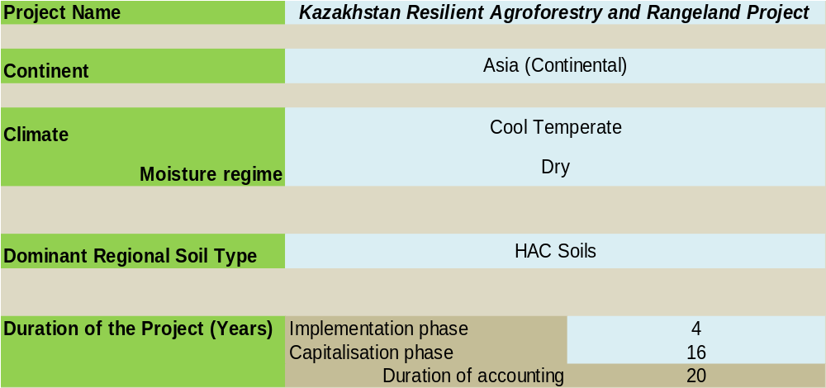
Interventions supported by the Kazakhstan Resilient Agroforestry and Rangeland Project
- Although the exact project activities will be identified during the implementation phase, the calculation of potential project mitigation benefits in both Aktobe and Pavlodar oblasts was carried out using the following assumptions:
- Six sub-projects on pasture cropping with perennial grass using fencing with the area of 200ha each (1200ha in total) will be implemented as a pasture rehabilitation activity on commune pastures/private lands;
- Four sub-projects on pasture rotation using electric fencing with the area of 400ha each (1600ha in total) will be implemented as a pasture rehabilitation activity on commune pastures/private lands;
- One sub-project with a demo-field on pasture watering system using a water well and a wind pump, which will have the capacity to water the livestock on 1,200ha will be most likely implemented on private land;
- Technical support will be provided to introduce SLM practices and landscape management approaches on an area of over 816,000 ha;
- The cattle (8,500 LU) that will be grazing on the targeted total project area of 34,000ha will have be managed better with the project interventions.
Calculations
Grassland systems module
- It is assumed that pasture cropping with perennial grass using fencing will save the pastures from transforming from moderately degraded to severely degraded pasture health type. Moreover, the pastures will be improved and will have a good quality. The pasture rotation activities related sub-projects will help to give a rest to severely degraded pastures, and the land cover there will be improved naturally. A demo-field with pasture watering system will be installed on a remote area, where the degradation of pastures is not that high. All three sub-projects types related to different pasture rehabilitation activities include at least one input that is why in with project scenario all of them will be improved with inputs. The introduction of SLM practices and landscape management approaches will not imply any input from the Project thus these pastures will be improved without inputs.
- 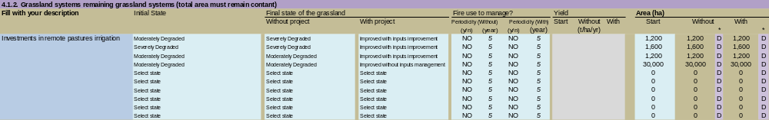
Livestock production module
- In the livestock production module estimates the GHG balance of the livestock farmers which will potentially benefit from the project on the targeted area of 34,000ha. The total number of livestock units which will be impacted by the project is estimated to be 8,500 LU. It is expected that the capacity building activities will support the farmers to introduce efficient feeding practices, including using specific agents and nutrients for CH4 reduction, breeding practices to improve productivity and management practices, however the total number of livestock impacted by the project will remain unchanged. In the situation with the project it is assumed that 70% of farmers will successfully introduce the improved feeding and breeding practices, while 30% of farmers will introduce the specific agents into the daily rations of their livestock. The table below demonstrates the balance between With and Without Project scenarios of livestock production.
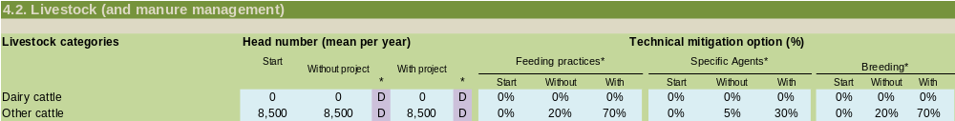
- EX-ACT Results module
- The net carbon balance is the difference between the gross results of With and Without Project scenarios achieved during 20 years, including 4 years of project implementation and 16 years of capitalization periods. This amount is estimated at 1,271,505 tCO2-eq of mitigated emissions (see the results table below).
- This improvement has been reached due to pasture rehabilitation activities and improved SLM practices in grassland management (-1,264,164 tCO2-eq) and improved livestock management (-7,341 tCO2-eq). The total balance of -1,271,505 tCO2-eq can be translated into -37 tCO2-eq per hectare over 20 years period or -1.9 tCO2-eq per hectare per year.
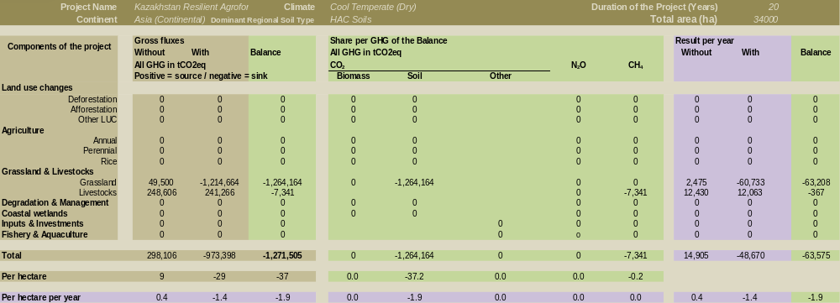
* Negative sign means carbon sequestration
- The abovementioned value (-1,271,505 tCO2-eq) is the direct lifetime GHG emission mitigation potential from the Project. According to the Guidelines for Greenhouse Gas Emissions Accounting and Reporting for GEF Projects (GEF/C.48/Inf.09, 7 May 2015), indirect emissions reductions have been re‐defined as “consequential emissions”. Consequential GHG emission reductions are those projected emissions that could result from a broader adoption of the outcomes of a GEF project plus longer‐term emission reductions from behavioural changes. Broader adoption of a GEF project proceeds through several processes including sustaining, mainstreaming, replication, scaling‐up and market change. Since, the exact project activities and the project pilot zones are not identified yet, it is suggested to complete the analysis as soon as these details will be available or at the mid-term review stage, estimating and taking into account the consequential emissions mitigation.

Annex O. Gender Action Plan

Background

Several country assessments and studies conducted by different international and national stakeholders identified that rural women are in vulnerable and disempowered position with little opportunity to participate in the role of decision-taking, access to knowledge and technologies, and control over productive resources.

Despite of women’s important contributions to agriculture, they face a number of disadvantages as compared to men. Rural women typically work as unpaid family workers, performing tasks both within their households and on family farms or household plots. Their contribution is invisible in official statistics and is often undervalued by women themselves as they perceive it as a continuation of their ‘natural’ role. Women also work as hired employees on smallholder farms, undertake much of the day-to-day farm work. Women represent less than one third (1/3rd) of agricultural producers and acting farms. While an increasing number of women are working in small and medium enterprises, women are mainly self-employed, and lack decent working conditions and social security benefits such as pensions. Women represent 70% of all employees in sectors that are traditionally feminized, where the prevalence of low-paying wages is high. In 2016, the agriculture sector employed approximately one-fifth of the population, comprising 714,400 women and 839,000 men, while accounting for only 4.8% of GDP. The majority of labor is concentrated in the small-farm sector, which produces 46% of agricultural output. Yet, the extent of women’s work in the agriculture sector could be underreported given that women are less likely to hold wage-earning positions, hold land, or have agribusiness shares in their name. Women’s work on family farms is often not viewed as an economic contribution and so remains underreported. Overall, women earn only 77% of what men earn in the agriculture sector. Such indicators can be explained by the poor awareness of GEWE in agriculture among stakeholders, policymakers, service providers and others in value chain. Implementation of national strategy papers and international commitments are not properly put in practice due to weak political will, lack of inter-ministerial network, absence of responsible parties, lack of financial support. Women’s political participation has improved significantly in the last ten years, however women are still underrepresented in public and political life and in decision-making positions, including in Parliament, local representative bodies, the executive bodies, local government, as well as in diplomacy. In decision-making, women comprise most civil servants and are underrepresented at higher-level decision-making positions. Women comprise 21.9% of Parliament members, but only 11.7% of the political-level civil servants. They are less likely to be political and business leaders and are more prescribed to the roles associated with the family due to glass ceiling, stereotypes and discrimination, which results in 1 out of 17 regions of Kazakhstan that has the only woman mayor. Therefore, the gender mainstreaming in project cycle management is critical to eliminate gender inequalities at policy and field levels.
The actions of GAP are built on the conclusions of country assessments and other studies about ways of elimination of persistent gender imbalances in agriculture sector. Similarly, some relevant recommendations and follow-up actions suggested in several assessments and studies will be integrated in this GAP.
Goal and Objectives:

Output 3.1.1 Training on sustainable pasture management practices:
- To conduct capacity needs assessment at the national, regional, and local levels that will include the assessment on knowledge of policies and tools on gender equality and empowerment of women;
- Organize Farmer Field Schools that involve or focus on women;
- Pasture management and feeding strategy that includes gender-sensitive recommendations for policy interventions;

Output 3.1.2: Demonstration of pasture/SLM rehabilitation and technologies:

- To actively involve female stakeholders (farmers, /women’s group/private or public organizations) in demonstrations, field works and on-farm population management and monitoring;
- The capacity-building programmes are gender-responsive and gender screened, and women trainees included;

Output 3.2.1: Demonstration of climate smart agricultural practices:

- To demonstrate profitable best practices and models, and encouraging the support of gender-responsive value chain development, framing all assessments and value chain development by the FAO guiding framework and guidelines, and by selecting value chains, among others, based on the opportunities for resilient livelihoods of women and men, including the most vulnerable.

Output 3.3.1: Economic assessment of investments in carbon sequestering projects in the agricultural sector:

- To carry out rapid gender analysis and include measures to support value addition by both women (e.g. dairy) and men (livestock management);
- To develop business models that will meet the practical needs and strategic priorities of women as well as men i.e. will take account of women’s/ men’s specific barriers in contributing to sustainable pasture management, building on gender analyses and consultations for the Project. They will also create economic opportunities for women as well as men in pasture management practices, such as through building windbreaks and other erosion control practices.
Output 3.3.2: Training on the international Carbon trading system:
- Build the national capacity based on the FAO monitoring methodologies and introduce local land-users to different land management monitoring systems that take account gender aspects, needs and differences through economic, social and ecological indicators.
- To include gender session into training curriculum.

Minimum Gender Mainstreaming Standards

The Project will, whenever required, collect disaggregated data by sex, age, and gender, including in the areas of education, organization, location; conduct a rapid gender assessment prior to significant activities in order to effectively tackle the gender imbalances within all levels of stakeholders; conduct stakeholder analysis, which will provide opportunities for consultations with and engagement of women’s organizations and beneficiaries, fostering women’s role as drivers of change in agrobiodiversity conservation; include featuring gender-related competencies in Terms of Reference of involved staff and consultants. The gender activities will be delivered through the Project’s components, which include specific targets and indicators to observe progress of gender mainstreaming in sustainable use of agrobiodiversity and obtaining benefits of application of genetic resources. International study tours and local exchange visits will be conducted with at least 30% of women and youth. The activities related to field studies, surveys and face to face interviews shall include at least 30% of women and youth as respondents.

Monitoring and Evaluation

In the framework of this GAP a number of gender-sensitive activities are designed together with targets, responsibilities and budget. These quantitative and qualitative targets will be incorporated in the Project Results Framework (see Annex A1) by M&E Officer and/or gender focal point to track and evaluate the project gender impacts and results. Specifically, the gender-sensitive indicators will help measuring share of men and women’s participation in project’s activities, including decision-making bodies, capacity-building activities, accessibility of any technical support services, as well as changes in behaviours, knowledge, skills and self-confidence of women.

Project activities to respond to the identified gaps | Indicators and Targets | Timeline | Responsibilities | Budget
Outcome 3.1: Expanded use of sustainable pasture management practices and technologies.
Output.3.1.1: Training on SPM practices. | Indicator: Gender sensitive Capacity building program developed.  Target: At least 1 session on gender issues
Output.3.1.1: Training on SPM practices. | Indicator: Capacity-building program is conducted in a gender –responsive manner  Target: 100% of trainers are capable to deliver the  Programme in a gender-responsive manner  Relevant parity among trainers is ensured. (Agro-pastoral master trainer)
Output 3.1.2: Demonstration of pasture/SLM rehabilitation and technologies. | Indicator: Number of target landscapes operating with demonstrated experiences and capacity in pasture SLM and planning with gender considerations  Target: at least 30% of activities of demonstrated experiences and capacity are women-targeted
Outcome 3.2: Enhanced public and private investments in sustainable pasture infrastructure. | Indicator: Percent of beneficiaries that see their income increased from adopting farmer-centric business models.  Target: at least 30% of beneficiaries are women or women led farms
Output 3.2.1: Demonstration of climate smart agricultural practices. | Indicator: Business models designed under this output are gender-responsive  Target: Analysis and recommendation to the development of business model respond to the needs of women owned and men owned VCs.  At least 2 women’s success stories are included in best practice articles for the visibility and empowerment purposes
Outcome 3.3: Participation of the GoK in the international carbon trading system.
Output.3.3.1: Economic assessment of investments in carbon sequestering projects in the agriculture sector | Indicator: Economic assessment is conducted in a gender-responsive manner  Target: at least 30% of women led organizations, participate in decision-making dialogues;  100% of policy documents on carbon trading include gender sensitive-analysis or have gender considerations with gender-responsive recommendations
Output.3.3.2: Training on the international carbon trading system. | Indicator: Training on the international carbon trading system is conducted in an inclusive way and has specific session on gender issues  Target: at least 30% of quota is provided to women activists or women-led organizations  At least 1 session is conducted on gender issues relevant to the sector

See Guidance Note on Gender Mainstreaming in project identification and formulation
World Bank. Available at https://data.worldbank.org/country/kazakhstan?view=chart. Accessed 2 July 2020.
Orr et al. 2017. Scientific Conceptual Framework for Land Degradation Neutrality. A Report of the Science-Policy Interface. United Nations Convention to Combat Desertification (UNCCD), Bonn, Germany.
Analytical report on conditions and use of lands in Kazakhstan for 2018, the Land Resources Management Committee of the Ministry of Agriculture of the Republic of Kazakhstan
See Stakeholder Engagement Matrix.
https://www.unwomen.org/-/media/headquarters/attachments/sections/csw/64/national-reviews/kazakhstan_en.pdf?la=en&vs=4030
https://sustainabledevelopment.un.org/content/documents/23946KAZAKHSTAN_DNO__eng_4.Juli19.pdf
https://digitallibrary.un.org/record/1645328
http://profkom-mmg.kz/kontseptsiya-gendernoj-i-semejnoj-politiki-v-respublike-kazahstan-do-2030-goda/
Домохозяйства Республики Казахстан. Итоги Национальной переписи населения Республики Казахстан 2009 года. Астана, 2011. Т. 1. [Households in the Republic of Kazakhstan. 2009 National Census Data. Astana, 2011.]
The Agency on Statistics of the Republic of Kazakhstan. 2011. “The Results of the 2009 National Population Census of the Republic of Kazakhstan” Analytical Report I. Astana.
Exchange rate as of 18 May 2020: $US 1 = KZT 420, the National Bank of Kazakhstan, web-site: https://nationalbank.kz/
R. Sarsembayeva. 2017. Implementation of the Strategy for Gender Equality in the Republic of Kazakhstan 2006–2016: The Sociological Analysis. Astana.
The Statistical Report on the Standard of Living of the Population in Kazakhstan, The Statistics Committee of the Ministry of National Economy of the Republic of Kazakhstan, 2019. https://stat.gov.kz/api/getFile/?docId=ESTAT327985
R. Sarsembayeva. 2017. Implementation of the Strategy for Gender Equality in the Republic of Kazakhstan 2006–2016: The Sociological Analysis. Astana.
The Statistics Committee of the Ministry of National Economy of the Republic of Kazakhstan, web-site: https://stat.gov.kz/official
UNFPA. 2019. Population Situation Analysis of the Republic of Kazakhstan. UNFPA.
Republic of Kazakhstan. 2003. Land Code of the Republic of Kazakhstan, Article 101:1. http://adilet.zan.kz/eng/docs/ K030000442.
N. Dudwick, K.Fock, and D. Sedik. 2007. Land Reform and Farm Restructuring in Transition Countries: The Experience of Bulgaria, Moldova, Azerbaijan, and Kazakhstan. Washington, DC: World Bank Group.
N. Dudwick, K.Fock, and D. Sedik. 2007. Land Reform and Farm Restructuring in Transition Countries: The Experience of Bulgaria, Moldova, Azerbaijan, and Kazakhstan. Washington, DC: World Bank Group.
ADB, Country gender assessment 2018, Kazakhstan
Law of the Republic of Kazakhstan “On the suspension of certain norms of the Land Code of the Republic of Kazakhstan, web-site: https://online.zakon.kz/Document/?doc_id=35258971#pos=0;106
Analytical report on conditions and use of lands in Kazakhstan for 2018, the Land Resources Management Committee of the Ministry of Agriculture of the Republic of Kazakhstan
Hankerson et al 2019, Modelling the spatial distribution of grazing in Kazakhstan, PLoS ONE.
Gross output of agricultural products produced by different categories of farms for 2018, The Statistics Committee of the Ministry of National Economy of the Republic of Kazakhstan, web-site: https://stat.gov.kz/official
Order of the Minister of Agriculture of Kazakhstan on the approval of the maximum permissible load rate for the total area of pastures dated 14 April 2015, http://adilet.zan.kz/rus/docs/V1500011064/links
Analytical report on conditions and use of lands in Kazakhstan for 2018, the Land Resources Management Committee of the Ministry of Agriculture of the Republic of Kazakhstan
http://www.fao.org/in-action/rural-invest/en/
Gender.stat.gov.kz , Men and Women of Kazakhstan 2018
Gender.stat.gov.kz , Men and Women of Kazakhstan 2018
Republic of Kazakhstan. 2016. Kazakhstan 2050: 563,000 Kazakhstanis Permanently Employed under the Employment Roadmap 2020. http://www.government.kz/en/chelovecheskij-kapital/1006480-563-000-kazakhstanis-permanentlyemployed-under-employment-roadmap-2020.html.
FAO 2020, Guidelines for Grazing Management Planning: A Holistic Approach, Country Representative Office in Turkey and Ministry of Agriculture and Forestry (MAF), Ankara.
Flannery, TF 1994, The future eaters: An Ecological History of the Australasian Lands and Peoples, Reed Books Australia, Port Melbourne.
FAO 2020, Guidelines for Grazing Management Planning: A Holistic Approach, Country Representative Office in Turkey and Ministry of Agriculture and Forestry (MAF), Ankara.
Beer, C., Zimov, N., Olofsson, J. et al. Protection of Permafrost Soils from Thawing by Increasing Herbivore Density. Sci Rep 10, 4170 (2020). https://doi.org/10.1038/s41598-020-60938-y
McMahon, P, 2016, The investment case for ecological farming, White Paper, SLM Partners
McMahon, P, 2016, The investment case for ecological farming, White Paper, SLM Partners
http://www.fao.org/land-water/land/land-governance/land-resources-planning-toolbox/category/details/en/c/1036360/
https://www.wocat.net/en/
http://www.fao.org/gef/projects/detail/en/c/1056825/
Regional territorial inspections of Aktobe and Pavlodar oblasts, 2018.
System-wide capacity development (CD) is essential to achieve more sustainable, country-driven and transformational results at scale as deepening country ownership, commitment and mutually accountability. Incorporating system-wide CD means empowering people, strengthening organizations and institutions as well as enhancing the enabling policy environment interdependently and based on inclusive assessment of country needs and priorities. - Country ownership, commitment and mutual accountability: Explain how the policy environment and the capacities of organizations, institutions and individuals involved will contribute to an enabling environment to achieve sustainable change - Based on a participatory capacity assessment across people, organizations, institutions and the enabling policy environment, describe what system-wide capacities are likely to exist (within project, project partners and project context) to implement the project and contribute to effective management for results and mitigation of risks. - Describe the project’s exit / sustainability strategy and related handover mechanism as appropriate.
FAO http://www.fao.org/3/a-i5575e.pdf
https://www.adb.org/documents/kazakhstan-country-gender-assessment-2018 .
WHO/UNICEF Joint Monitoring Programme for Water Supply and Sanitation, Country and Regional Drinking Water and Sanitation Coverage Estimates for 1990, 2000 and 2015, http:// www.wssinfo.org/data-estimates/tables/.
https://wonderfoundation.org.uk/wp-content/uploads/2019/08/Women-in-Kazakhstan-Wonder-Foundation-Insight-Report-Digital.pdf
UNDP. 2016. Human Development Data (1990–2015). http://hdr.undp.org/en/data.
ADB. 2018. Country Gender Assessment.
OECD. 2013. OECD Review of Agricultural Policies: Kazakhstan 2013. OECD Publishing. https://www.oecd-ilibrary.org/ agriculture-and-food/oecd-review-of-agricultural-policies-kazakhstan-2013_9789264191761-en
FAO. 2014. Rural Women in Eastern Europe and Central Asia. Rome.
Please refer to GEF Gender Equality Guidelines, Guide to maistreaming gender in FAO's project cycle, GEF Gender Guidelines.
H: High; M: Moderate; L: Low.
World Bank. Climate Change Knowledge Portal – Kazakhstan. https://climateknowledgeportal.worldbank.org/country/kazakhstan Accessed 17 June 2020.
World Bank. Climate Change Knowledge Portal – Kazakhstan. https://climateknowledgeportal.worldbank.org/country/kazakhstan Accessed 17 June 2020.
Eckstein, David, Marie-Lena Hutfils and Mail Winges. 2019. Global Climate Risk Index 2019 Who Suffers Most From Extreme Weather Events? Weather-Related Lossed Event in 2017 and 19982to 2017. Briefing Paper. German Watch. Available at: https://germanwatch.org/files/Global Climate Risk Index 2019_2.pdf
Kompas, T., Pham, V. H., & Che, T. N. (2018). The effects of climate change on GDP by country and the global economic gains from complying with the Paris ClimateAccord. Earth’s Future,6, 1153–1173.https://doi.org/10.1029/2018EF000922
This is based on Annex E unless otherwise referenced.
Land degradation can be defined differently, and models give different results. See UNCCD, CSIRO (2017). Good Practice Guidance, SDG Indicator 15.3.1: Proportion of land that is degraded over total land area. Technical Report ;and Sims, N.C.; England, J.R.; Newnham, G.J.; Alexander, S.; Green, C.; Minelli, S.; Held, A. Developing good practice guidance for estimating land degradation in the context of the United Nations Sustainable Development Goals. Environmental Science & Policy 2019, 92, 349-355, doi:https://doi.org/10.1016/j.envsci.2018.10.014. The land degradation assessment, particularly the improved area under grasslands in the south of Pavlodar should be treated with caution until ground-truthing and stakeholder consultations can confirm these trends.
Hankerson BR, Schierhorn F, Prishchepov AV, Dong C, Eisfelder C, Müller D (2019), Modelling the spatial distribution of grazing intensity in Kazakhstan. PLoS ONE 14(1): e0210051.https://doi.org/10.1371/journal. pone.0210051
Global Facility for Disaster Reduction and Recovery. Think Hazard. Available at http://thinkhazard.org/en/report/132-kazakhstan. Access 17 June 2020.
Specific guidance on how FAO can promote the Four Pillars of Decent Work in rural areas is provided in the Quick reference for addressing decent rural employment (as well as in the full corresponding Guidance document). For more information on FAO’s work on decent rural employment and related guidance materials please consult the FAO thematic website at: http://www.fao.org/rural-employment/en/.
Please note that output based indicators are not mandatory as long as the targets for each output are well defined.
The average rural population in 1 targeted rayon is 19,000 people. It is expected that the project will reach 80% of rural community in 4 different selected rayons.
The indicative average cost of the practices is US$ 1,000/ha.
The estimated average area of the targeted rayon is about 204,000 ha. Four rayons will be selected.
Quarter of the project financing.
Including project and private financing.
See FAO Operational Guidelines for Stakeholder Engagement
Please include identification and consultations of disadvantage and vulnerable groups/individuals in line with the GEF policy on Stakeholder Engagement and GEF Environmental and Social Safeguard.
This section has to be adapted to each specific country.
Compliance Reviews following complaints related to the Organization’s environmental and social standards: http://www.fao.org/aud/42564-03173af392b352dc16b6cec72fa7ab27f.pdf
ADB. 2018. Country Gender Assessment.
OECD. 2013. OECD Review of Agricultural Policies: Kazakhstan 2013. OECD Publishing. https://www.oecd-ilibrary.org/ agriculture-and-food/oecd-review-of-agricultural-policies-kazakhstan-2013_9789264191761-en

